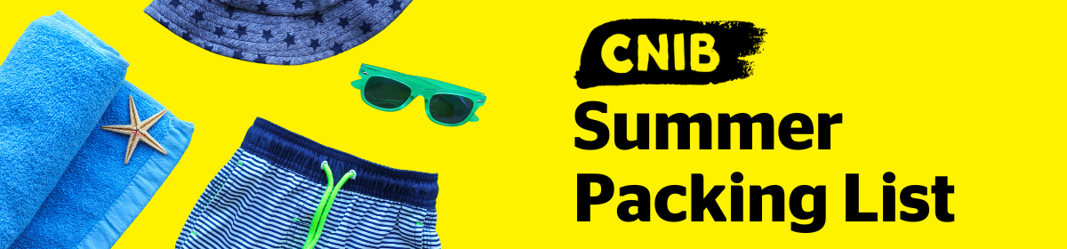

Clothing:
- T-shirts
- Long sleeve shirts
- Shorts
- Pants
- Sweater
- Sweatpants
- Rain Jacket
- Hat
- Closed-toe shoes
- Sandals or flip flops
- Bathing suit
- Socks and underwear
- Pajamas

Bedding & Towels:
- Face, hand, bath towels
- Beach towels

NEW! For Children & Youth Programs* & Family Weeks only

Please bring your own bedding: pillow and pillowcase; sleeping bag and/or twin-size sheet set and blanket (protective mattress covers will be provided). CNIB Lake Joe will ONLY provide bedding for guests who are travelling from out-of-province.

*Camp Abilities, PLAY, Summer Camp, CIT, and CLDP.

Toiletries:
- Toothpaste & toothbrush
- Female hygiene products
- Hairbrush
- Shampoo & conditioner
- Soap or body wash

Camp-related goodies:
- Swimming goggles
- Sunscreen and bug spray
- Flashlight

Optional:
- Personal down time activities (books, cards, colouring books)
- Tuck money (souvenirs, snacks, t-shirts, sweatshirts etc.)
- Cooler (we have free ice available on site for you)

Things to leave at home:
- Weapons
- Nut Products
- Bedding (will be provided by CNIB Lake Joe)
- Ice (will be provided by CNIB Lake Joe)

Important Notes:
- There will be no access to do your own laundry so please bring enough clothes to last the entire duration of your stay.
- There will not be any town runs by CNIB Lake Joe staff (for shopping trips), so please bring everything you may need, including plenty of masks.

