2024 CNIB Lake Joe
Camp Programs
Enriching lives. Making memories. Building independence.

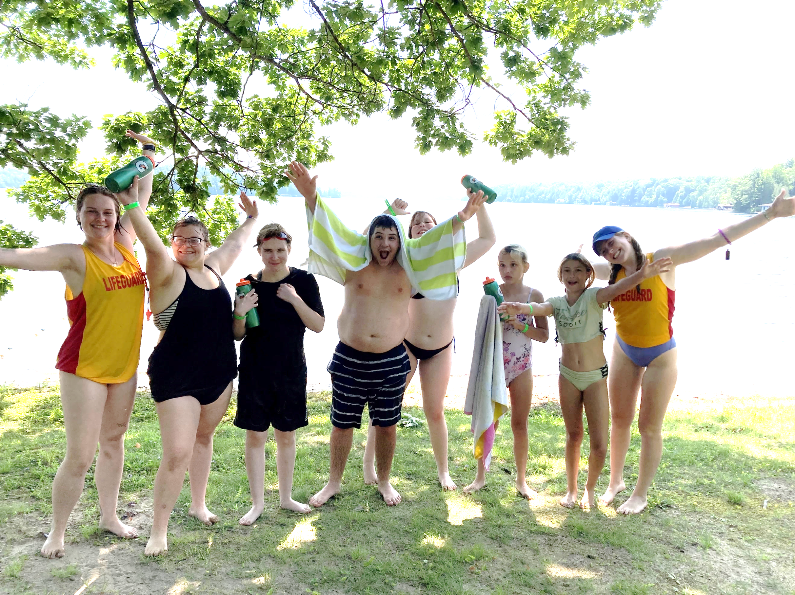

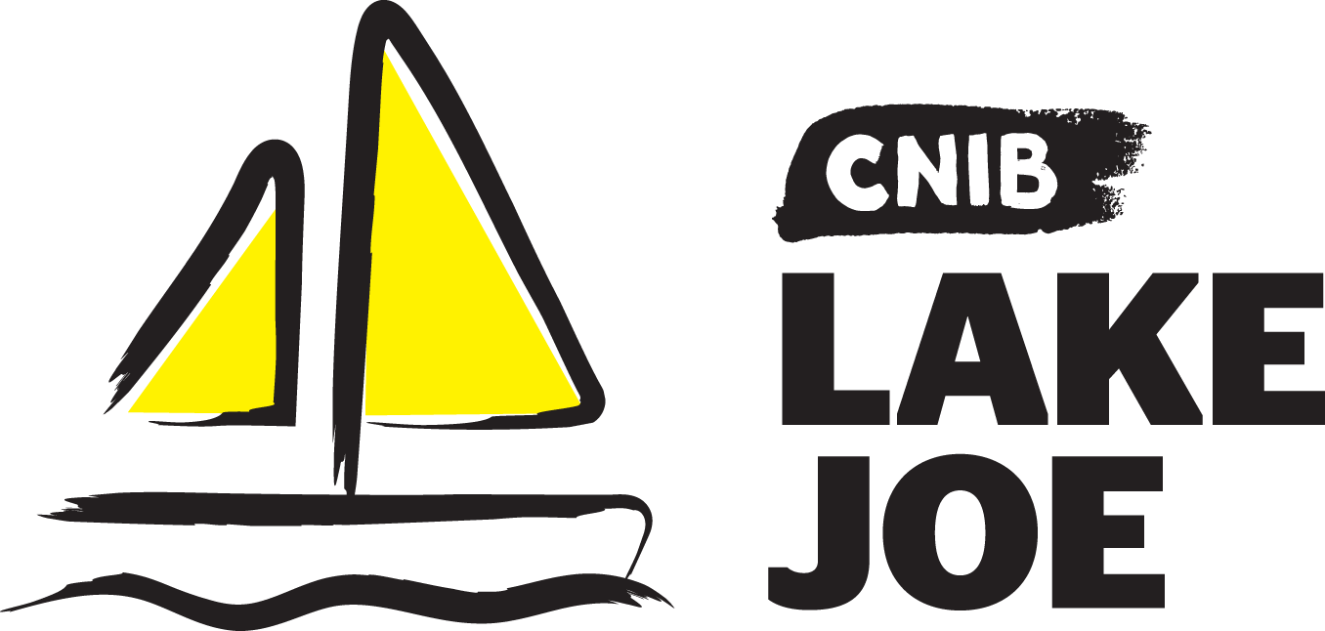

Table of Contents
About CNIB Lake Joe 3
Children & Youth Programs 5
Adult Programs (19+) 9
Family Programs 12
Holiday Programs 14
CNIBLakeJoe@Home Virtual Programs 16
Programs Summary 17
2024 Program Fees 18
Application Process 21
Getting to Camp 23
Get Involved 25

Please note: CNIB Lake Joe may update or make changes to the 2024 schedule. Every effort will be made to keep the programs and fees as represented, however, unforeseen circumstances may result in the substitution or cancellation of a program. We appreciate your understanding and look forward to finding the perfect program for you and your family.

About CNIB Lake Joe
We are excited to share information about our CNIB Lake Joe 2024 season! Since 1961, CNIB Lake Joe has been providing a unique blend of recreation and skills development in a safe, inclusive environment. Dedicated to providing enriching experiences for Canadians with sight loss, it's a one-of-a-kind camp in Canada. Located in the heart of Muskoka, CNIB Lake Joe is an accessible lakefront property that stretches over 12.5 acres on the northwest corner of beautiful Lake Joseph.
CNIB Lake Joe is proud to be an accredited member of the Ontario Camps Association, registered High Five organization and an affiliated member of the Lifesaving Society.
This year we are excited to offer a wide range of CNIB Lake Joe camp programs plus our “Partner Programs” in collaboration with staff teams from CNIB, Vision Loss Rehabilitation Canada, CNIB Deafblind Community Services, and INCA Québec. There will be new programs to dazzle and delight along with our classic camp programs that everyone loves. See you soon!
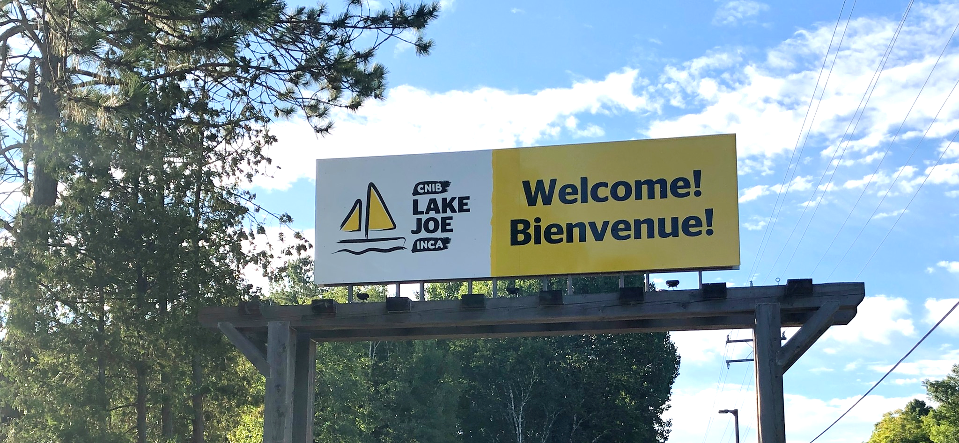

Here are just some of the activities you can enjoy at CNIB Lake Joe!
- Make a splash in Lake Joseph: fishing, paddling (canoe, kayak, stand-up paddleboard), pontoon boat cruises, sailing, swimming, tubing, waterskiing, wakeboarding, and water sliding.
- Get creative: music, pottery, crafts, dancing, and talent shows.
- Get active: climbing tower, soccer pitch, basketball, beep baseball, tennis, shuffleboard, mini-golf, tandem-bike riding, archery, hiking, yoga, hockey and more.
- Learn new skills: in a fun, safe and supportive environment.
- Rest and relax: explore the Multi-sensory room, enjoy a book by the lake, visit with friends, new and old, around the campfire.
Don’t forget, there are lots of virtual programs – online and on the phone at CNIBLakeJoe@Home where you can learn, laugh, and stay connected with your camp community year-round!
To apply, please visit: cnibLakeJoe.CampBrainRegistration.com

For more information, contact CNIB Lake Joe:
Email: LakeJoe@cnib.ca
Toll Free: 1-877-748-4028
Phone: 705-375-2630
Web: cnib.ca/LakeJoe
Address: CNIB Lake Joe, 4 Joe Finley Way, MacTier, ON P0C 1H0

Children & Youth Programs
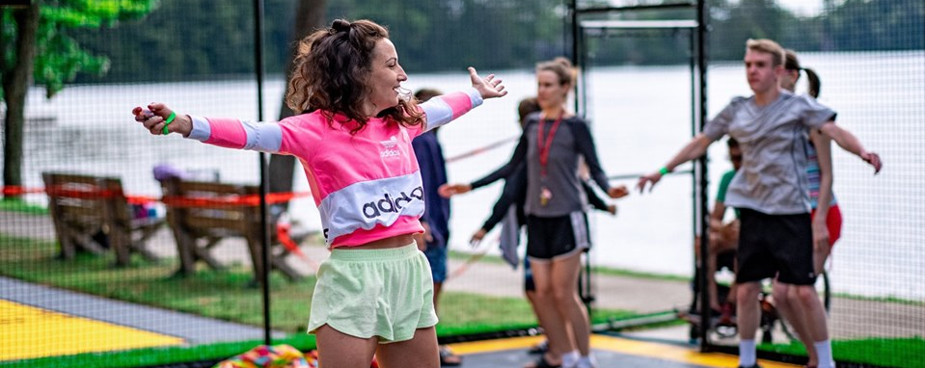
These programs are open to children and youth who are blind or partially sighted. Some programs also welcome sighted siblings and friends. In 2024, thanks to the incredible generosity of donors, we are able to offer deeply discounted rates (see Fees section for details) including ground transportation from specific hubs in Ontario (see Transportation section for details). Please review the “Important Program Points” included in the program descriptions for full details.

Welcome to CNIB Lake Joe’s Children & Youth Camp Programs
Pre-camp virtual orientation session
Included in the registration fee for all children & youth programs, this Zoom meeting is your chance to meet others in advance, review housekeeping details, learn more about camp, and get answers to your questions so you can spend all of your time at CNIB Lake Joe focused on fun, family and friends. Full details will be provided to registrants at the beginning of the season.

PLAY (Pushing Limits for Active Youth)
July 1-6, 2024 | Ages: 8-18
PLAY is a program for kids who are interested in getting active and trying out new sports. From 5-a-side soccer to archery, Power Showdown to the climbing wall, participants will try their hand at a variety of different sports and activities that encourage a healthy and active lifestyle. In addition to active programs, there will be health and wellness workshops including healthy eating and self-care to complement this adaptive sports component.
Note: This program is open to children and youth who are CNIB clients as well as sighted siblings and friends.

Camp Abilities
July 1-6, 2024 | Ages 8-18
This goal-based active program is aimed at athletic development. Participants will receive coaching from instructors who will help guide athletes to achieve their performance goals through specialized sports programs. Participants will have the opportunity to choose from hockey, soccer or water sports as their discipline, and will participate in their chosen specialty every morning. During the remainder of the day, they will participate in other fun recreational programs at CNIB Lake Joe.
Note: This program is open to children and youth who are CNIB participants as well as their sighted siblings and friends.

Important program points:
- Blind Hockey registrants: This is an introduction program for blind hockey. The focus will be on skill development with less emphasis on game play. Participants in the blind hockey program are expected to possess basic skating skills and have the necessary hockey equipment, including protective gear such as chest, pants, and shin guards, elbow pads, gloves, a neck guard, mouthguard, helmet, as well as skates and a stick. If equipment is a concern and would limit the ability to participate in the program, please reach out to Emily Harrison, Lead, Guest Experience at emily.harrison@cnib.ca.
- Watersports registrants: The watersports program will be focused on waterskiing and wakeboarding. Participants are required to have basic swimming skills and must be able to lift their own body weight out of the water and onto a platform. Participants are not required to bring their own water ski or wakeboard equipment. All equipment will be provided.

Summer Camp
July 15-20, 2024 | Ages 8-18
Experience the excitement and tradition of summer camp in our accessible facility. Learn new skills, try new activities and create new friendships, all while developing confidence and independence in a safe and supportive environment.
This program includes a combination of activities and scheduled programs where everyone gets involved, such as archery, pottery, swimming, music, art, canoeing, 5-a-side soccer, mini-golf and the climbing wall! Campers will also be divided into groups based on their age and will be able to explore friendships and experience all the joys of camp with their peers.
Note: This program is open to children and youth who are participants of CNIB as well as sighted siblings and friends.

Partner Program: English as a Second Language (ESL) Immersion
July 15-20, 2024 | Ages 8-18
French-speaking children who are blind or have low vision will be joining the Summer Camp program to have fun and make friends while practicing and perfecting their English language skills. Bonjour et bienvenue!
For more information about the ESL component of this program and to apply, please contact Salma Moudrika, Program Lead, Children and Youth at salma.moudrika@inca.ca or 1-800-465-4622 ext. 236.

Canadian Leadership Development Program (CLDP)
July 29-August 3, 2024 | Ages 15-29
Join a group of like-minded young adults on the shores of beautiful Lake Joseph for a chance to relax, learn, become a better leader, and have the best summer ever! This exciting week will be filled with a combination of workshops, recreational activities and social events.
Learn about public speaking, advocacy, self-awareness and personal brand, all in addition to the traditional activities that make CNIB Lake Joe so special. Working with skilled facilitators, participants will have the opportunity to try new things in this fun, safe and supportive environment, and further explore leadership.

Important program point: This program aims to provide participants with leadership knowledge and skills that can be applied in various spaces. The application for the CLDP program will have additional questions that are to be completed by the applicant to gauge the participants’ fit for this program and ensure their success.

Counsellor-in-Training (CIT)
July 29 - August 10, 2024 | Ages 16-19
Gain job skills and experience while having fun at our program designed to develop leadership skills and empower youth to take an active role in camp life.
This two-week program is devoted to leadership workshops and skills development in all areas of camp and will include shadowing CNIB Lake Joe staff members to further understand what skills are required and what the staff roles entail at camp.
From learning about goal setting to building campfires and facilitating activities, this program is designed to help participants gain confidence and build the necessary skills to potentially become an active member of the CNIB Lake Joe team.

Important program points:
- This two-week program is available for people with sight loss and their sighted peers.
- Prospective participants will be required to fill out a supplementary application and participate in an interview with program staff prior to being accepted into this program.
- Successful completion of this program will ensure participants receive an interview for future camp staff positions but does not guarantee employment.

Partner Program: CNIB Buddy Dog Camp
August 19-24, 2024 | Ages 7-16
CNIB Buddy Dog graduates and those waiting or applying for their CNIB Buddy Dog are invited to enjoy summer camp at CNIB Lake Joe along with a parent/guardian!
This program combines CNIB Buddy Dog training sessions with fun camp activities, giving participants plenty of opportunities to form lifelong friendships, develop independence, and make cherished memories. Children already paired with Buddy Dogs will deepen their bonds with their dogs while children and families on the CNIB Buddy Dog waiting list can familiarize themselves with Buddy Dogs and the responsibilities of having one.

Important program points:
- Participants in this partner program must be a CNIB Buddy Dog graduate or applicant on the waiting list.
- Participants in this program must be accompanied by a parent or guardian.
To find out more about the CNIB Buddy Dog Camp or the CNIB Buddy Dog Program contact Miriam Mas, Program Lead, Buddy and Ambassador Dog Training at miriam.mas@cnib.ca or 343-997-2498.

Partner Program: Writing with Feeling: Braille Writers’ Retreat
August 12-15, 2024 | Ages 6-19
If you love writing, this action-packed writer’s retreat for CNIB kids and teens is perfect for you. Participants will meet other young writers with sight loss from across Canada and get tips and feedback from professional writers. All participants will enjoy braille-themed and accessible activities.

Important program points:
- Prospective participants will be required to apply. Priority will be given to applicants who have entered or are planning to enter the annual CNIB Braille Creative Writing Contest.
- Participants in this program must be accompanied by a parent or guardian.
For more information and to apply, please contact Karen Brophey, Program Lead, Literacy at karen.brophey@cnib.ca or 647-302-4047.

There are more programs to explore in our Family Programs and Holiday Weeks sections, or return to our table of contents.

Adult Programs (19+)
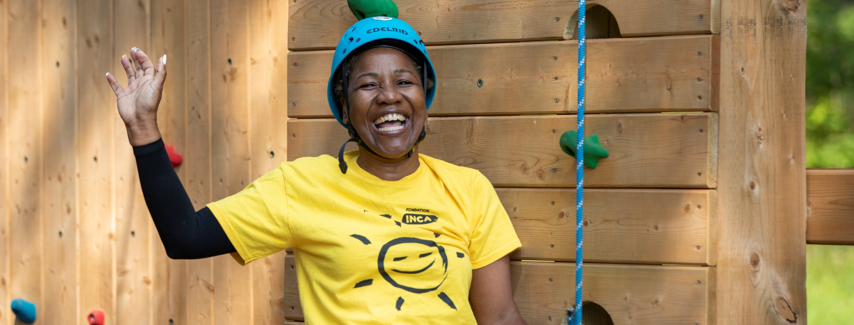
Our adult programs are designed to engage our community, whether you’re coming for the first time or as a favourite past-time. Some have mandatory program activities, while others are “drop-in” programs. Please review the detailed descriptions below.

Important program point: To attend Adult Programs, participants should be able to navigate the site with limited guidance after an initial introduction and site tour and will not require one-on-one support from staff. Participants needing additional support throughout their stay should register with someone who will provide the level of assistance required.

Welcome to CNIB Lake Joe’s Adult Camp Programs
Pre-camp virtual orientation session
Included in the registration fee for adult programs, this Zoom meeting is your chance to meet others registered in advance, review housekeeping details, learn more about camp and get answers to your questions so you can spend all of your time at CNIB Lake Joe focused on fun, family and friends. Full details will be provided to registrants at the beginning of the season.

Partner Program: Guide Dogs AdvoCamp
June 6-10, 2024 | Ages 19+
AdvoCamp is a weekend for working guide dog teams to get together to learn, network and enjoy the beauty of CNIB Lake Joe! With a focus on access rights and advocating for yourself, the weekend also includes lots of tips for your four-legged partners and, of course, recreation and fun!
For more information about this partner program, please contact Larissa Proctor, Director, Community Relations and Engagement at larissa.proctor@cnib.ca or 226-920-5498.

Adult Leisure Weeks
Week 1 – June 17-22, 2024 (priority for guests who are Deafblind) | Ages 19+
Week 2 – July 22-27, 2024 | Ages 19+
Escape and spend a week on the shores of beautiful Lake Joseph in Muskoka. Choose from a variety of activities, such as swimming, sailing, fishing, outdoor cooking, art and music, allowing you to connect with others who have similar interests. Enjoy camp experiences at your leisure through drop-in programs.

Active Adult Week
July 8-13, 2024 | Ages 19+
Experience new activities and sports, meet new friends, and build confidence. Each day, guests will learn about a different sport or active recreational program and focus on this area for the morning.
Skilled facilitators and blind athletes will guide you through each sport, outlining the rules, sharing important adaptations for safety and comfort, and coaching you to success. During the afternoon, guests will have a more leisurely “choose your own adventure” experience and can participate in “drop-in” programs. Additionally, you’ll also learn about nutrition, mental wellness and how to keep up your skills and stay active wherever you are.

Important program point: Active Adult Week is designed for people who can and want to participate in physical activity for three hours each morning. Guests who are not interested in or able to attend the morning sports sessions should consider the “free flow” experience offered by the Adult Leisure Weeks or Holiday programs.

Young Adult Week
July 8-13, 2024 | Ages: 19-29
Need an escape from your busy life? A change of scenery? A chance to meet new people like you? We invite you to join us for Young Adult Week for people ages 19-29. Enjoy fun camp activities like art, music, and social and other recreational activities with other like-minded people on similar journeys and make it a summer to remember. This program will involve structured, set programs in the morning and a “choose your own adventure” experience in the afternoon where guests can decide what “drop-in” programs they want to attend.

Canadian Leadership Development Program (CLDP)
July 29-August 3, 2024 | Ages 15-29
Join a group of like-minded young adults on the shores of beautiful Lake Joseph for a chance to relax, learn, become a better leader, and have the best summer ever! This exciting week will be filled with a combination of workshops, recreational activities and social events.
Learn about public speaking, advocacy, self-awareness and personal brand, all in addition to the traditional activities that make CNIB Lake Joe so special. Working with skilled facilitators, participants will have the opportunity to try new things in this fun, safe and supportive environment, and further explore leadership.

Important program point: This program aims to provide participants with leadership knowledge and skills that can be applied in various spaces. The application for the CLDP program will have additional questions that are to be completed by the applicant to gauge the participants’ fit for this program and ensure their success.

Partner Program: Orientation & Mobility / Guide Dog Immersion
September 15-20, 2024 | Ages 19+
The Orientation & Mobility / Guide Dog Immersion program is an intensive, weeklong, collaborative training program for applicants of CNIB Guide Dogs. Each day, participants will work one-on-one with Orientation & Mobility (O&M) Specialists and Guide Dog Mobility (GDM) Instructors to develop and refine the skills required to be successful guide dog handlers. Guests will have the opportunity to practice in real life settings with guide dogs at CNIB Lake Joe and in nearby downtown Parry Sound.

Important program points:
- Participants in this program must be a CNIB Guide Dog program applicant.
- Invitations for this program are sent directly to applicants who may benefit from more O&M and/or GDM training.
- Click here to learn more about applying for a CNIB Guide Dog.
To find out more about this program, contact Tracy Garbutt, Client & Stakeholder Relations, CNIB Guide Dogs at tracy.garbutt@cnib.ca, 204-894-6926.

There are more programs to explore in our Family Programs and Holiday Weeks sections or return to our table of contents.

Family Programs
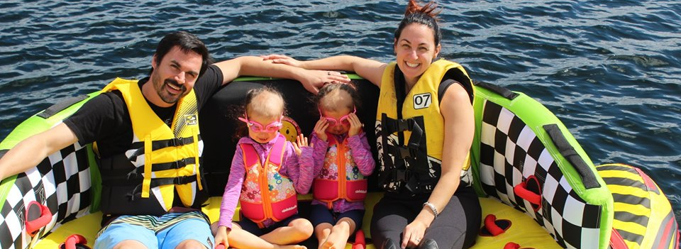
Our family programs give people with sight loss and their families an opportunity to enjoy everything Muskoka has to offer on beautiful Lake Joseph in a safe and inclusive environment. Activities are available for all ages and events just for adults, youth and kids.

Welcome to CNIB Lake Joe’s Family Programs
Pre-camp virtual orientation session
Included in your program registration fee, this Zoom meeting is your chance to meet other families in advance, review housekeeping details, and get answers to your questions so you can spend all of your time at Lake Joe focused on fun, family and friends. Full details will be provided to registrants at the beginning of the season.

Family Weeks
Week 1 – August 5-10, 2024 (priority for families with children with sight loss)
Week 2 – August 19-24, 2024
Enjoy the splendour of Muskoka on beautiful Lake Joseph in one of CNIB Lake Joe’s fabulous Family Week programs. Go for a dip in the lake, take a tandem bike out for a spin, go fishing, cruise the lake, or relax by the campfire. There are activities available for all ages! We offer daily kids’ camps and teen camps for our younger guests and opportunities for adults to socialize. This is your chance to combine the freedom of a cottage or resort with traditional summer camp activities for the whole family to enjoy!

Partner Program: CNIB Buddy Dog Camp
August 19-24, 2024 | Ages 7-16
CNIB Buddy Dog graduates and those waiting or applying for their CNIB Buddy Dog are invited to enjoy summer camp at CNIB Lake Joe along with a parent/guardian!
This program combines CNIB Buddy Dog training sessions with fun camp activities, giving participants plenty of opportunities to form lifelong friendships, develop independence, and make cherished memories. Children already paired with Buddy Dogs will deepen their bonds with their dogs while children and families on the CNIB Buddy Dog waiting list can familiarize themselves with Buddy Dogs and the responsibilities of having one.

Important program points:
- Participants in this partner program must be a CNIB Buddy Dog graduate or applicant on the waiting list.
- Participants in this program must be accompanied by a parent or guardian.
To find out more about the CNIB Buddy Dog Camp or the CNIB Buddy Dog Program contact Miriam Mas, Program Lead, Buddy and Ambassador Dog Training at miriam.mas@cnib.ca or 343-997-2498.

Partner Program: Writing with Feeling: Braille Writers’ Retreat
August 12-15, 2024 | Ages 6-19
If you love writing, this action-packed writer’s retreat for CNIB kids and teens is perfect for you. Participants will meet other young writers with sight loss from across Canada and get tips and feedback from professional writers. All participants will enjoy braille-themed and accessible activities.

Important program points:
- Prospective participants will be required to apply. Priority will be given to applicants who have entered or are planning to enter the annual CNIB Braille Creative Writing Contest.
- Participants in this program must be accompanied by a parent or guardian.
For more information and to apply, please contact Karen Brophey, Program Lead, Literacy at karen.brophey@cnib.ca or 647-302-4047.

There are more programs to explore in our Adult Programs and Holiday Programs sections or return to our table of contents.

Holiday Programs
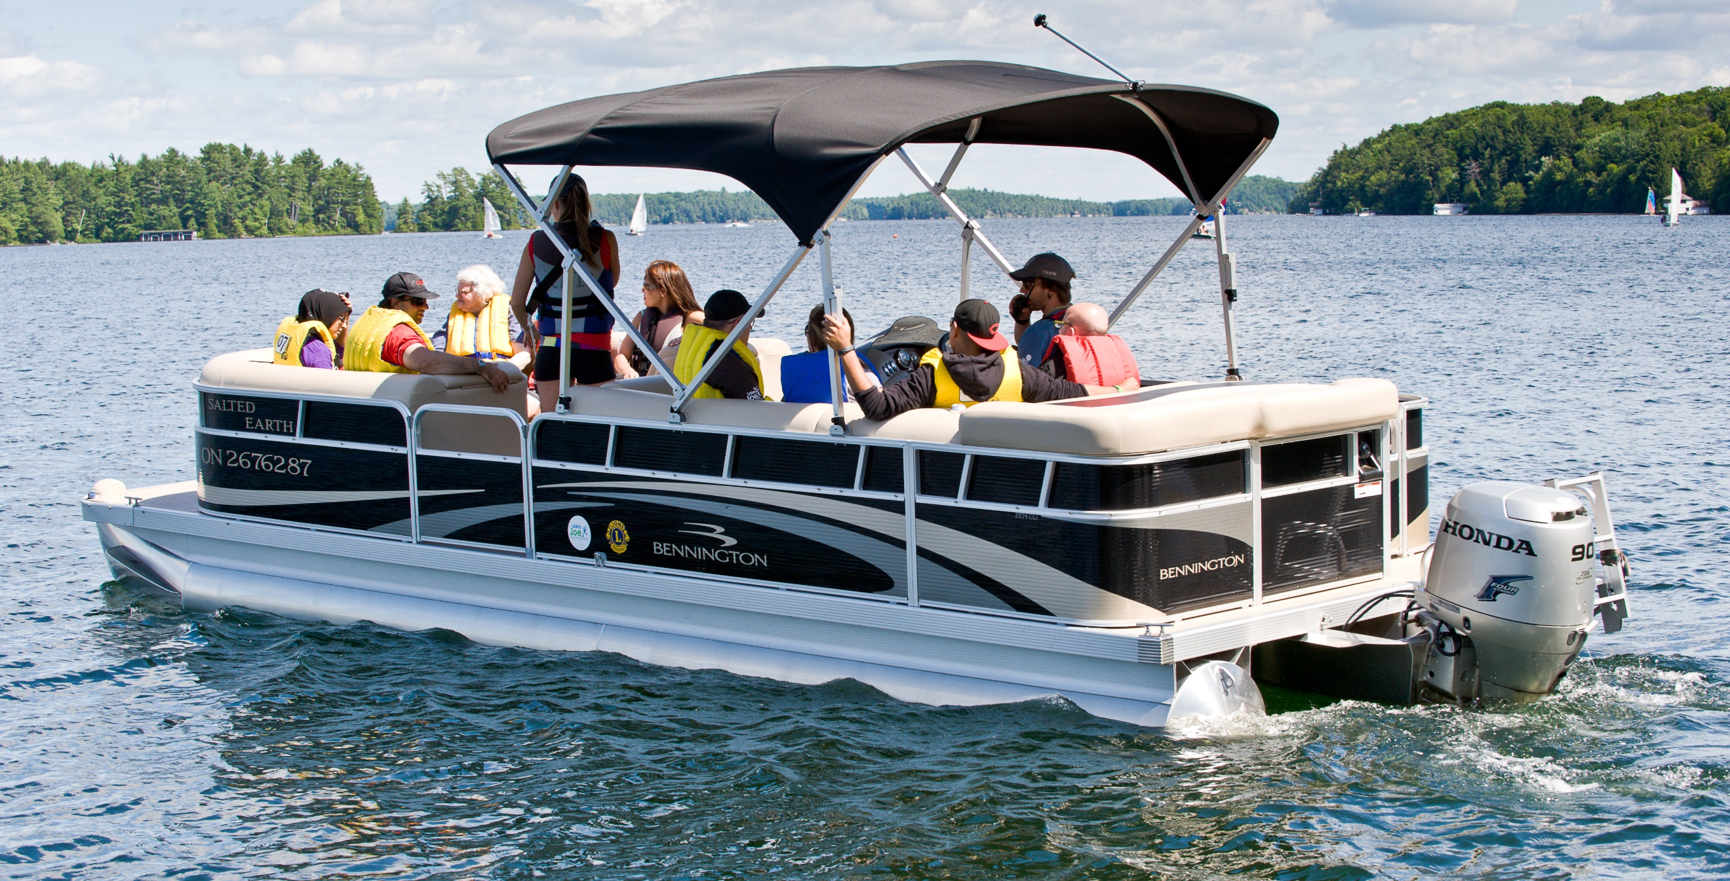
Holiday programs are designed for any everyone in our community, welcoming individuals of all ages. Individuals, families, couples, and groups of friends are all welcome to join our Holiday programs! The Holiday programs feature “drop-in activities” so that guests can engage in as much or as little of the programming as they would like.

Important program point: To attend Holiday Programs, participants should be able to navigate the site with limited guidance after an initial introduction and site tour and will not require one-on-one support from staff. Participants needing additional support throughout their stay should register with someone who will provide the level of assistance required.

Welcome to CNIB Lake Joe’s Holiday Programs
Pre-camp virtual orientation session
Included in your program registration fee, this Zoom meeting is your chance to meet other participants in advance, review housekeeping details, learn more about camp and get answers to your questions so you can spend all of your time at Lake Joe focused on fun, family and friends. Full details will be provided to registrants at the beginning of the season.

NEW! May Long Weekend Getaway
May 17-20, 2024 | All ages
Celebrate spring – and the Victoria Day long weekend – at CNIB Lake Joe! Get a head start on the camp season and enjoy a four-day adventure that will give you a sampler of all things camp with special activities that can only be offered in May.

Holiday Weeks
Week 1 – August 12-15, 2024 | All ages
Week 2 – August 26-31, 2024 | All ages
Visit CNIB Lake Joe with your friends or family or come independently, make new friends, and enjoy camp exactly the way you like it. Instead of formal camp programming you can build your own experiences through a “choose your own adventure” atmosphere. Guests will be provided a schedule of activities at the beginning of the week and can choose the programs they want to attend. Sample the wide array of amenities and activities and tailor your holiday time at CNIB Lake Joe.

There are more programs to explore in our Adult Programs and Family Programs sections or return to our table of contents.

CNIBLakeJoe@Home Virtual Programs
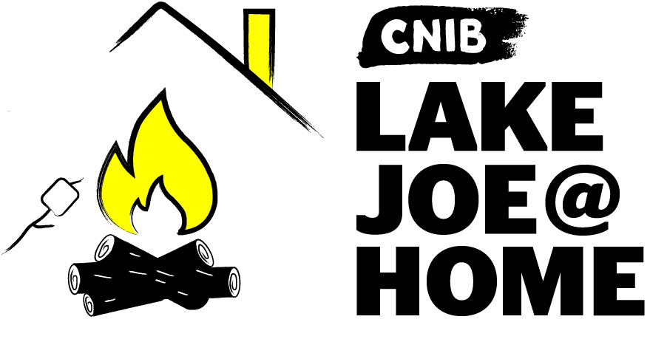

Our virtual programs keep our camp community connected all year long. If you haven’t already participated, please visit CNIBLakeJoe@Home and join us!
We offer a wide range of programs where you can learn and laugh. Join us for weekly coffee break get-togethers, monthly specialty programs (Curiosity Corner, Reading Room, Music Trivia, Reading Room), holiday celebrations, special camp-in-a-box programs and more.
These programs are offered at no cost to you. Pre-registration is required.
Note: You don't need a computer to participate. Staff can call you to facilitate your participation in the program over the phone.

But wait, there’s more!
New CNIBLakeJoe@Home virtual sessions are always being added. If you have suggestions for future programs, please leave us a note in our Virtual Suggestion Box.
We also encourage you to explore our online calendar to see what’s happening in your community and connect with friends, new and old.
For more information about CNIBLakeJoe@Home virtual programs, please contact Taylor Gaudon, Virtual Program Coordinator at taylor.gaudon@cnib.ca or call 705-375-2630, ext. 5500.

Programs Summary
Browse all our 2024 programs at glance, broken down by month.

May
- NEW! May Long Weekend Getaway: May 17-20

June
- Guide Dogs AdvoCamp: June 6-10, 2024
- Adult Leisure #1: June 17-22, 2024

July
- PLAY: July 1-6, 2024
- Camp Abilities: July 1-6, 2024
- Active Adult Week: July 8-13, 2024
- Young Adult Week: July 8-13, 2024
- Summer Camp/ESL Immersion: July 15-20, 2024
- Adult Leisure #2: July 22-27, 2024
- Canadian Leadership Development Program: July 29-August 3, 2024
- Counselor-in-Training: July 29-August 10, 2024

August
- Family Week #1: August 5-10, 2024
- Braille: Writing with Feeling: August 12-15, 2024
- Holiday Week #1: August 12-15, 2024
- CNIB Buddy Dogs: August 19-24, 2024
- Family Week #2: August 19-24, 2024
- Holiday Week #2: August 26-31, 2024

September
- Orientation & Mobility / Guide Dog Immersion: September 15-20, 2024
P.S. Don’t forget that CNIBLakeJoe@Home virtual programs run year-round!

2024 Program Fees
All camp experiences include meals, accommodations, and all on-site programs and activities. Thanks to the generosity of CNIB supporters, camp fees are highly subsidized to keep camp fees as low as possible. Further subsidies are available for adults who qualify. Special discounts this year are also being offered on all CNIB Lake Joe Children & Youth Programs. Note: All CNIBLakeJoe@Home virtual programs are free-of-charge!
For more information, visit cnib.ca/LakeJoe, email LakeJoe@cnib.ca, or call us at 1-877-748-4028 or 705-375-2630.

Children & Youth Programs
Children & Youth Programs | Full Fee | Deposit  (due April 30) | Final Fee  (due June 3)
PLAY  July 1-6 | $150 | $50 | $100
Camp Abilities  July 1-6 | $150 | $50 | $100
Summer Camp / ESL Immersion  July 15-20 | $150 | $50 | $100
Canadian Leadership Development Program  July 29 - August 3 | $150 | $50 | $100
Counselor-in-Training  July 29 - August 10 | $150 | $50 | $100

Children & Youth Partner Programs
- ESL Immersion (July 15-20): Please contact Salma Moudrika at salma.moudrika@inca.ca or 1-800-465-4622 ext. 236.
- Writing with Feeling: Braille Writers’ Retreat (August 19-24): Please contact Karen Brophey at karen.brophey@cnib.ca or 647-302-4047.
- CNIB Buddy Dogs (August 12-15): Please contact Miriam Mas at miriam.mas@cnib.ca or 343 997-2498.

Adult Programs
Adult Programs | Full Fee | Deposit  (due April 30) | Final Fee  (due June 3)
Adult Leisure Weeks  June 17-22  July 22-27 | $725 | $100 | $625
Active Adult Week  July 8-13 | $725 | $100 | $625
Young Adult Week  July 8-13 | $150 | $50 | $100

Adult Partner Programs
- Guide Dogs AdvoCamp (June 6-10): Please contact Larissa Proctor at larissa.proctor@cnib.ca or 226-920-5498.
- Orientation & Mobility / Guide Dog Immersion (September 15-20): Please contact Tracy Garbutt at tracy.garbutt@cnib.ca, 204-894-6926.

Family & Holiday Week Programs
Family Programs & Holiday Weeks | Full Fee | Deposit  (due April 30) | Final Fee  (due June 3)
May Long Weekend Getaway  May 17-20 | Ages 0-5: Free  Ages 6-29: $90  Ages 30+: $435 | No deposit required. | Full fee is due by April 19.
Holiday Week  August 26-31 | Ages 0-5: Free  Ages 6-29: $150  Ages 30+: $725 | $25 for each family member | Ages 0-5: Free  Ages 6-29: $125  Ages 30+: $700
Family Weeks  August 5-10  August 19-24 | Ages 0-5: Free  Ages 6-29: $150  Ages 30+: $725 | $25 for each family member | Ages 0-5: Free  Ages 6-29: $125  Ages 30+: $700

Application Process
For information and support, please email LakeJoe@cnib.ca, or call 1-877-748-4028 or 705-375-2630.

Step 1: Apply
Application opens Monday, January 15, 2024, at 12pm (noon) Eastern.
If you would like to apply to participate in an in-person program at CNIB Lake Joe, please complete the required online application.
If you are new to using our application system, you will be required to create an account to complete your application. If you are returning to our application system, please use your current account. If you have forgotten the password to your account, you can set-up a new password by requesting a new password on the login page.
You will be asked to select the program/week you would like to attend, select transportation needs if any, and add any additional guests to your application if you are attending camp with more than one person from the same household. Deposits and payment are collected at a later date, with a timeline outlined below.
Note: If you are applying for the May Long Weekend program May 17-20, there is a different payment timeline outlined in our fee summary.
Please be prepared to fill out all required forms for your application such as medical information, accessibility information, General Waiver contract, financial assistance requests, and contact information (if needed).
Program selections and wait lists:
- Applications received by February 20: notification of program confirmation will be provided by February 26.
- Applications received after February 20: will be processed and confirmed on an ongoing basis until all remaining spots have been filled.
- If you need to cancel or come off a wait list, please let us know as soon as possible by emailing LakeJoe@cnib.ca, or calling 1-877-748-4028 or 705-375-2630.

Need a little extra help with your application?
Please contact us LakeJoe@cnib.ca, or call 1-877-748-4028 or 705-375-2630 so we can set an appointment to help you with your application.

Step 2: Pay the Deposit
Deposits will be accepted between April 2 – April 30, 2024.
Starting Tuesday, April 2, 2024, you will be able to access the “deposit payment” section of the registration platform to pay your deposit via credit card. You are welcome to make your full payment of camp fees at this time if desired.
Paying by credit card is the preferred method as payments are confirmed immediately and refunds can be provided swiftly.
You may also mail a cheque or money order made payable to “CNIB Lake Joe” and send to: 4 Joe Finley Way, Mactier, ON P0C 1H0. Please provide a note indicating the name of the guest your payment is intended for.
Please note that no cheques or money orders will be cashed until after April 2.
If your deposit payment is not received by Tuesday, April 30, your space will be forfeited and given to a waitlisted applicant. We will make every effort to contact you to confirm your plans before forfeiting your space.
If you have any concerns with paying your deposit, please email LakeJoe@cnib.ca, or call 1-877-748-4028 or 705-375-2630.

Step 3: Pay the Balance
Any balance owing is due by Tuesday, June 3, 2024.
After paying your deposit, the remaining camp fees are due on or by Monday, June 3, 2024. Reminder emails and phone calls will be sent to guests who have not paid their fees or when a cheque/money order is not in our possession.
If the full payment is not received by June 3, your space will be forfeited and given to a waitlisted applicant. We will make every effort to contact you to confirm your plans before forfeiting your space.
Any registrations after June 3, must be paid in full upon completion. We will contact you via email or phone to remind you about these payments.
If you have any concerns with paying your balance, please email LakeJoe@cnib.ca, or call 1-877-748-4028 or 705-375-2630.

Getting to Camp
We welcome guests from across Canada and around the world!
CNIB Lake Joe is located at: 4 Joe Finley Way, MacTier, ON P0C 1H0

Arriving by Car?
Please note parking is free but limited. Please park in one of the designated parking spaces.

Directions from Toronto/Southern Ontario*
- Take Hwy 400 north just past Barrie to Hwy 400 extension (formerly Hwy 69)
- Continue north on Hwy 400 to exit 189 for ON-69 toward MacTier/Gravenhurst
- Merge onto Lake Joseph Road (formerly Hwy 69) past Hwy 169
- Turn right onto Joe Finley Way
*GPS often provides directions to take Hwy 407 toll road. The toll road saves approximately 10 minutes from the drive (approx. 2 hours), but at a cost. Please check a website like google.com/maps for directions or remember to adjust GPS settings.

Directions from Northern Ontario
- Take Hwy 69 south to Hwy 400 south
- Continue south on Hwy 400 to exit 207 for ON-69 toward MacTier/Gravenhurst
- Merge onto Lake Joseph Road (formerly Hwy 69)
- Turn left onto Joe Finley Way

Directions from Eastern Ontario
- Take Hwy 417 west to Bruce St/County Road 20 to Hwy 60 west
- Continue on Hwy 60 and merge onto Hwy 11 south
- Take exit 219 for Muskoka Rd 3 toward Huntsville/Aspdin
- Turn right onto Aspdin Rd/Muskoka District Road 3 (Regional Road 3 W)
- Turn right onto Hwy 141 west and turn left onto Lake Joseph Rd (formerly Hwy 69)
- Turn left onto Joe Finley Way

Do You Need Transportation?
We are pleased to work with you to provide transportation from Pearson International Airport and other transportation hubs throughout Ontario which may include:
- London
- Hamilton
- Barrie
- Sudbury
Additional fees may apply.
Once at CNIB Lake Joe, simply head to the Welcome Centre to check-in and receive your room key. We are waiting for you!
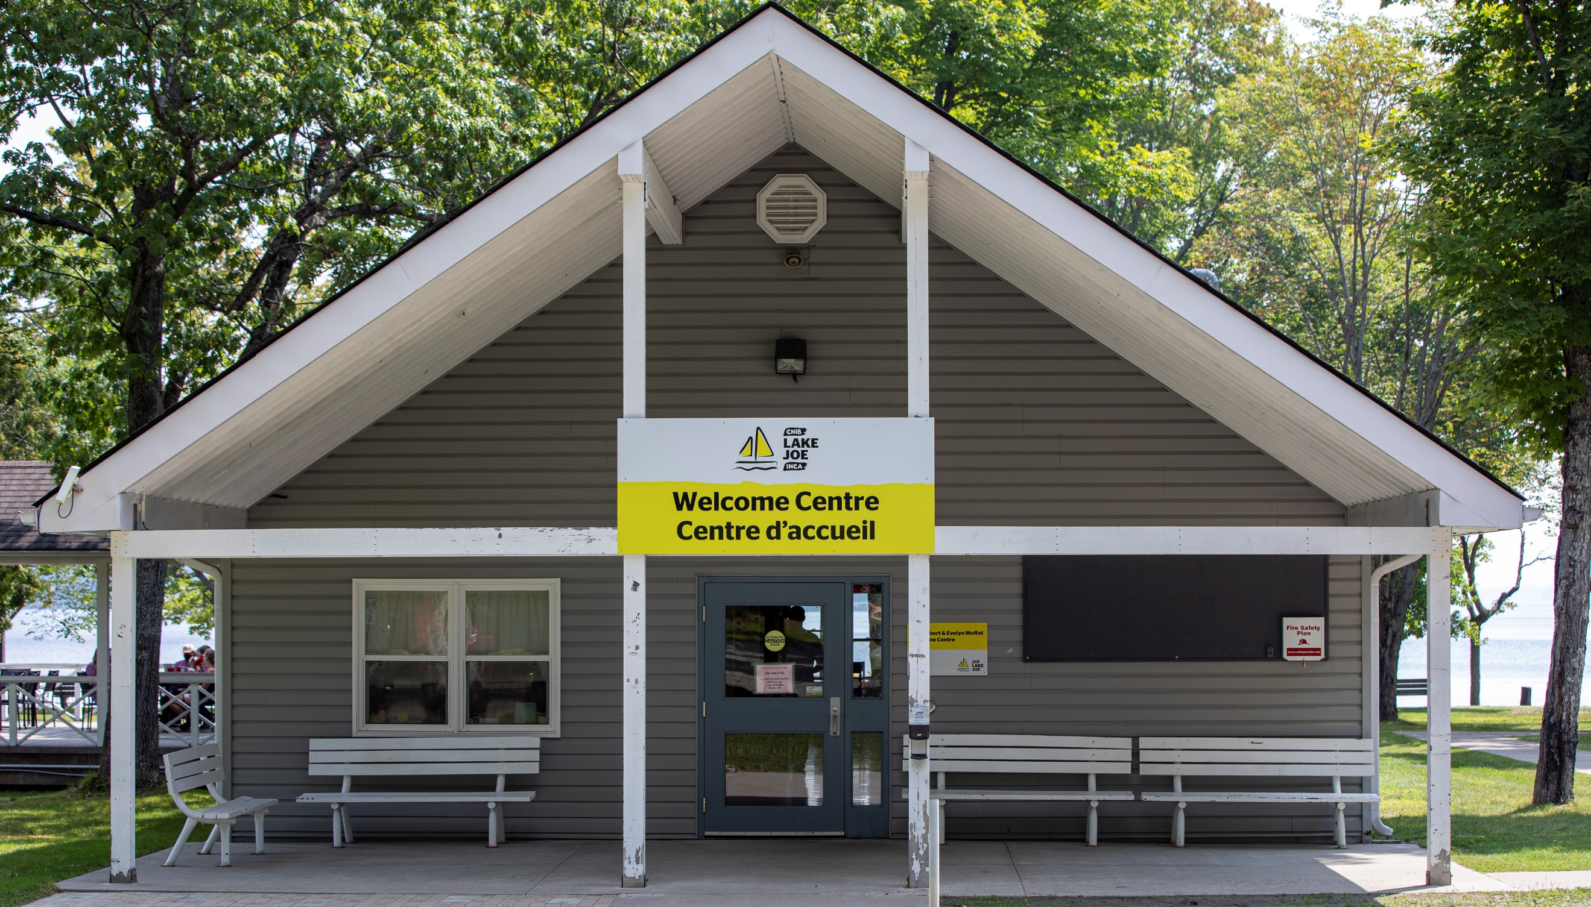

Get Involved
We can’t wait to welcome you to CNIB Lake Joe as our guest, but there are so many ways to enjoy CNIB Lake Joe:
- Participate in CNIBLakeJoe@Home and CNIB virtual programs
- Join our staff team
- Volunteer at CNIB Lake Joe
- Attend an event (visit cnib.ca/LakeJoe for upcoming events)
- Donate
- Subscribe to the “Let’s Go: CNIB Lake Joe” e-newsletter
- Follow us on Facebook and Instagram
- Visit CNIB Lake Joe’s YouTube playlist
- Listen to our “CNIB Lake Joe on the Go” podcasts
For more information, visit cnib.ca/LakeJoe, email LakeJoe@cnib.ca, or call 1-877-748-4028 or 705-375-2630.

CNIB Lake Joe
4 Joe Finley Way
MacTier, ON P0C 1H0
Visit cnib.ca/LakeJoe
Email LakeJoe@cnib.ca
Toll Free: 1-877-748-4028
Phone: 705-375-2630

