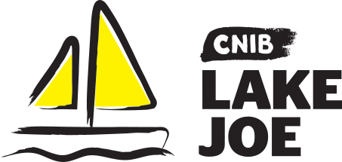

Suggested Packing List

Clothing:
- T-shirts
- Long sleeve shirts (UV sun shirts recommended)
- Shorts
- Pants
- Sweater
- Sweatpants/Trackpants
- Socks and underwear (week’s worth)
- Pajamas
- Rain Jacket
- Wide brim hat
- Closed-toe shoes (athletic shoes preferred)
- Sandals or flip flops
- Bathing suit
- Water shoes (optional)

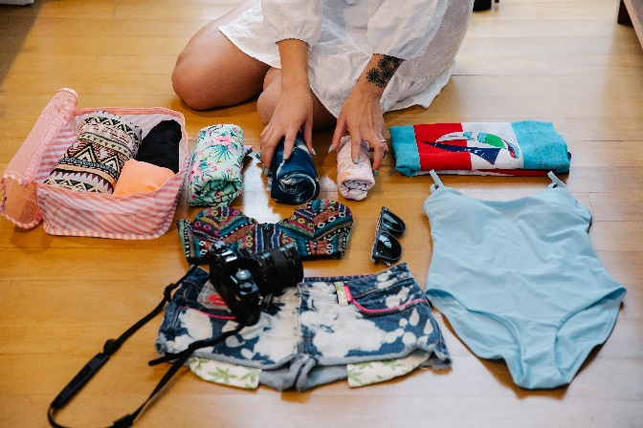

Toiletries:
- Tooth paste & toothbrush
- Female hygiene products
- Hairbrush
- Shampoo & conditioner
- Soap or body wash
- Loofah/scrub

Camp-related goodies:
- Towels (beach towel and shower towel)
- Sunscreen
- Bug spray
- Flashlight
- Personal protective equipment for COVID like face masks (optional)
- Swimming goggles (optional)
- Ear plugs for sleeping (optional)
- White t-shirt or other item for tie-dying (optional)
- Personal down time activities (i.e., books, playing cards, colouring books, journal, etc.)
- Tuck money (e.g., souvenirs, snacks, t-shirts, sweatshirts etc.)
- Cooler (we have free ice available on site for you)

Things to leave at home:
- Weapons
- Illegal drugs (does not include prescribed and/or over the counter medication)
- Valuables
- Nut products
- Bedding (will be provided by CNIB Lake Joe)

Important Notes:
- There will be no access to do your own laundry so please bring enough clothes to last the entire duration of your stay.
- There will not be any town runs by CNIB Lake Joe staff (for shopping trips), so please bring everything you may need for the week.

