CNIB Business Education Guide

CNIB Business Education Guide 1
About Us 2
CNIB 2
Vision Loss Rehabilitation Canada 2
CNIB Deafblind Community Services 3
Understanding Sight Loss 3
Customer Accessibility 4
General Things to Keep in Mind 4
Accessible Built Environments 4
Guide Dogs 4
Accessible Customer Service 5
Accessible Payment Terminals 5
Employees with Sight Loss 6
Technology Accommodations 7
Tips for a More Accessible Workplace 8
Application Process 8
Interviews 8
CNIB Services 9
Frontier Accessibility 9
Business-to-Business Services: 9
Come to Work Program 10
Talent Pool 10
Mentorships 11
Get Involved 11
Additional Resources 11

About Us

CNIB is the primary organization supporting people who are blind or partially sighted in Canada. There are three organizations under the CNIB umbrella: Vision Loss Rehabilitation Canada (funded by the provincial government in each province except Québec), Deafblind Community Services (funded by the provincial government in Ontario, Saskatchewan, and British Columbia) and CNIB (funded by donations).

CNIB
Founded in 1918, CNIB is a non-profit organization driven to change what it is to be blind today. We deliver innovative programs and powerful advocacy that empower people impacted by blindness to live their dreams and tear down barriers to inclusion. Our work is powered by a network of volunteers, donors, and partners from coast to coast to coast.
Programs and services include:
- Advocacy
- Career support (Come to Work)
- Entrepreneurship (The Venture Zone)
- Children & Youth programs
- CNIB Eye Van
- CNIB Guide Dogs
- CNIB Lake Joe
- Culture, sport, and recreation programs
- Literacy programs
- Technology programs
For more information, visit cnib.ca

Vision Loss Rehabilitation Canada
Vision Loss Rehabilitation Canada is a provincially funded, accredited health care organization staffed by a passionate team of certified professionals. The organization provides professional, high-quality, and sustainable rehabilitation to Canadians with vision loss, now and into the future.
Services include:
- Low vision services
- Essential skills for daily living
- Travel and mobility instruction
- Services for children and families
- Assistive technology services
For more information, visit visionlossrehab.ca

CNIB Deafblind Community Services
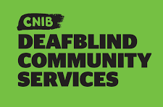
CNIB Deafblind Community Services is one of Canada's leading providers of specialized support and emergency services for people who are Deafblind. Our intervenor services and literacy programs enable people who are Deafblind to maximize their independence and engagement with the world around them.
Programs and services include:
- Intervenor services (ON, SK, BC)
- Emergency intervenor services (ON)
- Literacy programs (ON)
For more information, visit deafblindservices.ca

Understanding Sight Loss
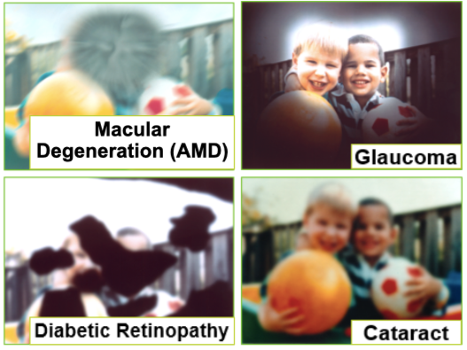
Blind and partially sighted are inclusive terms that cover a wide spectrum of sight loss, and anyone can be impacted at any stage in life. Many people believe that blindness means total darkness, however, only one in 10 who are blind have total sight loss. Legal blindness is only a legal term to limit some activities for safety reason, or to determine eligibility for disability-related government programs and benefits. It does not define a person’s ability to live independently.
Common Causes of Sight loss

Everyone experiences sight loss differently and to varying degrees. Certain retinal conditions can cause distortion or blind spots in a person’s central vision. Eye conditions like glaucoma and retinitis pigmentosa (RP) impact peripheral sight, creating “tunnel vision.” There are other eye conditions that can impact a person’s depth perception, sensitivity to light, and/or ability to see detail.
When you come across a person experiencing sight loss do not assume what they can or cannot see. With specific accommodations, people with sight loss can live meaningful lives and offer invaluable skills. Many of these accommodations are easy and simple to implement.

Customer Accessibility

General Things to Keep in Mind
Every person’s experience with sight loss is unique, and necessary tools or accommodations vary by person as well as by situation. Each person with sight loss knows their vision best and will know what accommodations will help them most effectively. We have an extensive list of things you can do as a business, but the most important thing you can do is have an open conversation with the person to determine how you can support them or if they need support at all.

Accessible Built Environments
- Ensure walking pathways (indoors and outdoors), meeting spaces, and working environments are barrier free and clear of obstruction or obstacles.
- Add contrasting colour and texture strips on stairs.
- Ensure signage is clear, not obstructed, and an appropriate size.
- More information can be found at clearingourpath.ca

Guide Dogs
Guide dog legislation across Canada:
- Across Canada, legislation prohibits discriminating against a person with a disability who is working with a guide dog.
- Guide dogs and their handlers are allowed access to any premises to which the public would normally have access. It’s the law.
- Legislation varies from province to province, however, in all provinces it contravenes the Charter of Rights and Freedoms to deny a blind person accompanied by a guide dog access to a federally owned or regulated place or service.
- More information on guide dog legislation in your province can be found here: Link: Guide Dog Legislation
Responsibilities regarding guide dog access:
- Business owners have a responsibility to ensure the rights of guide dog teams are respected – meaning business owners cannot deny access or refuse service to a guide dog team.
- If a guide dog’s behaviour is inappropriate, the business or organization has the right to ask the guide dog handler to leave. Inappropriate behaviour generally means the guide dog is not under the handler’s control (such as barking after being told not to, or jumping up)
- It is unacceptable to ask for proof that a dog is a guide dog, unless it is behaving inappropriately. It is best practice to assume the guide dog is a qualified guide dog, unless given reason to think otherwise. When competing rights are an issue – such as allergies – a compromise needs to be made to maintain the rights of everyone involved.

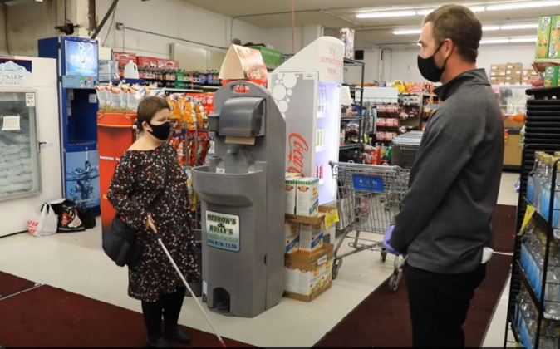
Accessible Customer Service
Because sight loss is a spectrum, customers who are blind or partially sighted will need different levels of assistance to purchase items or navigate public spaces. How can you offer appropriate support for someone who is blind or partially sighted?
- All staff, regardless of position, should receive training on how to interact with a person who is blind or partially sighted. This should include how to properly describe objects, and how to effectively guide a person with sight loss.
- Do not assume that the individual needs help. Customers will offer what works best for them, such as requiring a shopping cart, basket, or sighted guide.
- Introduce yourself and your position and ask if the individual needs help. It is helpful to speak in a clear voice and face the customer when addressing them. Always speak directly to the customer, not to someone accompanying them.
- Never grab the customer’s arm, hand, or mobility cane, as this can be disorienting and dangerous.
- When helping a person with a guide dog, it may be easier to help navigate with a cart. This way, there is room for the person with sight loss to hold onto something and follow the store staff, while also keeping control of their guide dog. Alternatively, they may tell their guide dog to follow, choosing not to use a cart.
- When interacting with a guide dog team, never touch the guide dog or guide dog harness. Do not pet, feed, or otherwise distract the guide dog.

Accessible Payment Terminals
- Ask if the person requires assistance with payment, when at the checkout.
- It is helpful to tell customers with sight loss what their total purchase will cost and explain the layout of the payment terminal.
- Include details such as: it has tap functions, there are tactile buttons, or it’s a touchscreen.
- If a plastic cover is present over a Point-of-Sale machine, the cashier should temporarily remove the cover, so the customer can access the keypad.
- Staff should identify that a plexiglass barrier is being used at check out. Identify where the opening of the plexiglass barrier is and what is on the other side of the barrier.
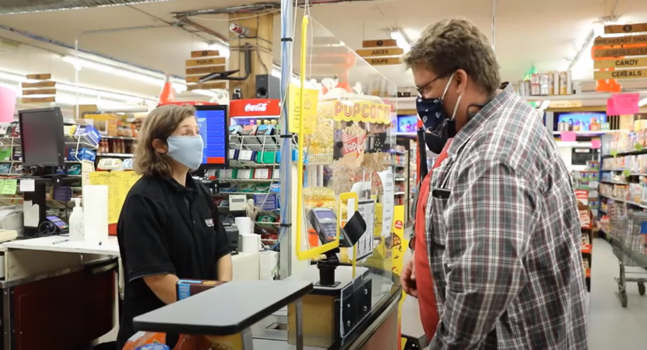
- Consider high contrast and bright tape around the edges, especially around the bottom opening, to identify the plexiglass barrier.

CNIB has worked with Moneris Solutions Corporation (‘Moneris’), with support from the Government of Canada to create an inclusive and accessible shopping experience for everyone through the development of a new accessible payment terminal.
Moneris has upgraded their software to provide improved accessibility features at Moneris payment terminals, such as increasing the font size, increasing the brightness, inverting the colours, and requesting audio feedback., CNIB's demonstrations to date, both virtual and in person have been positive.
Customers can enable an interface on Moneris Core payment terminals with features designed to help people independently navigate the terminal without having to share their PIN or ask for assistance. When the accessibility mode is enabled, step-by-step instructions will walk a customer through completing a transaction.
More information and detailed instructions can be found at Link: Accessible Payment Terminals

Employees with Sight Loss

Accommodations for an employee with sight loss are often simple and inexpensive. Many employees with sight loss may benefit from low-tech accommodations such as improved contrast, magnification, or changes in lighting. The employee may also need access to high-tech assistive technologies such as synthetic speech software or other technical modifications. As an employer it is your legal responsibility to provide workplace accommodations; your employee has a right to them throughout Canada.
Financial assistance is available for more expensive accommodations, and training or job modifications may be required as an accommodation. Talk to the employee or applicant about accommodation because everyone’s experience and needs are different. The employee will be able to tell you what kind of accommodations they will need.

Accommodations can be simple environmental changes like:
- Adding a lamp to the employee's workspace.
- Removing the bulb from an overhead light near the employee.
- Keeping hallways and common spaces free of obstacles.
- Using a larger computer monitor

Technology Accommodations
People who are blind or partially sighted are often knowledgeable and experienced in their accessible technology of choice. In addition to specialized standalone technology, accessibility features are often built into the operating systems of smartphones or computers, like VoiceOver (iOS), TalkBack (Android), or Magnifier (Windows).
Some different types of accessibility software and hardware include:
- Screen readers: Software programs that read information on a computer aloud to a user via a headset.
- Screen magnifiers: Software programs that enlarge the visual display of a computer.
- Refreshable braille: These display devices can be connected to a computer or an SD memory card, allowing the user to read the content on their screen or a file in braille format.
- Closed-circuit Television (CCTV): device used to enlarge printed documents, displaying the enlarged document on a screen.
- Smartphones: These often have built-in accessibility features. For example, the iPhone has the option for users to enable its built-in VoiceOver screen reading program or use the camera as a magnifying glass.

Tips for a More Accessible Workplace
- Ensure overall lighting meets the specific needs of the employee or volunteer, providing adjustments and/or additional lighting resources, as needed.
- Use large print/braille labels or tactile dots on equipment, tools, facilities, and documents.
- Use electronic text and voice mail communication methods instead of written notes.
- Assign people to help with printed and handwritten materials that cannot be converted electronically.
- Ensure there is open communication in the workplace so that the employee feels comfortable discussing their potential needs for accommodation.

Application Process
Distinguish between nice-to-have and actual job requirements. Is it essential that employees have a driver’s license? If this line is included in all job descriptions, including those where it is not necessary for the role, it will exclude many candidates.
- Advertise jobs where people with sight loss can access them. Provide vacancy details to your local disability employment advisor, connect with CNIB's Come to Work Program, and/or post the vacancy on an accessible website that works with screen magnifying and screen reading software.
- Make sure the application form and material for candidates are available in an accessible format like large-print or as an accessible electronic document.
- If the application must be completed on site, ask the applicant if they need a volunteer to assist them with the process.
- Consider including an equal opportunities or disability statement in your job ad, outlining your commitment to equity and diversity.
- Make sure that all staff involved in selection and interviews understand and embody the principles of equity and diversity.

Interviews
- After shortlisting candidates, ask all applicants—whether a candidate has disclosed a disability or not—if there's anything they need to be able to do their best in the interview. If they do need something, they will tell you at this stage so that you can make reasonable adjustments.
- When being introduced to someone with sight loss, say hello and wait for them to offer their hand to be shaken.
- At the start of the interview, ask the candidate if they require any adjustments. (ex. A person with sight loss may ask to sit facing away from a window.)
- If handing out materials in an interview, make sure you have copies available for someone with sight loss in their preferred format.
- Keep the room free of clutter and obstacles, especially on the floor.
- Offer to guide the candidate to the interview room and within the building.
- If a person has not disclosed their sight loss, do not ask if they are blind.
- Focus on the candidate's abilities, rather than their sight loss. They will be able to explain how they go about completing tasks and getting things done.
- At the end of the meeting, let people know if they have left anything behind.
More information about creating accessibility in the workplace can be found on our website: Link: Creating an Inclusive Workplace

CNIB Services

Frontier Accessibility
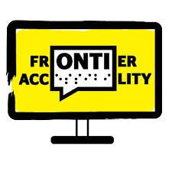
CNIB Frontier Accessibility is a CNIB social enterprise offering support to businesses and organizations to ensure all Canadians with disabilities can benefit from barrier-free communities and workplaces. It is a national organization that provides product expertise in accessible technologies, and support and training in both of Canada’s official languages. Our approach to providing customized solutions ensures that all organizations will have the tools to champion a culture of inclusion.

Business-to-Business Services:
- Products and technology: Whether it’s something as small as a magnifying glass or as sophisticated as a portable video magnifier with optical character recognition, we can work with you and your business to develop a custom solution that works for you and your budget.
- Workplace accommodations: One in five Canadians identify as having a disability. We take a universal accessibility approach to ensure your workplace can incorporate the accommodation needs of all your employees – meaning you can hire and work with the best candidates.
- Digital and websites: We live in a fast-paced and evolving digital world. CNIB Frontier Accessibility will work with you to conduct audits and identify actions that ensure all your digital platforms are inclusive and meet global standards, including WCAG and VPAT.
- Communication materials: Sometimes a project may require creating accessible materials or resources that you might not be familiar with – things like braille, descriptive audio, American Sign Language (ASL) translation, or accessible PDFs. We provide access, training, and support to ensure that you and your organization can create content that everyone can engage with.
- Navigation and wayfinding: Navigating a new environment is stressful for anyone. We offer inclusive strategic supports with various technological solutions including low frequency Bluetooth beacons, smartphone apps and tactile signage. With these types of tools. everyone can safely and easily navigate your business and the environment around it.
To access our support, information can be found at https://frontier-cnib.ca/

Come to Work Program
The CNIB Foundation's Come to Work program connects job seekers who are blind or partially sighted with employers who want to discover the full potential of Canada's talent.

Talent Pool
The CNIB Foundation partners with Vision Loss Rehabilitation Canada to ensure job seekers who are blind or partially sighted have pre-employment skills, including orientation and mobility (e.g., how to travel independently to and from work), independent living (e.g., how to dress for success) and technology training (e.g., how to use screen readers, smartphone apps, etc.). We also work with employment agencies to provide resources for job searching, résumé writing, and interviewing.
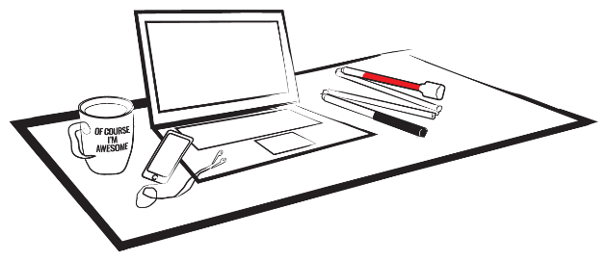
CNIB’s Come to Work program introduces employers to an innovative talent pool of Canadians who are blind or partially sighted and provides job seekers with work experience.

Mentorships
The CNIB Foundation is piloting an online program that connects individuals through mentorship matches. There are times when individuals can benefit from the advice, guidance, and support of a mentor. There are also times when individuals can share their expertise and experiences to guide mentees in the right direction to foster professional development.

Get Involved
To become a Partner, join our Talent Pool or volunteer as a mentor, contact cometowork@cnib.ca or call 1-800-563-2642.

Additional Resources

- Accessible Payment Terminals
- Accessible Built Environment
- Accessible Materials
- Accessible Customer Service Video Series
- Clear Print Accessibility Guidelines
- CNIB Business to Business Services
- Canadian Guide Dog Legislation
- Sighted Guide Technique Video Series
- White Cane Factsheet

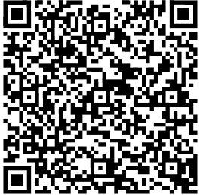
Contact us for further support on how to make your business accessible to people with sight loss.
Email: advocacy@cnib.ca

