White Cane Facts

What is a white cane?

White canes are used by people who are blind or partially sighted. A person with sight loss can use a white cane to feel the ground so that they don’t trip or bump into things. A white cane also lets other people know that a person is blind or partially sighted. If someone sees a person using a white cane, they can give them space and make sure they don’t leave things in the way.

What are the different types of cane?
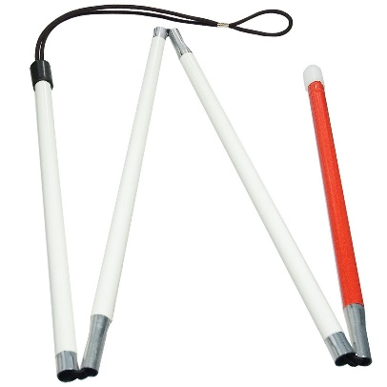
There are three different types of white canes used in Canada:
- The Identification (ID) cane. This is a short, thin cane that is used by people who do not need to use the cane to get around but want to let other people know they can’t see very well or can’t see at all. Some people use their ID cane to find important things, like a door, a curb, or stairs.

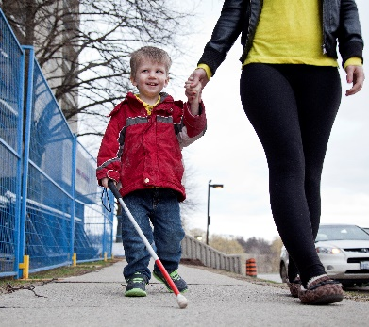
- The Mobility Cane. The mobility cane is thicker and longer than an ID cane and can have different types of tips on the end. People use a mobility cane to find things that might be in their way or where to cross the road.
- The Support Cane. This cane is used by someone who needs a cane to support them when walking, but also wants to let people know that they have sight loss.

Things you can do to be helpful and kind
- Remember that if someone is using a white cane, they might not be able to see you and move around you. If you see someone with a white cane, step to one side so you don’t bump into each other.
- If in doubt, ask! If someone using a white cane looks lost or confused, introduce yourself and ask them if they’d like any help. If they say no, that’s okay. It probably means they already know where they are going, or they want to figure it out on their own. Either way, they will be happy that you offered.
- Never leave your bikes, bags, or anything in the middle of the sidewalk or hallway. Someone who can’t see very well could trip over them and get hurt.
- Remember that the correct way to talk about a white cane is to call it a white cane, not a stick or pole.
- A cane is like part of a person’s body, so you should never touch it without asking. For the person who is using the white cane, that could be very frightening and even dangerous.

