CNIB Lake Joe 2022
In-person Camp Programs
Enriching lives. Making memories. Building independence.
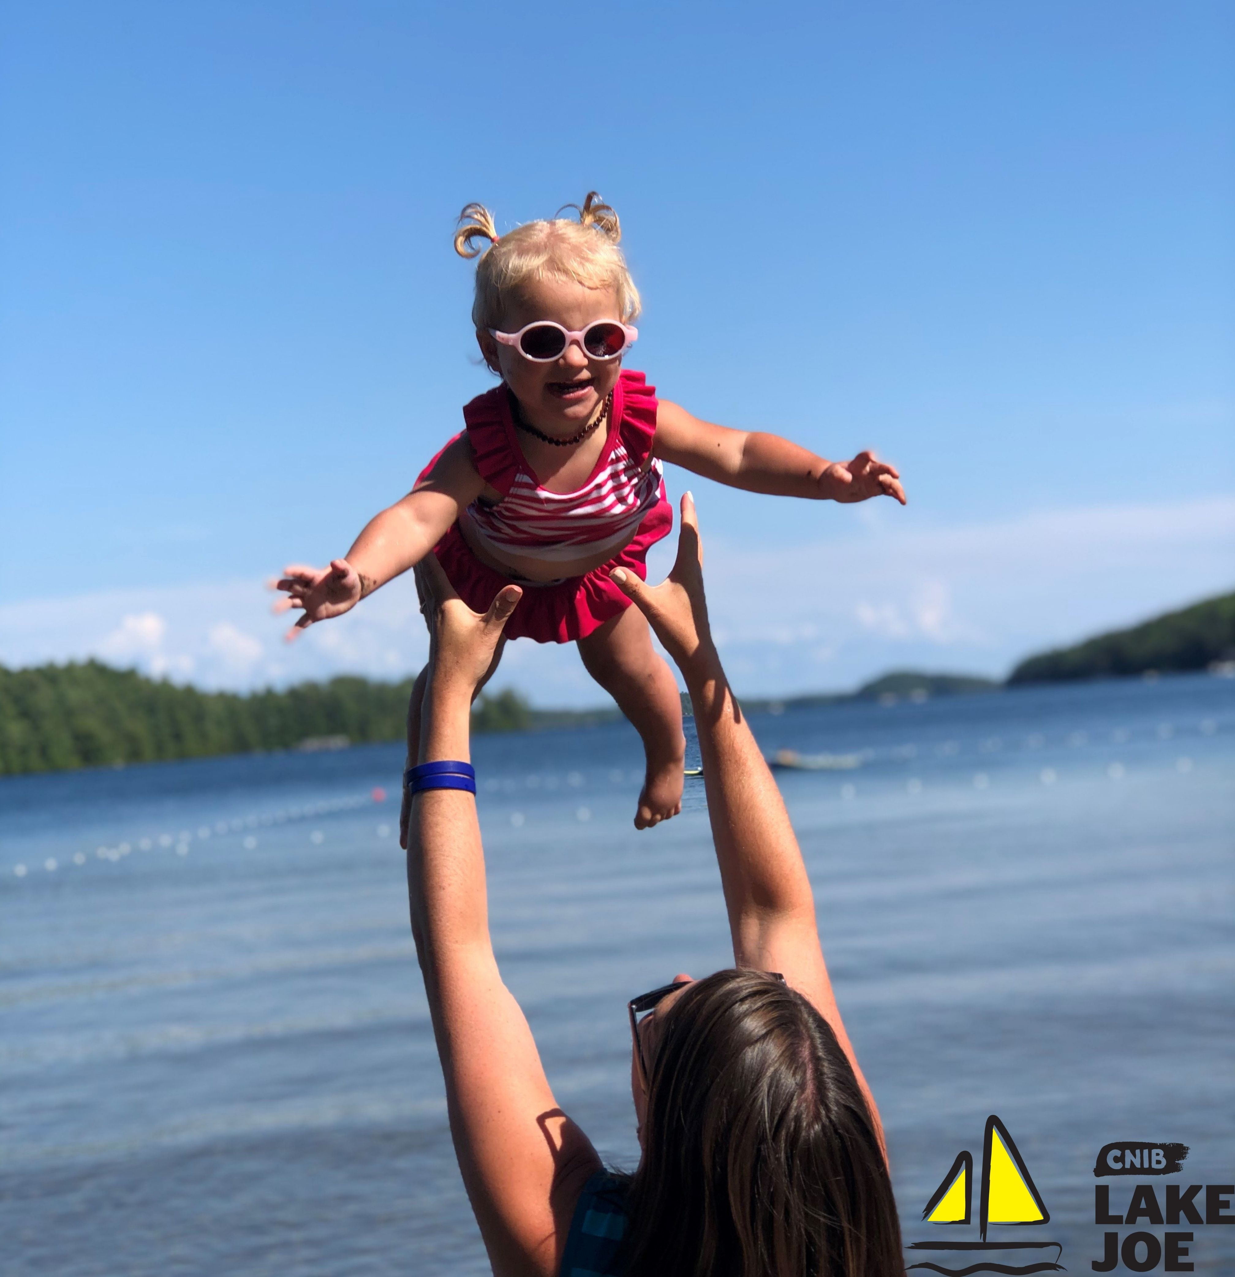

Table of Contents

About CNIB Lake Joe 3
Children & Youth Programs 5
Adult Programs (ages 19+) 9
Family Programs (all ages) 11
Holiday Programs (all ages) 12
CNIBLakeJoe@Home Virtual Programs 13
Program Summary – by date 15
Program Summary – by age 16
COVID-19: Pandemic Precautions 17
Fee Summary 19
Application / Registration Process 21
Getting to Camp 23

Please note: CNIB Lake Joe may update or make changes to the 2022 schedule. Every effort will be made to keep the programs and fees as represented, however, unforeseen circumstances, including COVID-19 health and safety protocols, may result in the substitution or cancellation of a program. We appreciate your understanding and look forward to finding the perfect program for you and your family.

About CNIB Lake Joe

We are excited to share information about our CNIB Lake Joe 2022 season!

Since 1961, CNIB Lake Joe has been providing a unique blend of recreation and skills development in a safe, inclusive environment. Dedicated to providing enriching experiences for Canadians with sight loss, it's a one-of-a-kind camp in Canada. Located in the heart of Muskoka, CNIB Lake Joe is an accessible lakefront property that stretches over 12.5 acres on the northwest corner of beautiful Lake Joseph. CNIB Lake Joe is proud to be an accredited member of the Ontario Camps Association and an affiliated member of the Lifesaving Society.

We have been busy anticipating your return with new programs and camper favourites that will dazzle and delight, all while keeping your health and safety top of mind! We’re here for you. Come join us.

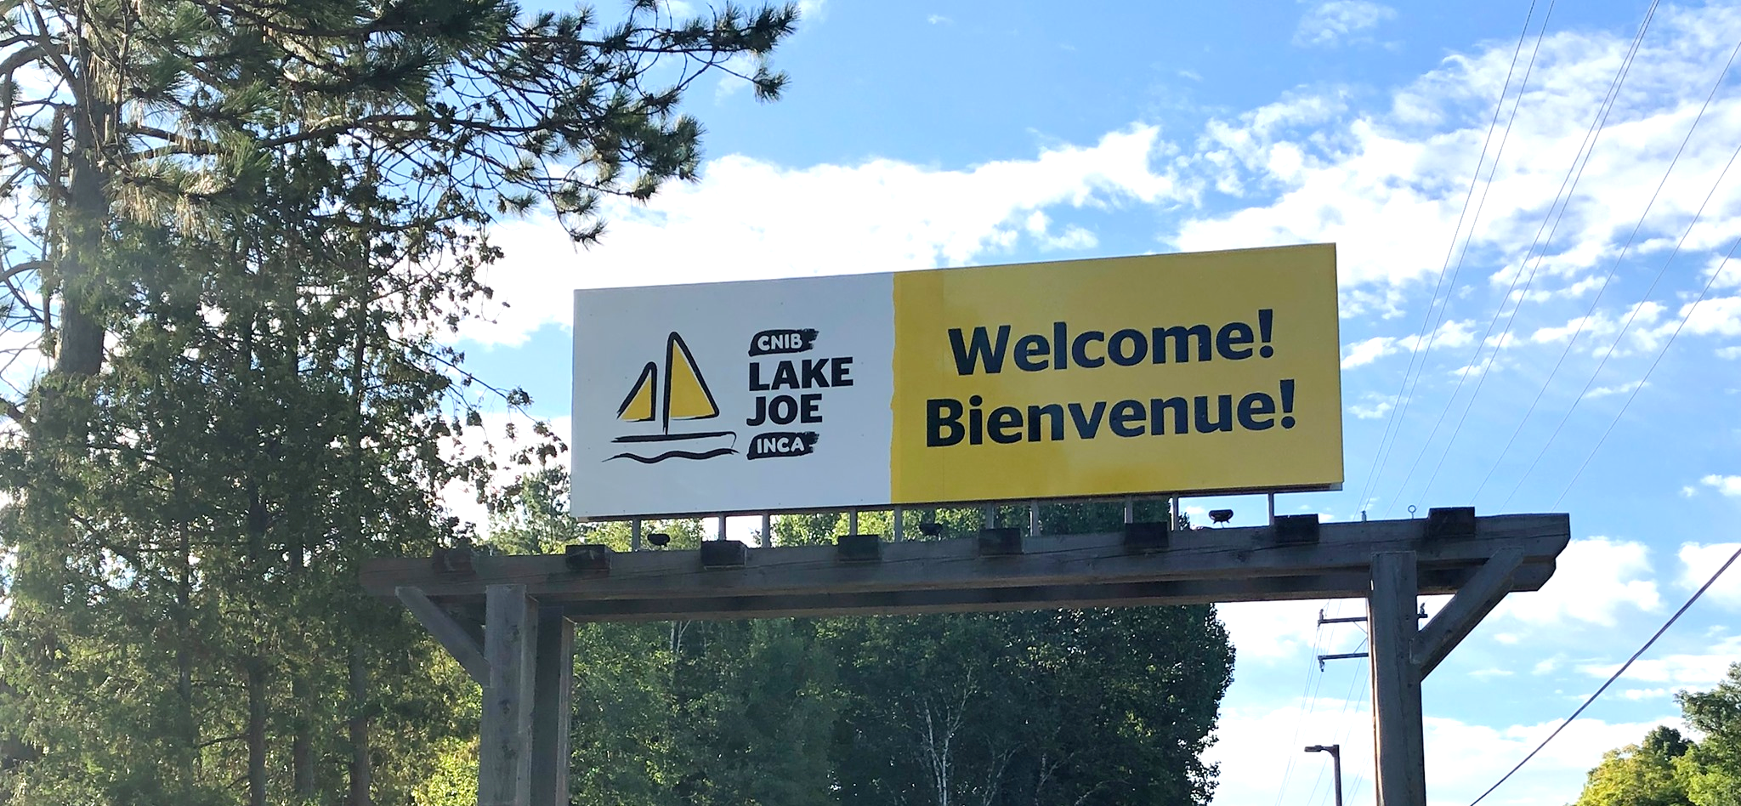

Here are just some of the activities you can enjoy at CNIB Lake Joe!

- Make a splash in Lake Joseph: fishing, paddling (canoe, kayak, stand-up paddleboard), pontoon boat cruises, sailing, swimming, tubing, waterskiing, wakeboarding, water sliding
- Get creative: music, pottery, crafts, dancing, talent shows
- Get active: climbing tower, soccer pitch, basketball, beep baseball, frisbee golf, tennis, volleyball, shuffleboard, mini-golf, tandem-bike riding, archery, hiking, yoga, hockey and more
- Learn new skills: in a fun, safe and supportive environment
- Rest and relax: enjoy a book by the lake, visit with friends, new and old, around the campfire

Don’t forget, there are lots of virtual programs – online and on the phone at CNIBLakeJoe@Home where you can learn, laugh, and stay connected with your camp community!

To apply, please visit: cniblakejoe.campbrainregistration.com

For more information, contact CNIB Lake Joe:
Email: lakejoe@cnib.ca
Toll Free: 1-877-748-4028
Phone: 705-375-2630
Web: cnib.ca/lakejoe
Address: CNIB Lake Joe, 4 Joe Finley Way, MacTier, ON P0C 1H0

Children & Youth Programs

These programs are open to children and youth with sight loss. Some programs also welcome sighted siblings and friends of those with sight loss.

Welcome to CNIB Lake Joe’s Children & Youth Camp Programs (virtual orientation session)
Included in the registration fee for all children & youth programs, this Zoom meeting is your chance to meet others in advance, review housekeeping details, and get answers to your questions so you can spend ALL of your time at CNIB Lake Joe focused on fun, family and friends. Full details will be provided to registrants at the beginning of the season.

NEW! Camp Abilities featuring blind hockey, 5-a-side soccer and sailing
July 11-16
Ages 8-18
This goal-based athletic program is aimed at athletic development. Participants will receive one-on-one coaching from instructors who will help guide athletes to achieve their performance goals through specialized sports programs. Participants will have the opportunity to choose from sailing, hockey or soccer as their discipline, culminating in a session-end regatta, game or match.

Note: This program is open to children and youth who are CNIB participants as well as their siblings.

PLAY
July 11-16
Ages 8-18
Pushing Limits for Active Youth (PLAY) is for those who are interested in getting active and trying out new sports. From basketball to archery, Power Showdown to goalball, participants will try their hand at a variety of different sports and activities that encourage an active lifestyle. Health and wellness workshops including independence, healthy eating and personal care complement this adaptive sports program. New this year, participants will get to try out skating/blind hockey and 5-a-side soccer.

Note: This program is open to children and youth who are CNIB clients as well as their siblings.

NEW! SCORE Scholars
July 25-30 at CNIB Lake Joe (July 17-25 in Toronto)
Grades 11, 12 and 1st year post-secondary
The SCORE Scholars program is part of CNIB’s new Learning Academy, designed to help youth build independence and pre-vocational skills. Participants will experience the joys of camp and interactive learning activities geared to help them develop the skills to successfully pursue post-secondary education and get career ready! Enjoy a blend of recreation and skills development in a safe, inclusive environment on the shores of CNIB Lake Joe. You'll participate in a leadership development program, take part in amazing activities like swimming, rock-wall climbing and water tubing AND receive a certificate for completing the entire two-week program.

Note: The SCORE Scholars program has specific application requirements. For more information and/or to download an application form, visit our website. If you have any questions, please contact Rhonda Underhill-Gray at rhonda.underhill-gray@cnib.ca or 647-535-8962.

Summer Camp/ESL (English as a Second Language) Immersion
July 25-30
Ages 8-18
Experience the excitement and tradition of summer camp in our fully accessible, waterfront facility. Learn new skills, try new activities and create new friendships, all while developing confidence and independence in a safe and supportive environment. This program includes a combination of group activities and individual choice programs, such as archery, court sports, swimming, music, art, sailing, canoeing PLUS 5-a-side soccer, mini-golf and scaling the climbing tower! Supported by experienced staff and skilled specialists, the summer camp experience will surely be a highlight for everyone!

Note: This program is open to children and youth who are participants of CNIB as well as their siblings.

Welcome to our French Friends! During the week of July 25-30, French-speaking children with sight loss will be joining the Summer Camp program to have fun and make friends while practicing and perfecting their English language skills. Bonjour et bienvenue! For more information about the ESL component of this program and to register, please contact David Trudel at david.trudel@inca.ca or 438-221-9649.

Canadian Leadership Development Program (CLDP)
August 8-13
Ages 15-29
Join a group of like-minded young adults on the shores of beautiful Lake Joseph for a chance to relax, learn and have the best summer ever! This exciting week will be filled with a combination of workshops, leisure activities and social events. Learn about public speaking, advocacy, self-awareness and personal brand, all in addition to the traditional activities that make CNIB Lake Joe so special. Working with skilled facilitators, participants will have the opportunity to try new things in this fun, safe and supportive environment.

Counsellor-in-Training
August 22-27
Ages 15-19
Gain job skills while having fun at our program designed to develop leadership skills and empower youth to take an active role in camp life. This program is devoted to leadership workshops and skills development in all areas of camp. From learning about goal setting to building campfires and facilitating activities, this program is designed to help participants gain confidence and build the necessary skills to be an active member of the CNIB Lake Joe team.

Note: This opportunity is available to CNIB participants AND non-participants. Prospective participants will be required to fill out a supplementary application and participate in an interview with program staff prior to being accepted into this program. Successful completion of this program will ensure participants receive an interview for future camp staff positions but does not guarantee employment.

NEW! Writing with Feeling: Braille Writers’ Retreat
September 30-October 2
Ages: 6-19
If you love writing, this action-packed writer’s retreat for CNIB kids and teens is perfect for you. Participants will meet other young writers with sight loss from across Canada and get tips and feedback from professional writers. All participants will enjoy braille-themed and accessible activities and will get to contribute to a collaborative braille-themed art project. One participant will also be chosen to be CNIB Lake Joe’s first Young Writer in Residence!

Note: Prospective participants will be required to apply. Priority will be given to applicants who have entered or are planning to enter the annual CNIB Braille Creative Writing Contest. For more information and to apply, please contact Karen Brophey at karen.brophey@cnib.ca or 647-302-4047.

Adult Programs (ages 19+)

Welcome to CNIB Lake Joe’s Adult Camp Programs (virtual orientation session)
Included in the registration fee for adult programs, this Zoom meeting is your chance to meet others registered in advance, review housekeeping details, and get answers to your questions so you can spend ALL of your time at CNIB Lake Joe focused on fun, family and friends. Full details will be provided to registrants at the beginning of the season.

CNIB Guide Dogs AdvoCamp
June 10-12
Advocamp is a weekend for working guide dog teams to get together to learn, network and enjoy the beauty of CNIB Lake Joe! With a focus on access rights and advocating for yourself, the weekend also includes lots of tips for your four-legged partners and, of course, recreation and fun!

Note: For more information, please contact Victoria Nolan at victoria.nolan@cnib.ca or 416-357-1571.

Adult Weeks
#1 June 20-25
#2 July 18-23
#3 August 15-20
Escape and spend a week on the shores of beautiful Lake Joseph in Muskoka. Whether you are seeking adventure or relaxation, we have something for you. Choose from a variety of activities, such as swimming, sailing, fishing, outdoor cooking, art and music, allowing you to connect with others who have similar interests. Try out our new climbing tower and mini golf course or try your hand at pizza making in our new outdoor pizza oven. End your days around the campfire with friends, new and old. Join us for an unforgettable, life-changing experience this summer!

Orientation & Mobility/Guide Dog Immersion Program
August 29-September 2
The Orientation & Mobility/Guide Dog Immersion program is an intensive, weeklong, collaborative training program for applicants of CNIB Guide Dogs. Each day, participants will work one-on-one with Orientation & Mobility Specialists and Guide Dog Mobility Instructors to develop and refine the skills required to be successful guide dog handlers. Guests will have the opportunity to practice in real life settings with guide dogs at CNIB Lake Joe and in downtown Parry Sound.

Note: For more information and to apply, please contact Kristen Black, Director, Operations and Business Development, CNIB Guide Dogs at Kristen.black@cib.ca or 343-961-1312.

Canadian Leadership Development Program (CLDP)
August 8-13
Ages 15-29
Join a group of like-minded young adults on the shores of beautiful Lake Joseph for a chance to relax, learn and have the best summer ever! This exciting week will be filled with a combination of workshops, leisure activities and social events. Learn about public speaking, advocacy, self-awareness and personal brand, all in addition to the traditional activities that make CNIB Lake Joe so special. Working with skilled facilitators, participants will have the opportunity to try new things in this fun, safe and supportive environment.

NEW! Vision Loss Rehabilitation Canada (VLRC) Intensive Immersion Program
October 17-20
The VLRC Intensive Immersion Program is an in-depth program that provides guests with a solid foundation in the skills they need to be as independent as possible. Throughout the week, guests will receive one-on-one instruction and support to strengthen their orientation & mobility and independent living skills at beautiful CNIB Lake Joe. Lessons will take place multiple times per day to develop the specific skills identified in the guests’ screening process.

Note: For more information and to apply, please contact Adam Dupuis at adam.dupuis@vlrehab.ca or 905-688-0022 ext. 5330.

There are more programs to explore in our Family Programs and Holiday Weeks sections!

Family Programs (all ages)

Welcome to CNIB Lake Joe’s Family Programs (virtual orientation session)
Included in your program registration fee, this Zoom meeting is your chance to meet other families in advance, review housekeeping details, and get answers to your questions so you can spend ALL of your time at Lake Joe focused on fun, family and friends. Full details will be provided to registrants at the beginning of the season.

Family Weeks
#1: August 1-6
#2: August 22-27
Our family weeks give people with sight loss and their families an opportunity to enjoy time together in the splendour of Muskoka on beautiful Lake Joseph. Go for a dip in the lake, take a tandem bike out for a spin, go fishing, cruise the lake, or relax by the campfire. There are activities available for all ages! We offer daily kids camp for the children and youth and adult evening programs with separate activities for the children. Family weeks combine the freedom of a cottage or resort with traditional summer camp activities for the whole family to enjoy!

NEW! Family Halloween Haunt
October 28-30
Have a boo-tiful time at our first-ever family-friendly Halloween retreat. There will be lots of treats (and a few tricks) including spooky story-telling at the campfire, creepy crafts, costumes and more. Parents can enjoy the fun-ky kid-focused activities as well as games for grown-ups.

There are more programs to explore in our Adult Programs and Holiday Programs sections

Holiday Programs (all ages)

Welcome to CNIB Lake Joe’s Holiday Programs (virtual orientation session)
Included in your program registration fee, this Zoom meeting is your chance to meet other families in advance, review housekeeping details, and get answers to your questions so you can spend ALL of your time at Lake Joe focused on fun, family and friends. Full details will be provided to registrants at the beginning of the season.

Holiday Weeks
#1: May 24-29
#2: July 4-9
Visit CNIB Lake Joe with your friends and family and enjoy camp exactly the way you like it. Instead of formal camp programming you can choose your own adventures and build your own experiences. Sample the wide array of amenities and activities and tailor your holiday time at Lake Joe to your own tastes.

NEW! Fall Colours Holiday Retreat
October 14-16
Everyone flocks to Muskoka in the summer, but residents say that the fall is their favourite time of year. The water is still warm, the evenings are cool for sleeping, and the changing colours of the leaves is a feast for the senses. Bright orange, red, and yellow trees sparkle while fallen leaves rustle in the wind and crunch under foot. This is the perfect way to stretch a summer vacation.

There are more programs to explore in our Adult Programs and Family Programs sections

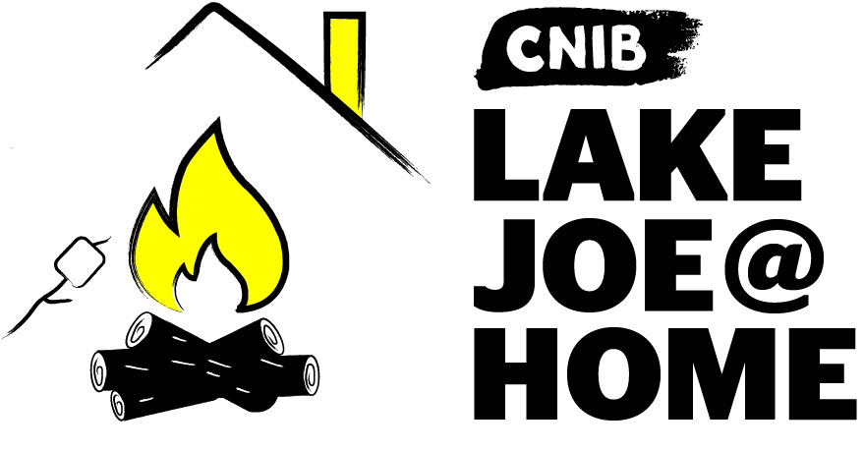

CNIBLakeJoe@Home Virtual Programs

Our virtual programs keep our camp community connected all year long. If you haven’t already participated, please visit CNIBLakeJoe@Home and join us! These programs are offered at no cost. Pre-registration is required. Here are some of our camper favourites:

Curiosity Corner
First Monday of each month from 3-4 p.m., Eastern Time
Keep curious and engaged with lifelong learning. In this monthly session we will be inviting special guests and experts to inform and inspire us on a variety of interesting topics!

Zoom registration link: https://cnib.zoom.us/meeting/register/tJwucOirrDMrGtGaZC2WBGD3Dh7Pd-2um-kU

Bingo & Games
Mondays, 7-8 p.m. Eastern Time
Join in as we alternate each week between bingo and virtual camp games! Friendly fun for all ages.

Zoom registration link: https://cnib.zoom.us/meeting/register/tJAkc-qvrzgtEtS0ChjgjfCjqGwhdPaS5Cqn

Coffee Break
Tuesdays, 9-10 a.m. Eastern Time
Join us Tuesday mornings for conversation, laughter and a chance to reminisce about your favourite CNIB Lake Joe memories. Pour yourself a coffee, tea, or beverage of choice, login and connect with your friends from Lake Joe.

Zoom registration link: https://cnib.zoom.us/meeting/register/tJ0pdOGqrTguHtFv8E4yqaCnPgVKRge8FEWO

Campfire Songs & Stories
Wednesdays, 7-8 p.m. Eastern Time
Join us for a virtual Lake Joe campfire with traditional campfire songs and stories. Fun for all ages!

Zoom registration link: https://cnib.zoom.us/meeting/register/tJwtduuvpz0rGt2ntEiE_60TtBjD4PUN77OQ

Trivia
Last Thursday of the month from 3-4 p.m. Eastern Time
Test your knowledge in a friendly quiz competition as you laugh and learn at the same time! There will be questions for all ages.

Zoom registration link: https://cnib.zoom.us/meeting/register/tJ0rfu-qqzIsHdFbuxHkWnq-nrelhKEm4LwN

But wait, there’s more!
New CNIBLakeJoe@Home virtual sessions are always being added. We also encourage you to check out hundreds of CNIB Foundation virtual programs to connect with friends, new and old!

Program Summary – by date
CNIBLakeJoe@Home programs run year-round!

May
- Holiday Week #1: May 24-29

June
- CNIB Guide Dogs AdvoCamp: June 10-12
- Adult Week: June 20-25

July
- Welcome to Lake Joe Orientation Sessions – Adults, Youth & Family/Holiday (virtual)
- Holiday Week #2: July 4-9
- PLAY/Camp Abilities: July 11-16
- Adult Week: July 18-23
- Summer Camp/ESL Immersion: July 25-30
- SCORE Scholars: July 25-30

August
- Family Week #1: August 1-6
- Canadian Leadership Development Program: August 8-13
- Adult Week: August 15-20
- Family Week #2: August 22-27
- Counselor-in-Training: August 22-27
- Orientation & Mobility/Guide Dog Immersion Program: August 29-September 2

September
- Writing with Feeling: Braille Writers’ Retreat: September 30-October 2

October
- Fall Colours Holiday Retreat: October 14-16
- Vision Loss Rehabilitation Canada (VLRC) Intensive Immersion Program: October 17-20
- Family Halloween Haunt: October 28-30

Program Summary – by age

Children & Youth (8-29)
- Welcome to Lake Joe Orientation Session - Youth (virtual)
- Camp Abilities (ages 8-18): July 11-16
- PLAY (ages 8-18): July 11-16
- SCORE Scholars (grades 11, 12 and 1st year post-secondary): July 25-30
- Summer Camp/ESL Immersion (ages 8-18): July 25-30
- Canadian Leadership Development Program (ages 15-29): August 8-13
- Counselor-in-Training (ages 15-19): August 22-27
- Writing with Feeling: Braille Writers’ Retreat (ages 6-19): September 30-October 2

Adults (19+)
- Welcome to Lake Joe Orientation Session – Adults (virtual)
- CNIB Guide Dogs AdvoCamp: June 10-12
- Adult Week #1: June 20-25
- Adult Week #2: July 18-23
- SCORE Scholars (grades 11, 12 and 1st year post-secondary): July 25-30
- Canadian Leadership Development Program (ages 15-29): August 8-13
- Adult Week #3: August 15-20
- Orientation & Mobility/Guide Dog Immersion Program: August 29-September 2
- Vision Loss Rehabilitation Canada (VLRC) Intensive Immersion Program: October 17-20

Family / All Ages
- Welcome to Lake Joe Orientation Session - Families (virtual)
- Holiday Week #1: May 24-29
- Holiday Week #2: July 4-9
- Family Week #1: August 1-6
- Family Week #2: August 22-27
- Fall Colours Holiday Retreat: October 14-16
- Family Halloween Haunt: October 28-30

COVID-19: Pandemic Precautions

1. Are COVID-19 vaccinations required to attend CNIB Lake Joe in-person in 2022?
Yes. All guests 12 years and older, must be fully vaccinated to attend CNIB Lake Joe. CNIB reserves the right to change/update this policy in accordance with local, provincial and federal guidelines.

2. What does fully vaccinated mean? Which vaccines are accepted?
“Fully vaccinated” means having received all required doses of a COVID-19 vaccine that has been vaccines approved by Health Canada. These are: AstraZeneca/COVISHIELD, Janssen (Johnson & Johnson). Moderna, and Pfizer-BioNTech.

- For AstraZeneca, Moderna and Pfizer, two doses are required. To be considered fully vaccinated against COVID-19, the second dose must be at least 14 days in advance of attending CNIB Lake Joe.
- For Janssen, one dose is required. One dose is required to be considered fully vaccinated against COVID-19.
- Participants who received a first dose of AstraZeneca and a second dose of Moderna or Pfizer are considered fully vaccinated.

3. What information will you be collecting and how will you collect it?
Participants will be required to provide proof of full vaccination to CNIB Lake Joe before attending programs onsite at CNIB Lake Joe. Valid proof of vaccination can include the following:

- provincial vaccine verification apps
- a vaccine passport
- an electronic vaccine receipt issued by the provincial government
- an original receipt from an issuing vaccination clinic or pharmacy

Participants will be required to submit proof of vaccinations with their health information at registration by uploading their documentation to their personal accounts along with health and/or medical information, or by bringing it with them and presenting it at check-in at CNIB Lake Joe. For those who do not upload their information in advance, proof of vaccination will need to be provided at check-in. Participants who have not provided proof of vaccination will not be permitted to attend in-person programs and activities at CNIB Lake Joe.

4. What if a participant cannot be vaccinated?
If a participant cannot be vaccinated for a reason protected by the provincial human rights legislation (such as a legitimate medical condition) in their province, please contact the General Manager, CNIB Lake Joe.

The participant may be asked to provide medical documentation or other proof to support the accommodation request. This may be (but is not limited to) documentation provided or signed by a medical doctor or nurse practitioner or an oath sworn in front of Commissioner. Each case will be assessed individually.

5. What if a participant does not wish to be vaccinated?
If a participant does not wish to be vaccinated and does not have a reason protected by a provincial human rights legislation (see above), CNIB welcomes them to participate in one of many CNIB and CNIB Lake Joe virtual program opportunities available.

6. How is the onsite program schedule different in 2022?
The onsite program schedule for 2022 has been planned, with health and safety as our main priority. Exciting new programs and activities have been added to provide more options for people to get back to camp. Depending on how many people are interested in attending onsite programs, there may be a limit of one week per person to ensure more people have an opportunity to join us. To provide 48 hours for sanitization between groups, guests will arrive Monday and depart Saturday.

7. What steps are being taken to keep everyone healthy and safe?
We are planning to offer onsite programs in 2022 in strict accordance with local, provincial and federal guidelines. The health and safety of our campers, staff and volunteers is always our highest priority. As we confirm our onsite programs for 2022, we are making the necessary adjustments to ensure appropriate health and safety protocols are in place to keep everyone safe at camp. For example:

- Enhanced cleaning measures will be in place, along with hand sanitizing stations throughout the site.
- There will also be screening for all campers/guests, staff, and volunteers, which may include Ontario Health approved rapid ID NOW™ COVID testing.
- Proof of vaccinations will be required to attend.
- All guests will be required to wear a mask in common areas, physically distance, and frequently wash their hands.
- We will host virtual orientation sessions in advance of onsite programs to ensure everyone will know what to expect.

For more information, visit our CNIB Lake Joe FAQ.

Fee Summary

All camp experiences include meals, accommodations, and all on-site programs and activities. Thanks to the generosity of CNIB Foundation supporters, camp registration fees are highly subsidized to keep camp fees as low as possible. Further subsidies are available for those who qualify.

Although our costs to operate onsite programs have increased due to the additional cleaning and sanitizing required, we are committed to holding our 2019 rates.

If you paid a deposit for the 2020 season and opted to have it carried over (deferred to be used towards 2021 and then 2022), you will not be required to pay another deposit at this time. The balance owing will be due by Monday, June 6, 2022. Any registrations after June 6, 2022 must be paid in full.

Note: All CNIBLakeJoe@Home virtual programs are free-of-charge!

For more information, visit cnib.ca/lakejoe, email lakejoe@cnib.ca, or call
1-877-748-4028 or 705-375-2630.

Children & Youth Programs | Fee | Deposit  (due April 1-30)
PLAY  - July 11-16 | $460 | $50
Camp Abilities  - July 11-16 | $460 | $50
Summer Camp/ESL Immersion  - July 25-30 | $460 | $50
Canadian Leadership Development Program  - August 8-13 | $460 | $50
Counsellor in Training  - August 22-27 | $460 | $50

Adult Programs | Fee | Deposit  (due April 1-30)
CNIB Guide Dogs AdvoCamp  - June 10-12 | $100 | $25
Adult Weeks  - Week #1: June 20-25  - Week #2: July 18-23  - Week #3: Aug 15-20 | $690 | $100
Fall Colours Holiday Retreat  - October 14-16 | $275 | $50

Family Programs & Holiday Weeks (all ages) | Fee | Deposit  (due April 1-30)
Holiday Weeks  - Week #1: May 24-29  - Week #2: July 4-9 | Call for details about Holiday Week fees. | $25 for each family member
Family Weeks  - Week #1: August 1-6  - Week #2: August 22-27 | Call for details about Family Week fees. | $25 for each family member
Family Halloween Haunt  - October 28-30 | Call for details about Family Halloween Haunt fees. | $25 for each family member

Application / Registration Process

Step 1: Apply

Applications open Tuesday, January 11, 2022
If you would like to attend an onsite program at CNIB Lake Joe, please let us know by completing a quick application, using the following link: https://cniblakejoe.campbrainregistration.com/

You will be asked to select the program/week you’d like to attend. No deposit or payment will be collected at this time. Please note that while we will make every attempt to accommodate requests, due to limited spaces this year for enhanced safety, application to the program does not guarantee attendance.

If the program you’ve selected has availability, we will send you a confirmation email within two weeks and will update your application to a registered status. If the program is full, you’ll be made aware and placed on a waiting list.

Step 2: Pay the deposit

Deposits and registration forms start Friday, April 1, 2022
Deposits will be accepted between April 1-30, 2022.

Starting April 1, you will be able to log back into the registration system to complete your forms (medical form, financial assistance application, dietary needs, agreeing to the waiver, etc.) and to pay your deposit via credit card. Alternatively, you can mail a cheque or money order, made payable to CNIB Lake Joe (4 Joe Finley Way, Mactier, ON P0C 1H0). Please note that no cheques or money orders will be cashed until April.

Step 3: Pay the balance

Any balance owing is due by Monday, June 6, 2022
After paying your deposit, the remaining camp fees are due by Monday June 6, 2022. Any registrations after June 6, 2022 must be paid in full. We will be in contact via email or phone to remind you about these payments.

For more information or if you need assistance, visit cnib.ca/lakejoe, email lakejoe@cnib.ca, or call 1-877-748-4028 or 705-375-2630.

Getting to Camp

We welcome guests from across Canada and around the world!

CNIB Lake Joe is located at: 4 Joe Finley Way, MacTier, ON P0C 1H0

Arriving by Car?

Directions from Toronto/Southern Ontario*
- Take Hwy 400 north just past Barrie to Hwy 400 extension (formerly Hwy 69)
- Continue north on Hwy 400 to exit 189 for ON-69 toward MacTier/Gravenhurst
- Merge onto Lake Joseph Road (formerly Hwy 69) past Hwy 169
- Turn right onto Joe Finley Way

*GPS often provides directions to take Hwy 407 toll road. The toll road saves approximately 10 minutes from the drive (approx. 2 hours), but at a cost. Please check a website like google.com/maps for directions or remember to adjust GPS settings.

Directions from Northern Ontario
- Take Hwy 69 south to Hwy 400 south
- Continue south on Hwy 400 to exit 207 for ON-69 toward MacTier/Gravenhurst
- Merge onto Lake Joseph Road (formerly Hwy 69)
- Turn left onto Joe Finley Way

Directions from Eastern Ontario
- Take Hwy 417 west to Bruce St/County Road 20 to Hwy 60 west
- Continue on Hwy 60 and merge onto Hwy 11 south
- Take exit 219 for Muskoka Rd 3 toward Huntsville/Aspdin
- Turn right onto Aspdin Rd/Muskoka District Road 3 (Regional Road 3 W)
- Turn right onto Hwy 141 west and turn left onto Lake Joseph Rd (formerly Hwy 69)
- Turn left onto Joe Finley Way

Parking is free but limited. Please park in one of the designated parking spaces.

Do You Need Transportation?

We are pleased to work with you to provide transportation from Pearson International Airport and other transportation hubs throughout Ontario. Additional fees may apply.

Once at CNIB Lake Joe, simply head to the Welcome Centre to check-in and receive your room key. We are waiting for you!

One more thing!

We can’t wait to welcome you to CNIB Lake Joe as our guest, but there are so many ways to enjoy CNIB Lake Joe:

- Participate in CNIBLakeJoe@Home and CNIB Foundation virtual programs
- Join our staff team
- Volunteer at CNIB Lake Joe
- Attend an event (visit cnib.ca/lakejoe for upcoming events)
- Donate
- Subscribe to the CNIB Lake Joe e-newsletter
- Follow us on Facebook and Instagram

For more information, visit cnib.ca/lakejoe, email lakejoe@cnib.ca, or call
1-877-748-4028 or 705-375-2630.

CNIB Lake Joe
4 Joe Finley Way
MacTier, ON P0C 1H0
Web: cnib.ca/lakejoe
Email: lakejoe@cnib.ca
Toll Free: 1-877-748-4028
Phone: 705-375-2630

