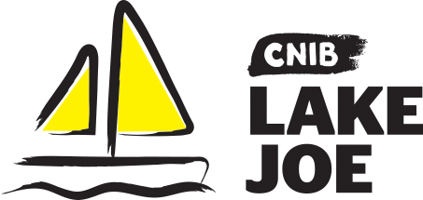

Walkway to Independence

Buy a Brick
Since 1961, people living with sight loss and their families have enjoyed CNIB Lake Joe programs, not only for the recreational activities, but for the confidence building and support offered by a community that understands living with blindness and sight loss. For most, it's an experience they'll never forget. You can help Enhance Lives, Make Memories, and Build Independence by buying a brick for the CNIB Lake Joe Walkway to Independence.
For your gift of $125, you will receive:
- A brick inscribed with either your name or the name of someone you wish to honour that will be placed on the Walkway to Independence
- A certificate of recognition in the name of the person you wish to honour.
Your donation will allow CNIB Lake Joe to continue providing life-changing programs for children and youth, adults, and families of people who are blind or partially sighted.
For more information: Sherri Helsdingen Manager, Community Engagement, CNIB Lake at Sherri.Helsdingen@cnib.ca or 705-241-2907.

CNIB Lake Joe “Buy a Brick” Order Form

c I would like to purchase _____ bricks(s) at $125 each to continue to build the Walkway to Independence at CNIB Lake Joe.

c I would like to support programs at CNIB Lake Joe by making an additional gift of $ __________________

Your name: __________________________________________________

Address (street, city province, postal code): ____________________________________________________________

____________________________________________________________

Phone: _________________________________________

Email Address: ___________________________________

Payment Information:

Total Amount Due: __________

c Please find my enclosed cheque to CNIB Lake Joe OR

c Please charge my credit card: c Visa c MasterCard c AMEX

Card# _ _ _ _ _ _ _ _ _ _ _ _ _ _ _ _ Expiry Date: _ _ / _ _

Name on Credit Card: __________________________________________

Signature: ___________________________________________________

c I wish to remain anonymous

Brick and Certificate details:

Please inscribe my brick as follows (maximum of 3 lines, 15 characters per line including spaces):

Line 1:
Line 2:
Line 3:

Please include this name on the certificate:

First ________________________________________________________
Last ________________________________________________________

For more information and to place an order:
Sherri Helsdingen, Manager, Community Engagement
Mail: CNIB Lake Joe, 4 Joe Finley Way, MacTier, ON P0C 1H0
Email: Sherri.Helsdingen@cnib.ca
Cell: 705-241-2907

Thank you!
Our campers and their families greatly appreciate your generosity.

