Connecting the Dots
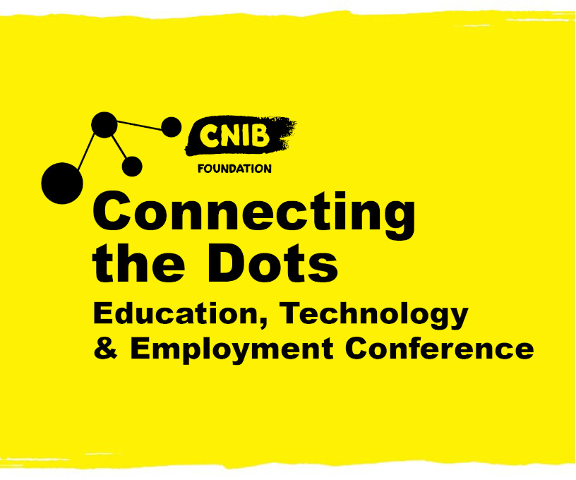Conference Program
October 22 & 23, 202

Day 1 Schedule Friday, October 22
Time | Event
9:30 a.m. | Vendor Alley Opens
10:30 a.m. | Opening Remarks  Angela Bonfanti, SVP, CNIB  Tim Rose, Senior Manager, Inclusion Partnerships, CIBC  Clearing Space by April Michell-Boudreau  Our Stories by Kairyn Potts
10:50 a.m. | Opening Keynote: The Future of Work  Stephen Harrington, Partner, Human Capital, Deloitte
11:20 a.m. | Vendor Alley Announcement  Mental Health, Nutrition & Movement Break
11:40 a.m. | Concurrent Workshops, Session 1
12:40 p.m. | Energy Break with Neville Wright  Vendor Alley Announcement  Mental Health, Nutrition & Movement Break
1:00 p.m. | CNIB Braille Creative Writing Contest
1:30 p.m. | Concurrent Workshops, Session 2
2:30 p.m. | Mental Health, Nutrition & Movement Break
2:45 p.m. | Concurrent Workshops, Session 3
3:45 p.m. | Vendor Alley Announcement  Mental Health, Nutrition & Movement Break
4:00 p.m. | Out of the Woulds with Big Daddy Tazz
4:15 p.m. | Day 1 Closing Remarks
4:25 p.m. | Vendor Alley Announcement
5:45 p.m. | Vendor Alley Closes

Day 1 Sessions Friday, October 22
Auditorium | Session Number & Title | Presenter(s)
Education | 101 Did You Know...and We’re Doing It – Dispelling Stigma and Smashing Barriers | Alicia Chenier, Danica Frappier, Curtis Ruttle, Emilee Schevers
Technology | 102 We said we would, and we did – Moneris Accessible Payment Terminals for All | John M. Rafferty, President and CEO, CNIB
Employment | 103 Mentoring – Table Stakes – Engaging to Enable | Rahi S. Tajzadeh
Education | 201 Overview of the ARL/CARL Marrakesh Treaty Implementation Task Force project | Gerald R. Beasley
Technology | 202 Me, My phone, and AI: Looking to the future | Cecily Morrison
Employment | 203 Come to Work Panel: The Future of Work | Derek Fraser, Carole Mendonca, Greg Swift, Olivia Weir
Education | 301 The Magic of Braille: How Six Dots Open the World to Everyone | Phillip Abrahams, Lorraine Banks, Darleen Bogart, Diane Lapidus, Pamela Marzolini
Technology | 302 Envision: AI for your eye | Karthik Kannan
Employment | 303 Master's Program in Visual Impairment & Rehabilitation | Natalina Martiniello, Joseph Paul Nemargut, Dr. Olga Overbury, Dr. Walter Wittich

Day 2 Schedule Saturday, October 23
Time | Event
9:30 a.m. | Vendor Alley Opens
10:30 a.m. | Opening Remarks
10:35 a.m. | Opening Keynote: Paralympian Megan Mahon
10:50 a.m. | Vendor Alley Announcement  Mental Health, Nutrition & Movement Break
11:15 a.m. | Concurrent Workshops, Session 4
12:15 p.m. | Energy Break with Hayley Wickenheiser  Vendor Alley Announcement  Mental Health, Nutrition & Movement Break
1:00 p.m. | Concurrent Workshops, Session 5
2:00 p.m. | Sizzler: CNIB’s New Youth Mentorship Program  Mental Health, Nutrition & Movement Break
2:15 p.m. | Concurrent Workshops, Session 6
3:15 p.m. | Vendor Alley Announcement  Mental Health, Nutrition & Movement Break
3:30 p.m. | Concurrent Workshops, Session 7
4:30 p.m. | Mental Health, Nutrition & Movement Break
4:40 p.m. | Connecting the Dots Closing Celebration  Because I Said I Would – Keynote by Alex Sheen  Fake Romance – Musical Performance by Alexa Marie  Giveaways!  Closing Remarks

Day 2 Sessions Saturday, October 23
Auditorium | Session Number & Title | Presenter(s)
Education | 401 Building Braille Excitement | Karen Brophey, Suzanne Decary-van den Broek, Stephanie Gee, Glenda Parsons, Rhonda Underhill-Gray, Adam Wilton
Technology | 402 Code Breakers | Ashley Nemeth
Employment | 403 Micro Certificates | Dan Bordenave, Fiona McArthur, Dr. Mahadeo Sukhai, Rachel Sumner
Education | 501 Introducing LEGO Braille Bricks | Suzanne Decary-van den Broek, Shelly Marks, Rhonda Underhill-Gray
Technology | 502 Microsoft Soundscape: Opening the Door to New Experiences | Jarnail Chudge & Mark Rankin
Employment | 503 The role and place of mentorship for young adults with blindness and low vision in Australia and Canada | Danika Blackstock, Dr. Melissa Cain, Melissa Fanshawe, Dr. Mahadeo Sukhai
Education | 601 Come Read with Me! Creating Meaningful Approaches to Childhood Literacy | Daphne Hitchcock & Glenda Parsons
Technology | 602 Reflection of refreshable braille through the lens of HumanWare Technology | Michel Pepin & Peter Tucic
Employment | 603 Mental Health at Work – Tools and Learnings | Chantelle Painter

Day 2 Sessions Con’t Saturday, October 23

Education | 701 Teaching Braille Displays Virtually: Ideas and Strategies for Preparing Visually Impaired and Deaf Blind Adult Users | Dr. Leo Bissonnette & Kim Kilpatrick
Technology | 702 Document Accessibility Testing with a Screen Reader | Dax Castro
Employment | 703 Microsoft Windows 11 Accessibility | TBC

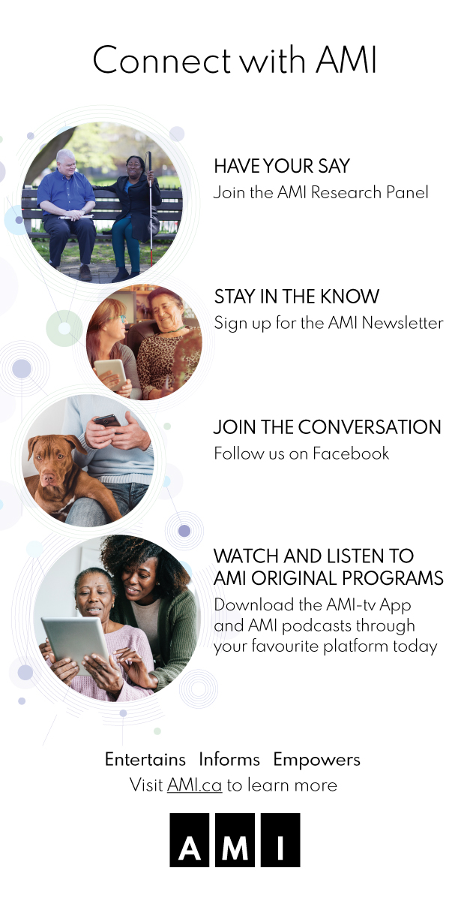

Visit Vendor Alley
In Vendor Alley, exhibitors may also be offering sessions and special events for you to participate in. Be sure to visit our virtual vendors and explore their products and services – you might even walk away with some swag!
Exhibitors include: AbleDocs, Aille Design, AMI, Bell, Centre for Equitable Library Access (CELA), CIBC, CNIB, CNIB Deafblind Community Services, CNIB SmartLife/Frontier Accessibility, Envision, Good Maps, HumanWare, Optelec Canada, Say Hello 2 Blindness Accessories, The Brick, Vision Loss Rehabilitation Canada.
Your Virtual Swag Bag
Think of this as your virtual shopping bag! When you visit an exhibitor booth in Vendor Alley, you can add their e-coupons, discounts and information to your swag bag. CNIB has also pre-loaded three documents in the swag bag. At the end of the conference, you can have your swag emailed directly to your inbox. Simply visit the swag bag, select your swag documents, and click the ‘email’ button. A talented group of Canadian-owned small businesses have offered exclusive discounts to our conference attendees. Many of these businesses are BIPOC-owned, founded by women and/or led by people with sight loss. You’ll find their special promotions and discounts housed under ‘event promos’ button. We’ve also included it in your swag bag, so you don’t miss a thing!
A chance to win!
Thanks to the generosity of our donors, you could walk away with one of several prizes including:
- A 58” television from The Brick
- A laptop from Lenovo
- One of four Amazon Echo
- One of four $25 pre-paid gift cards
Registered attendees are automatically entered for a chance to win. Randomly selected winners will be announced throughout the duration of the conference CNIB staff, volunteers, Connecting the Dots Sponsors and exhibitors are not eligible to participate.

Session Descriptions
We have three different auditoriums (the Education, Technology, Employment auditoriums) simultaneously offering virtual sessions throughout the day.

Clearing Space by April Michell-Boudreau
Join us for this unique smudging experience by April Mitchell-Boudreau, owner and founder of Lofttan. Owner/designer April Mitchell-Boudreau is a Turtle clan Mohawk with roots at Six Nations. She’s passionate about awakening and engaging the creator that lives inside all of us.

Our Stories by Kairyn Potts
Join us for this presentation from Kairyn Potts (or simply Kai) (he/him) who is Nakota Sioux from the Alexis Nakota Sioux Nation in Treaty 6 Territory. He recently moved and has now made his home in Tkaronto, Dish with One Spoon Territory. He is an advocate for youth; he currently works as a youth programs developer for an Indigenous non-profit organization in the GTA that focuses on providing supports and services to the Two-Spirit/IndigiQueer community.

Opening Keynote: The Future of Work
Stephen is Deloitte’s National Leader for Workforce Strategy and Future of Work Advisory and has been a writer and speaker on the future of work since 2011. With 20 years’ experience in Consulting, Stephen leads transformations in workforce strategy to fundamentally get at changes in work, workforce and workplace to fuel business strategy. Stephen’s experience spans from strategy to design – he helps clients set workforce strategy to fuel business strategy, and then designs programs not simply to chase elusive ‘best-practice’ but to craft implementation solutions to meet the unique needs of client’s and their employees.
Presenter: Stephen Harrington, Partner, Human Capital, Deloitte

101 Did You Know...and We’re Doing It – Dispelling Stigma and Smashing Barriers
Living with sight loss has many different experiences for youth when navigating education, employment and recreation. The members of CNIB’s National Youth Council join for an engaging and honest panel discussion exploring how they continue to break down stigmas around blindness and smashing barriers.
Speakers: CNIB National Youth Council Members; Alicia Chenier, Danica Frappier, Curtis Ruttle, Emilee Schevers

102 We said we would, and we did – Moneris Accessible Payment Terminals for All
Last year, at Connecting the Dots, it was announced that Canadians with sight loss would soon be able to make purchases on their own with reduced risk of compromising the security of their personal and financial information. CNIB has been working together with Moneris Solutions Corporation (‘Moneris’), and supported by the Government of Canada, to create an inclusive and accessible shopping experience for everyone. As or May 31, 2021, as part of National AccessAbility Week 2021, the Minister of Employment, Workforce Development and Disability Inclusion, Carla Qualtrough, participated in the Payments Canada 2021 Summit and in the introduction of new accessibility features for electronic payment terminals by Moneris. Developed in collaboration with the CNIB and the Government of Canada, the new features unveiled by Moneris, such as enhanced font sizes, increased contrast, and bilingual audio prompts giving clear instructions, will help Canadians with visual disabilities when making a payment. Participants will learn more about the launch of the new payment terminals and the road ahead toward a barrier-free Canada.

103 Mentoring – Table Stakes – Engaging to Enable
The value of Mentoring has often been spoken to, but it continues to be an asset. As we look at Mentoring as it pertains to Entrepreneurs ("Venture Pool"), the Spark Innovation Educational Centre is partnering with CNIB, the Venture Pool, and the wider community of Entrepreneurs to foster community collaboration, support, and re-usable resources to help enable for success.
Speaker: Rahi S. Tajzadeh, CEO, KnowQuest Inc. and CEO, The Big Leaf Inc

Energy Break with Neville Wright
Sit back and enjoy this interactive energy break with Neville Wright! Neville is a multitalented individual who holds many titles: 3x Olympian, Performance Therapist, Coach, Mentor and most notably a Keynote Speaker. Prior to that, Neville spent 16 years as an Athlete representing Canada on the World Stage in Track and Field and Bobsleigh.

CNIB Braille Creative Writing Contest
Since 1997, CNIB has organized a Canada-wide Braille Creative Writing Contest for children and youth. This important competition celebrates braille literacy and encourages young people (ages K-12) to flex their creative muscles while practicing their braille skills. Join us to hear a collection of imaginative stories, essays and poems from our 2021 CNIB Braille Creative Writing Contest winners. Prepare to be entertained!
Presenter: Karen Brophey, Lead, Literacy, CNIB

201 Overview of the ARL/CARL Marrakesh Treaty Implementation Task Force project
It has been estimated that less than 10% of the world’s published books are available in accessible formats for people who are print disabled. The Canadian Association of Research Libraries (CARL) and our US sister organization, the Association of Research Libraries (ARL) together represent the largest academic research libraries in North America, and collectively hold just under 760 million titles in print and electronic formats. Our Marrakesh Implementation project explores the issues related to the copyright, discovery, description and access to collectively enable our member libraries to describe, digitize, and make available content in alternate formats. In addition, the project looks to connect beneficiaries of the Marrakesh Treaty in both Canada and the US, to request and gain access to accessible versions of the materials held in our libraries.
Speaker: Gerald R. Beasley, Carl A. Kroch University Librarian

202 Me, My phone, and AI: Looking to the future
In the ORBIT project, we take a disability-first approach to build AI algorithms that work well for people who are blind or low vision. To ensure that, we are creating a large open-source dataset collected only by blind and low vision people. With this dataset, the ORBIT team will challenge researchers at Microsoft as well as the research community in general to develop techniques that would enable phones to recognize items that are specific to the user – this is what we call personalized object recognition.
Speaker: Cecily Morrison, Principal Researcher, Microsoft

203 Come to Work Panel: The Future of Work
Talent Pool members will learn what to expect from workplaces in the post Covid world; what new recruitment processes might be in place and why in person vs. home-based or a combination of both. The objective for participants is to learn about the evolution of work. New Tools being used (i.e., pre-screening, virtual interviewing), hybrid work (meaning combined work from anywhere and work from office), as well as the training/experience opportunities employers/managers are seeking out to engage previously un-tapped labor markets.
Speakers:
- Derek Fraser, Manager, Talent Acquisition, Sunlife
- Carole Mendonca, Senior Manager of Accessibility, Deloitte
- Greg Swift, Chief Operating Officer, Lawyers in House
- Olivia Weir, Advisor, Diversity, Equity & Inclusion Recruitment, BMO

301 The Magic of Braille: How Six Dots Open the World to Everyone
This workshop seeks to demystify the brilliance and utility of braille. Participants will be introduced to the basics of the simple yet versatile braille code. Experts will be on hand to provide insights and answer questions about the myriad ways that braille can provide people with vision loss and their supporters access to everything that the world around them has to offer. From stories to wayfinding information, calendars to math and technical information, and so much more: braille unlocks it all. This is your opportunity to ask your questions about what braille can do for you --- and receive answers that you can understand. Parents are especially welcome.
Speakers:
- Phillip Abrahams, UEB Instructor, CNIB
- Lorraine Banks, UEB Instructor, CNIB
- Darleen Bogart, National Braille Convenor, CNIB
- Diane Lapidus, Braille Instructor, CNIB
- Pamela Marzolini, Braille Transcriber, CNIB

302 Envision: AI For Your Eyes

Envision empowers visually impaired people to become more independent by speaking out the visual world around them. With features ranging from real-time text recognition to video calling, Envision Glasses opens the door for the future of wearable assistive technology. In this session, we will talk about everything Envision and give you insights on how technology can empower the blind and visually impaired community.

Speaker: Karthik Kannan, Co-Founder & CTO, Envision

303 Master's Program in Visual Impairment and Rehabilitation
In 2016, and in consultation with one national and two local vision rehabilitation centers, the Université de Montréal established a bilingual master's degree program in Visual Impairment and Rehabilitation to specifically train rehabilitation professionals in orientation & mobility (O&M), low vision (emphasis on individuals with functional vision) and vision rehabilitation therapy (emphasis on individuals who are blind). Trainees may choose between a professional track, leading to employment as vision rehabilitation professionals, or the research track, leading towards research and/or industry. Participants will Learn about career options in orientation and mobility, low vision, and blindness rehabilitation; Understand the application process and eligibility criteria for pursuing the Master’s in Vision Impairment and Rehabilitation at the Université de Montréal; and gain an overview of program options, courses, and internships within the master's program.
Speakers:
- Natalina Martiniello, PhD, CVRT, Université de Montréal
- Joseph Paul Nemargut, PhD, COMS, Assistant Professor, Université de Montréal
- Dr. Olga Overbury, Professor, Université de Montréal
- Dr. Walter Wittich, CLVT, Associate Professor, Université de Montréal

Speaker: Out of The Woulds
Possibilities over disabilities
Speaker: Big Daddy Tazz

Opening Keynote: Paralympian Megan Mahon
Born and raised in Northern Ontario Meghan is now living in Alberta and is the Program Lead for Children and Youth programming at CNIB, based out of the Calgary office. In addition to her full-time position Meghan is also an accomplished para-athlete and plays for the Canadian women’s goalball team and has competed previously in the Rio 2016 Paralympic Games and most recently at Tokyo 2020. Born with a genetic eye condition called Incomplete Achromatopsia, what Meghan sees every day is all she has ever known. The impact this condition has on her vision has certainly not prevented her from living her life to the fullest.
Presenter: Megan Mahon, Program Lead, Children and Youth, CNIB, Paralympian & Player for Canadian Women’s Goalball National Team

401 Building Braille Excitement
Find out how the Braille Challenge feeds the hearts and minds of Canadian students learning and using braille. Hear about fun foundational braille games and activities especially designed to encourage young reluctant or struggling braille users. And when your student is ready to compete for prizes, the Braille Challenge offers testing options too. Did you know that this year four Canadian students placed among the top 50 (10 finalists per age category) in all of North America? As a teacher or parent of a braille user, you already know that braille literacy is key to your student’s future success in education and employment. Provincial Resource Centres, TVI’s and CNIB Foundation staff are ready, willing and able to support you and your student in this important braille literacy journey. Karen Brophey, Lead Literacy for CNIB Foundation, will introduce coordinators of Braille Challenge regional events from across Canada.
Speakers:
- Karen Brophey, Program Lead, Literacy, CNIB
- Suzanne Decary-van den Broek, Executive Director, CNIB
- Stephanie Gee, Vision Specialist, Calgary Board of Education
- Glenda Parsons, Director of Programs for Students who are Blind or Visually Impaired, APSEA
- Rhonda Underhill-Gray, Program Lead, Beyond the Classroom & SCORE, CNIB
- Adam Wilton, Program Manager, Provincial Resource Centre for the Visually Impaired (PRCVI)

402 Code Breakers
Learn to Code! The power of putting technology in the hands of youth. As we hire youth, we have found that many of them do not have the technology skills that are needed in today’s digital environment. In Saskatchewan we have started a program called Learn To Code. This program uses the Code Jumper Program to teach kids the basics of coding using a tactile method. With building their interest in technology we see a growth in their confidence and ability to adapt to a digital world.
Speaker: Ashley Nemeth, Manager, Programs & Operations, CNIB

403 Micro Certificates
Learning re-imagined - As the future of work changes, the educational landscape must also swiftly adapt to ensure our workforce has the right knowledge and skills but also to reflect the needs of equity-seeking groups. Panelists from Ontario Tech University, Talent, Spark Innovation Education Centre and CNIB dive into current and future education needs and discuss effective ways (e.g., micro-credentials), to deliver flexible, dynamic, and inclusive learning to give more choices and employment opportunities to more people.
Speakers:
- Dan Bordenave, CEO, Spark Innovation Education Centre
- Fiona McArthur, PhD, Strategic Project Manager, Office of the President, Ontario Tech University
- Dr. Mahadeo Sukhai, Director of Research and Chief Inclusion & Accessibility Officer, CNIB
- Rachel Sumner, Executive Director, Ontario Tech Talent

Energy Break with Hayley Wickenheiser
Sit back and enjoy this interactive energy break with Hayley! Hayley Wickenheiser is a Canadian former ice hockey player, resident physician, and executive for the Toronto Maple Leafs. She was the first woman to play full-time professional men’s hockey in a position other than goalie.

501 Introducing LEGO Braille Bricks
The concept is play-based methodology that teaches braille to children who are blind or partially sighted. Each brick is identical to standard LEGO® except that the studs are arranged to correspond to numbers and letters in the Braille alphabet. Each brick shows the printed version of the symbol or letter, allowing sighted and blind children to play and learn together on equal terms. The concept opens a whole new world of playful learning that teaches children Braille in an enjoyable and tactile environment, and sighted peers can play and learn - a truly inclusive experience.
Speakers:
- Suzanne Decary-van den Broek, Executive Director, CNIB
- Shelly Marks, Vision Itinerant Teacher
- Rhonda Underhill-Gray, Program Lead, Beyond the Classroom & SCORE, CNIB

502 Microsoft Soundscape: Opening the Door to New Experiences
Microsoft Soundscape uses 3D spatial audio to promote a person’s mobility and independence by enhancing their awareness of their surroundings by calling out landmarks and points of interest from where they actually are. As such, Soundscape can be considered a map which is delivered in 3D sound to augment a person’s experience through audio. Soundscape can function as your main wayfinding system, but it can also work in the background and provide you with effortless ambient awareness. This provides a greater sense of empowerment and choice and allows each and every one of us to be able enjoy the outdoors with greater confidence and less stress.
Speakers:
- Jarnail Chudge, Innovation Architect, Microsoft
- Mark Rankin, Certified Orientation and Mobility Specialist, Vision Loss Rehabilitation Ontario (VLRO)

503 The role and place of mentorship for young adults with blindness and low vision in Australia and Canada
We examined the experiences with mentorship within two distinct groups: school-aged children in Australia with blindness and low vision and working-aged individuals with blindness and low vision in Canada. Qualitative data was collected from semi structured individualized interviews regarding the experiences, understanding, and valuing of mentorship within these two groups. Participants will learn about the different roles that mentorship plays in the lives and career paths of young adolescents in Australia and working-age adults in Canada; how perceptions of and goals related to mentorship change with age and stage of life; the importance of social connectedness and a sense of belonging to a community to youth and young adults who are blind or partially sighted, and how formal and informal mentorship can serve to fill that need; and how effective mentorship programming can be built using the findings of this research.
Speakers:
- Danika Blackstock, IDEA Specialist, CNIB
- Dr. Melissa Cain, Senior Lecturer, Education, Australia Catholic University
- Melissa Fanshawe, Senior Lecturer, School of Education, University of Southern Queensland, Australia
- Dr. Mahadeo Sukhai, Director of Research, CNIB
Sizzler: CNIB’s New Youth Mentorship Program
Presenters: Caelin Lloyd, Youth Volunteer, CNIB & Rhonda Underhill-Gray, Program Lead, Beyond the Classroom & SCORE, CNIB

601 Come Read with Me! Creating Meaningful Approaches to Childhood Literacy
Children begin to read through observing print in their home and community, and by hearing word patterns as adults around them read aloud. They then play with print by pretending to read and repeating familiar sentences or word rhymes. For our children who are blind or have low vision, we must provide deliberate and purposeful opportunities to observe braille, tactile graphics, and large print in a variety of contexts and locations. Reading for our children is more than listening, it is taking an intentional role in the action of reading. Presenters will share practical ideas on how to create meaningful routines to include braille and tactile awareness.
Speakers:
- Daphne Hitchcock, TSVI
- Glenda Parsons, Director of Programs for Students who are Blind or Visually Impaired, Atlantic Provinces Special Education Authority (APSEA)

602 Reflection of refreshable braille through the lens of HumanWare Technology
In terms of the expectations in any environment (work, school, play) we are all expected to do tasks no different to what was expected several years ago. In many cases multiple tools might need to be used to achieve one task, although we are seeing new assistive technology devices improving the workflow. Attendees will learn the impact refreshable Braille display now plays in the fast-paced world today; the different tools available in braille support categories; and the new era of intelligent refreshable Braille Displays.
Speakers:
- Michel Pepin, Sales Director, HumanWare Technologies
- Peter Tucic, Brand Ambassador, HumanWare Technologies

603 Mental Health at Work – Tools and Learnings
Learn how The Brick developed tools and resources to support their staff to deal with the challenges of the world today.
Speaker: Chantelle Painter, Human Resources Manager, Recruitment and Engagement, The Brick

701 Teaching Braille Displays Virtually: Ideas and Strategies for Preparing Visually Impaired and Deafblind Adult Users
As Braille and mobile technologies advance, the ability for a Braille Display or a Notetaker to interact with other devices (mobile phones, Macs and Pcs) is an incredibly useful feature. Yet many adults find themselves shut out from Braille display technology. We will present the GTT experience where weekly support sessions were provided for potential users via Zoom to bridge this gap. The presenters will provide their insights about preparing adult users for the transition to the world of Braille display technologies. They will share their ideas about teaching braille displays in a virtual environment and discuss how peer mentoring helps people to best use their Braille technology.
Speakers:
- Dr. Leo Bissonnette, former Manager of the Access Centre for Students with Disabilities at Concordia University
- Kim Kilpatrick, GTT Program Coordinator, Canadian Council of the Blind (CCB)

702 Document Accessibility Testing with a Screen Reader
Passing an accessibility checker is only the beginning of ensuring your documents are accessible and provide a robust user experience. This session will provide numerous tips and techniques as well as pitfalls to avoid when testing documents for accessibility. We will walk through what to test, how to test various elements and some not-so-obvious barriers to accessibility that you should be looking for.
Speaker: Dax Castro, Vice President, ADAcademy at AbleDocs

703 Microsoft Windows 11 Accessibility
The new Microsoft Windows 11 is launching on October 6th! As new technologies come into play it is important to understand how those technologies are maintaining function and enabling new functionality for individuals to be successful in their daily lives through live, work and play. The Microsoft Canada team will be presenting the new accessibility features with an interactive question and answer session.

Thank you to our Sponsors

National Media Partner

National Sponsor

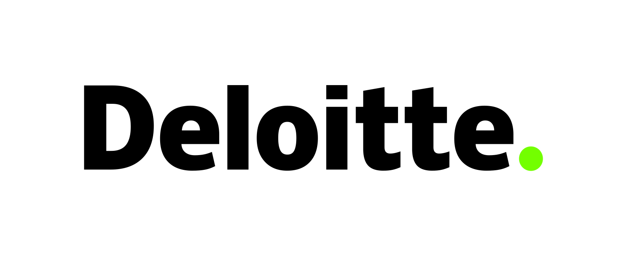

Regional Sponsor

Technology Sponsor
Employment Sponsor

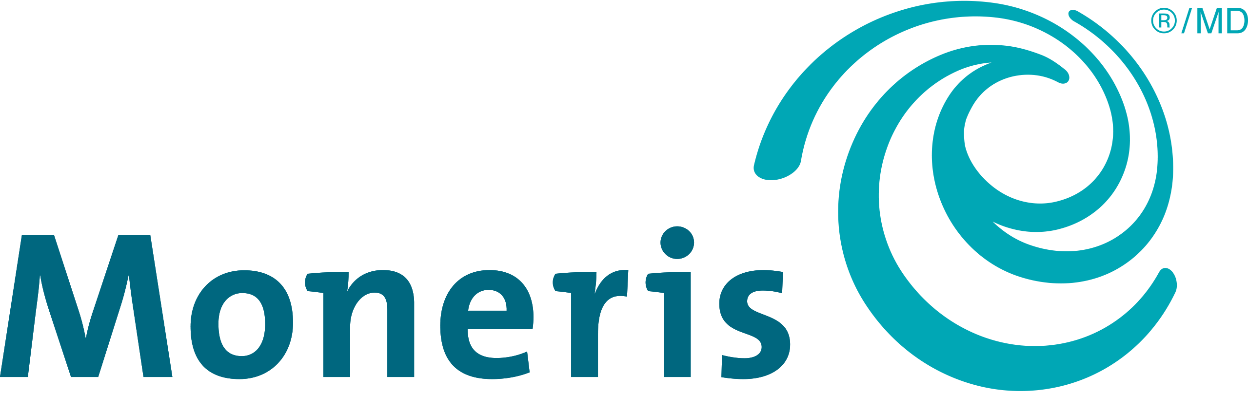

Accessibility Sponsor

Special Sponsors

