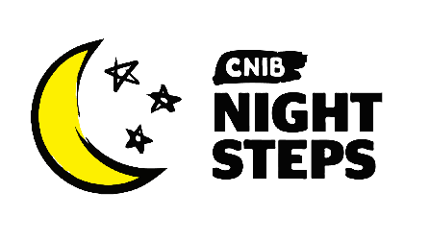
Name:
Address:
City: Province: Postal code:

Phone number: Email address:

Registration Fee
Adults - $25 Donation (tax deductible)
Clients & Youth - Free Volunteers & Staff - Free

Payment
Cash (Do not mail, can be dropped off at a CNIB office.)
Cheque (Make cheques payable to "CNIB".)
I wish to have a CNIB employee call me to pay by credit card.

Fundraising Goal
What is your personal fundraising goal? (The suggested minimum goal is $100.) $_____

*Are you a CNIB client?
Yes No

Permission Questions
I allow CNIB to contact me by email to support my involvement in this event.
I allow the general public to donate on my page.
I give permission to display my name on the list of Top Fundraisers.
I would like to sign up to receive general information and updates from CNIB.

The completed form can be dropped off or mailed to your local CNIB office or emailed to debbie.erb@cnib.ca. If you would like to speak to a CNIB representative, please call us at
1-800-563-2642 x6108
CNIB is committed to protecting the privacy of our donors, supporters and stakeholders. We maintain a record of your personal information for registration, tax receipting purposes and to occasionally contact you with fundraising communications. If for any reason you do not wish to be contacted, please call the CNIB Helpline at 1-800-563-2642. Charitable registration #119219459

