Traffic Warning Signs for the possible presence of pedestrians who are blind

Background
People who are blind or partially sighted may feel unsafe navigating their neighbourhood because of cars travelling at a high speed or in a dangerous manner. Because of this, municipalities and political representatives across Ontario sometimes receive correspondence from residents who are blind or partially sighted (or from parents with children living with sight loss) to request that the municipality place warning signs that are designed to alert drivers for the possible presence of blind, deaf or autistic pedestrians (vulnerable road users) in their neighbourhood. These requests are normally made either through a politician's office or the local municipality and the correspondence is sent on to CNIB. CNIB Foundation and Vision Loss Rehabilitation Ontario (VLRO) can also be contacted directly to provide support or recommendations on whether a warning sign installation is an appropriate course of action.
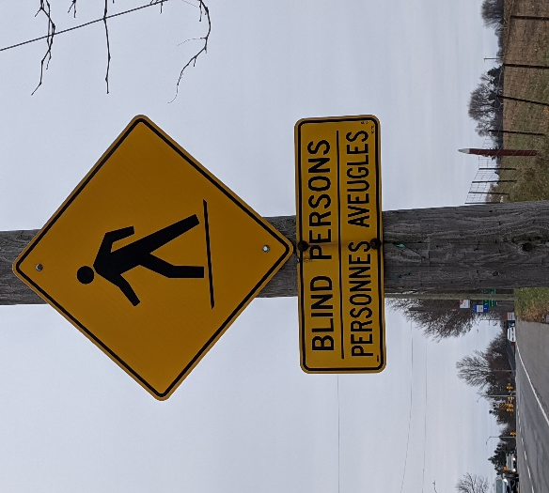
This type of traffic warning sign is not included in The Ministry of Transportation Ontario's Traffic Manual – Book 6 Warning Signs. However, the guidance in Book 6 does provide flexibility to municipalities to customize signs for specific warnings to drivers. Municipalities in Ontario have jurisdiction over their roads and have the authority to determine which warnings signs to install. Common examples of this type of signage include a yellow warning diamond shaped sign that says "Slow, Blind Child Area", "Blind Pedestrian Crossing" or an image of a person using a cane to cross the road.
Example image of blind pedestrian warning sign. Ottawa, ON

The Issue
- People who are blind or partially sighted feel unsafe navigating their neighbourhoods so they request their municipality installs a traffic warning sign in the hope it will change driver behaviour.
- To the best of our knowledge, we are not aware of any research that demonstrates that these signs improve driver behaviour in neighbourhoods where they are installed. Changes to the built environment that make it more accessible (tactile warning surface indicators, accessible pedestrian signals, high contrast between sidewalk and roadway etc.) and also adopting traffic calming methods (changing the environment to create a more calming roadway by adding dividers in the middle of the road, narrowing the street) are tried and tested approaches to improving accessibility and safety.
- These signs run the risk of providing a pedestrian with sight loss a false sense of security when crossing roads and traversing their neighbourhood.
- While these signs might bring comfort to one pedestrian with sight loss, others might feel that these signs are singling them out or make them feel stigmatized.

Recommendations
- The municipality should adopt a complete streets approach when designing traffic infrastructure, and should consult CNIB's Clearing Our Path to learn about guidelines for accessibility to the built environment for pedestrians with sight loss.
- Municipalities should consider the design of communities to maximize walkability for all pedestrians, including vulnerable road users, and should consult people with lived experience.
- Municipalities should also consider adoption of Vision Zero principles when planning street designs or modifications.
- There might be certain circumstances where these signs might be appropriate, such as outside schools for the blind or in remote and rural areas where there is minimal pedestrian infrastructure i.e no sidewalks, intersections. Warning signs, if installed, should be in conjunction with improvements to the built environment where possible.
- If drivers are driving dangerously then the municipality should explore traffic calming strategies.
- People who are blind or partially sighted should contact Vision Loss Rehabilitation Canada or their local post-vision loss rehabilitation provider to conduct an assessment of the individual's O&M skills and of the built environment in their local area. Post-vision loss rehabilitation professionals such as O&M Specialists will be able to provide advice to the individual and to the municipality regarding any necessary changes to the built environment (i.e. traffic calming measures, accessible pedestrian signals, etc.
- Once an O&M has given their professional advice, CNIB Foundation can also assist through its Advocacy Leads who would provide 1:1 self-advocacy support to the individual when dealing with their municipality and other decision makers.
- When these requests are directly received by a municipality, with the affected individual's consent, they should consult with sight loss organizations who can provide support and recommendations as outlined above.

