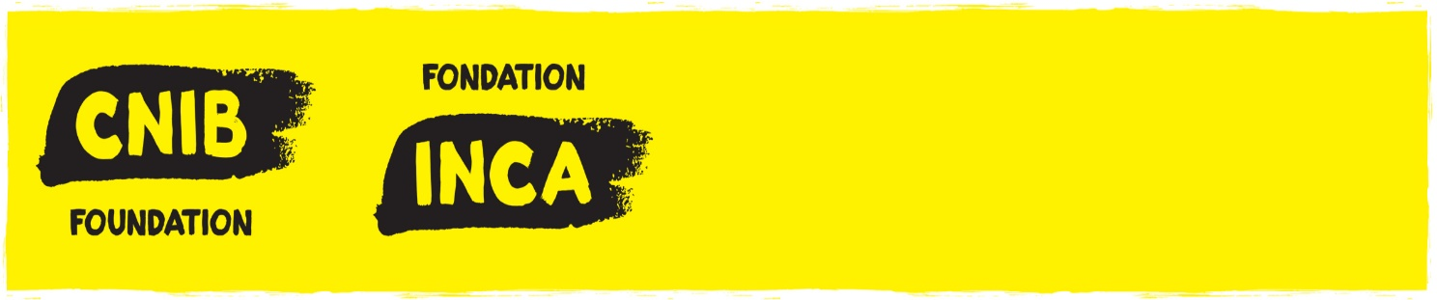

ROSS C. PURSE DOCTORAL FELLOWSHIP

APPLICANT'S NAME:

DEGREES HELD (Indicate the month & year attained, name of program and of University):

ACADEMIC APPOINTMENT or POSITION AT HEALTH FACILITY:

INSTITUTION:

FACULTY:

DEPARTMENT:

ADDRESS:

TELEPHONE:

E-MAIL:

CITZENSHIP:

COMPETITION DATE:

TITLE/NAME OF PROJECT:

ABSTRACT: (A brief, non-technical description of your research in max 500 words, written in simple and clear language suitable for a lay audience. This will be posted on the CNIB website if awarded):

RESEARCH OUTLINE ATTACHMENT:
Complete the following questions on this form. For item 3 (“Outline of proposed program”), please attach a research outline of no more than 10 pages (not including references). Applications that exceed 10 pages will not be considered.

- Indicate which discipline your proposed program is closely related to. If the field of study is multidisciplinary, specify related disciplines.
i) Degree sought:
ii) University to award degree:
iii) Department:
iv) Where will you be during the period for which you are seeking support?
- At the university to award degree:
- Elsewhere (specify):

2. Attach the outline of proposed program which should include:
- Specific interest area within your discipline
- Title of thesis, if known.
- If you are doing course work, please attach a concise statement of how your course work relates to the field of vision loss and how your future doctoral work will orient and contribute to this field of study. If you are writing your doctoral dissertation, please attach a concise statement of how your dissertation is an original addition to the literature and knowledge that currently exists within the field of vision loss.
- Please include approvals by the University and/or REB, if any.
- Indicate what you hope to accomplish during the period for which you
are seeking support.
- Indicate your career aspirations after completion of your graduate or doctoral degree.
- If you have published or co-authored any papers or articles related to your proposed field of study, please include copies with your application.

SIGNATURE OF APPLICANT REQUIRED:
I declare that to the best of my knowledge, the information provided in this application and attachments is true and no material fact has been withheld.

Signature of Applicant: Date:

ADDITIONAL SIGNATURES REQUIRED:

Signature of Dept. Head or Supervisor: Date:

Print Name:
ALL APPLICATIONS MUST BE ACCOMPANIED BY:
- Applicant’s (and if applicable, co-applicants’) complete curriculum vitae and publication list;
- Letter of support from Head of Department and/or Host Research Facility
- Letter from department or health facility verifying academic appointment, or position at health facility, or co-applicants appointment or position;
- Letter of concurrence (if different from home university) from Institute where research will be undertaken;
- A photocopy that indicates proof of citizenship;
- Letter of acceptance from institution where advanced training will be taken;
- Confidential reports from the following persons:
  - Thesis Supervisor or Director of Studies, AND
  - Another faculty member
- Official Transcripts (from University for evidence of applicants’ academic standing).

All applications must be sent by email or regular mail to:
Cheryl-Ann Ali
Executive Assistant
CNIB
1929 Bayview Avenue
Toronto, ON M4G 3E8
E-mail: cheryl-ann.ali@cnib.ca

