CNIB Lake Joe
2020 Program Guide
Enriching lives. Making memories. Building Independence.
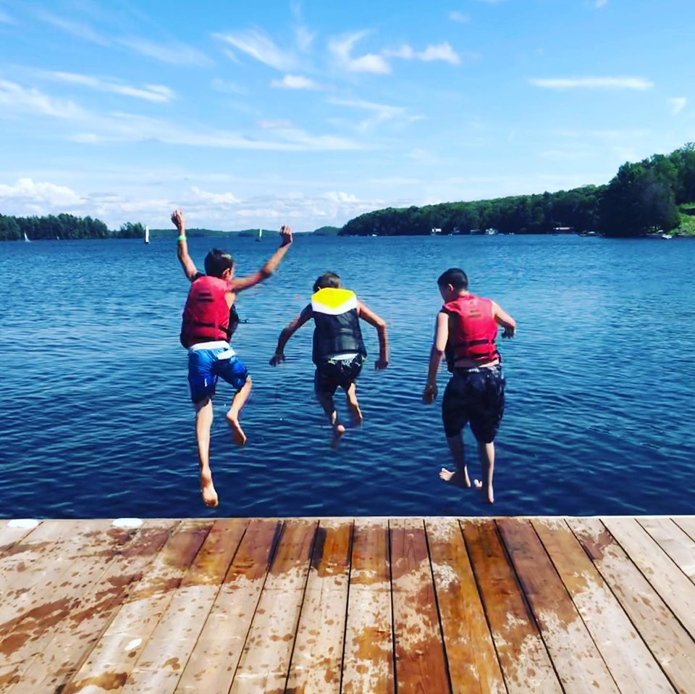
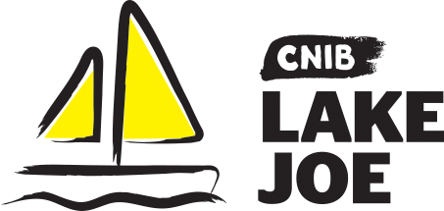

Table of Contents

About CNIB Lake Joe 3
Child & Youth Programs 4
Family Programs 9
Adult Programs 11
Program Summary – by date 13
Program Summary – by age 14
Program Summary – by theme 15
Fee Summary 17
Register Now! 19
Getting to Camp 20

Please note: CNIB Lake Joe may update or make changes to the 2020 schedule. Every effort will be made to keep the programs and fees as represented; however, unforeseen circumstances may result in the substitution or cancellation of a program. We appreciate your understanding and look forward to finding the perfect program for you and your family.

About CNIB Lake Joe

Since 1961, CNIB Lake Joe has been providing a unique blend of recreation and skills development in a safe, inclusive environment. Dedicated to providing enriching experiences for Canadians with sight loss, it's a one-of-a-kind camp in Canada. Located in the heart of Muskoka, CNIB Lake Joe is an accessible lakefront property that stretches over 12.5 acres on the northwest corner of beautiful Lake Joseph. CNIB Lake Joe is proud to be an accredited member of the Ontario Camps Association and an affiliated member of the Lifesaving Society.

Here are just some of the activities you can enjoy at CNIB Lake Joe!

- Make a splash in Lake Joseph: fishing, paddling (canoe, kayak, stand-up paddleboard), pontoon boat cruises, sailing, swimming, tubing, waterskiing, wakeboarding, water sliding
- Get creative: music, pottery, crafts, dancing, talent shows
- Get active: basketball, tennis, volleyball, shuffleboard, mini-golf, tandem-bike riding, archery, hiking, yoga and more
- Learn new skills: in a fun, safe and supportive environment
- Explore Muskoka: on an excursion
- Rest and Relax: enjoy a book by the lake, visit with friends, new and old, around the campfire

To apply, please visit: cniblakejoe.campbrainregistration.com

For more information, contact CNIB Lake Joe:
Email: lakejoe@cnib.ca
Toll Free: 1-877-748-4028
Phone: 705-375-2630
Web: cnib.ca/lakejoe
Address: CNIB Lake Joe, 4 Joe Finley Way, MacTier, ON P0C 1H0

Child & Youth Programs

These programs are open to children and youth with sight loss. Some programs also welcome sighted siblings and friends of those with sight loss.

Northern Exposure (NorEx)
Grades: 6-8
Dates: June 1-4
Northern Exposure (NorEx) is an opportunity for you to engage in activities in a safe, accessible and fun environment that support the learning outcomes of the physical education curriculum. Our skilled staff will provide opportunities for you to push yourself and develop your confidence through sports and recreation, including voyageur and tandem canoeing, archery, tandem-cycling, and sailing. Health and wellness activities will further support your independence and promote healthy living. You may be supported by your itinerant teacher and/or Vision Loss Rehabilitation Canada staff.

Wilderness Immersion for Leadership Development (WILD)
Ages: 15-19
Dates: June 28-July 3
Test your mettle in the wild! Wilderness Immersion for Leadership Development (WILD) is an adventure program where you will work cooperatively with others on a multi-day canoe trip in Algonquin Park. With the assistance of skilled staff, our adventurers will work on outdoor skills like paddling, portaging and camping while gaining valuable lessons on communication, teamwork and problem-solving. You will have the opportunity to take on a high-ropes course to start your adventures.

Note: You will be required to fill out a supplementary application to participate in this program.

Summer Camp
Ages: 8-18
Dates: June 28-July 3
Start the summer off right at our summer camp week! Learn new skills, try new activities and create new friendships, while developing confidence and independence in a safe and supportive environment. This program includes a combination of camp-wide activities as well as individual choice programs, such as archery, court sports, swimming, art, sailing and canoeing. Supported by experienced staff and skilled specialists, this classic camp experience will surely be a highlight of your summer.

Note: Open to children and youth with sight loss and their siblings and friends.

Pushing Limits for Active Youth (PLAY)
Ages: 8-18
Dates: July 26-31
Pushing Limits for Active Youth (PLAY) is for those who want to experience different sports at Lake Joe. From basketball, to archery, to water sports, you will have an opportunity to try a variety of different sports and activities that encourage an active lifestyle. Health and wellness workshops, including independence, healthy eating and personal care, complement this adaptive sports program.

Note: Open to children and youth with sight loss and their siblings and friends.

Camp Abilities at Lake Joe
Ages: 8-18
Dates: July 26-31
This goal-based program is aimed at athletic development. You will receive one-on-one coaching from experts and instructors who will help guide you to achieve your performance goals through specialized sports programs. You will have an opportunity to choose sailing or triathlon (swim, bike, run) for your discipline, culminating in a session-end regatta or triathlon.

Note: Open to children and youth with sight loss and their siblings and friends.

SCORE (Skills, Confidence & Opportunities through
Recreation & Education)
Ages: 15-20
Dates: July 19-31 (at Lake Joe from July 26-31)
CNIB's national SCORE program is a two-week summer experience that combines the joys of camp with excursions and activities geared to helping youth with sight loss learn and develop skills to pursue post-secondary education. The first week is hosted in Toronto with the second week at CNIB Lake Joe. You'll participate in a leadership development program (and receive a certificate upon completion) and take part in fun activities like swimming, rock-wall climbing, tandem biking and water tubing.

Note: You will be required to fill out a supplementary application and participate in an interview with SCORE staff prior to being accepted into this program. For more information, please email Rhonda Underhill-Gray at rhonda.underhill-gray@cnib.ca, or call 1-800-563-2642 or 647-535-8962.

Counsellor in Training (CIT)
Ages: 15-19
Dates: July 26-August 8
Gain job skills while having fun at our two-week program designed to develop leadership skills and empower you to take an active role in camp life. The first week is devoted to leadership workshops and skills development in all areas of camp. From learning about goal setting to childhood development, building campfires to facilitating an activity, this program is designed to help you gain confidence and build the necessary skills to be an active member of the team. You will be paired with a mentor throughout your placement, so you can continue to develop your skills and learn in a hands-on environment.

Note: You will be required to fill out a supplementary application and participate in an interview with program staff prior to being accepted into this program. Successful completion of this program will ensure you receive an interview for future camp staff positions, but it does not guarantee employment.

Canadian Leadership Development Program (CLDP)
Ages: 15-21
Dates: August 10-14
Be the change! Connect with youth from across the country and join the conversation. This program will focus on public speaking, advocacy, critical thinking, self-awareness and personal branding while developing confidence and independence through specialized activities. Working with skilled facilitators, you will have an opportunity to try new things in this fun, safe and supportive environment.

Note: This program is for youth with sight loss.

"Youth programming gave me the opportunity to meet other youth who were visually impaired like me and that's a really strong bond. I'm now looking into college programs for working with children and can happily say and Lake Joe
really helped put me on that path."

Emilee Schevers, CNIB Lake Joe camper and Camp Counsellor

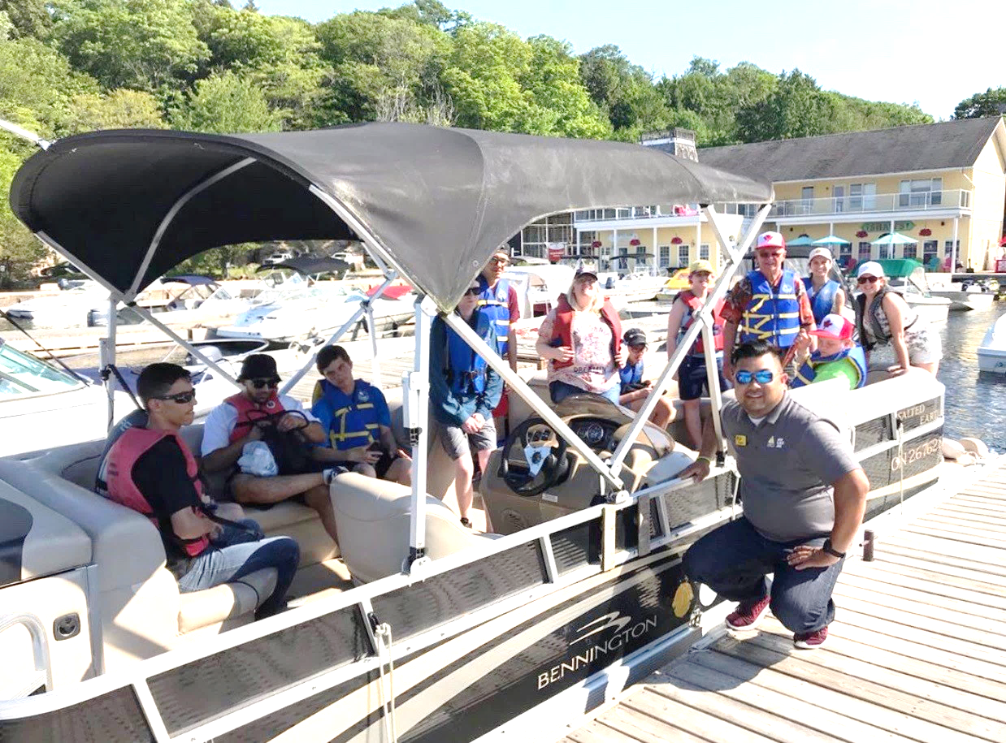
Participants from the 2019 Canadian Leadership Development Program (CLDP) enjoying a pontoon boat ride to Port Carling for ice cream.

Family Programs

Family Weeks 1 & 2
Dates: July 19-25 and August 2-8
Our family program gives you and your family an opportunity to enjoy the beauty of Muskoka together. Go for a dip in the lake, take a tandem bike out for a spin, go fishing, cruise the lake, or relax by the campfire. There's something for everyone! We offer daily kids-camp for children and youth, optional off-site excursions, and adult-only evenings with separate activities for the kids. Family weeks combine the freedom of a cottage or resort with classic summer camp activities for the whole family to enjoy!

New! Family Week 3
Dates: August 23-29
New this year, Family Week 3 will be devoted to families with children who are blind or partially sighted. In addition to the classic camp activities offered during other family weeks, this program will include workshops for parents. Go for a dip in the lake, take a tandem bike for a spin, go fishing, cruise the lake or relax by the campfire. There's something for everyone!

New! Family Fishing Weekend
Dates: October 2-4
In this program, you and your child will be partnered with an angler to explore fishing opportunities in Muskoka! You will learn different techniques and strategies on the hunt for the big one while participating in fun challenges throughout the day. Fish on!

Note: Limited spaces available. The types of fishing boats will vary.
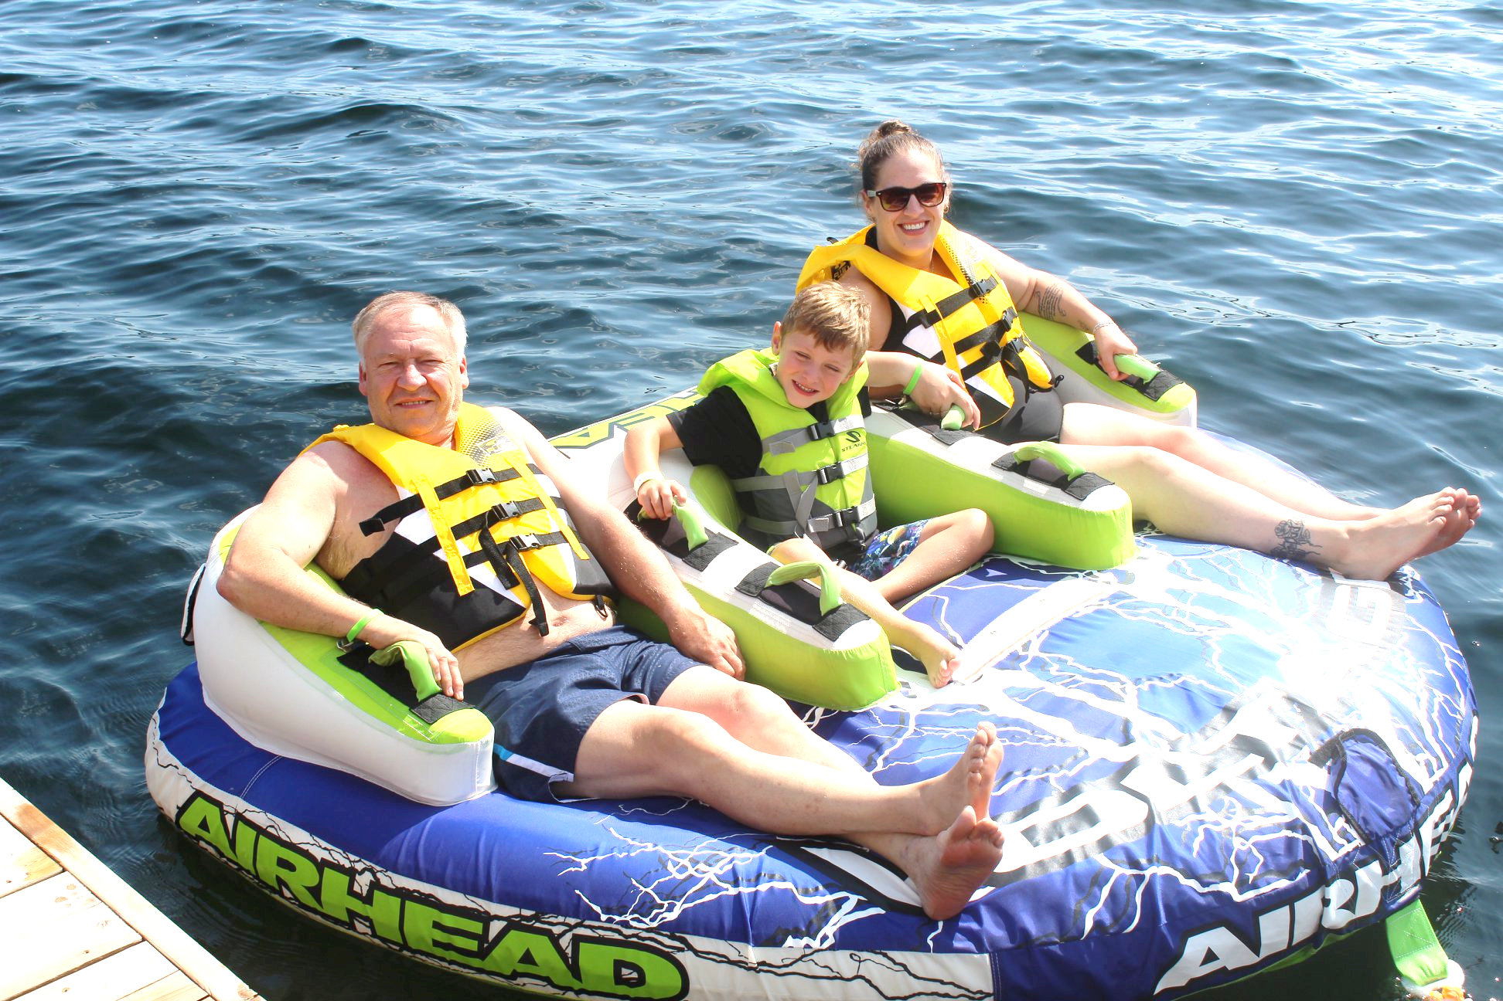
Family fun in the tube!

"I attended Lake Joe for the first time at 12 years old during Family Week. I was given a tour by someone who was partially sighted. Later we noticed someone teaching yoga who was completely blind. I couldn't believe this magical place existed…I thought, "I have finally found my people." I wasn't talking about people who were blind and partially sighted. I was talking about people who were successful, positive and independent. And now I know I can do anything."

Emma Van Dyk, CNIB Lake Joe camper and Camp Counsellor

Adult Programs

New! Adult Adventure Week
Dates: June 15-19
Start your adventure high atop the canopy on a challenge course before you head into the wilderness for a multi-day canoe trip in Algonquin Park. Facilitated by skilled staff, you will paddle, portage, cook outdoors and camp while connecting with nature and other like-minded individuals.

Note: This program requires a degree of fitness. You will be required to fill out a supplementary application and may require a signed letter from a physician to participate.

New! Young Adult Week (ages 19-35)
Dates: June 15-19
Join like-minded young adults on the shores of beautiful Lake Joseph for a chance to relax, unwind and have fun! This five-day, four-night experience will include a combination of workshops, leisure activities and social events. Compete in an Amazing Race, participate in a murder mystery or book club, and enjoy classic summer camp activities in beautiful Muskoka.

Adult Weeks #1, #2, #3
Dates: July 5-11, July 12-18, August 30-September 5
Escape and spend a week on the shores of beautiful Lake Joseph in Muskoka. Whether you are seeking adventure or relaxation, we have something for you. Choose from a variety of on-site activities such as swimming, sailing, fishing, lawn games and art, allowing you to connect with others who have similar interests and experiences. Try out our water slide or try your hand at pizza making in our new outdoor pizza oven. Optional off-site activities available for those who want to explore the area. Enjoy the campfire with friends, new and old. Join us for an unforgettable, life-changing experience this summer!

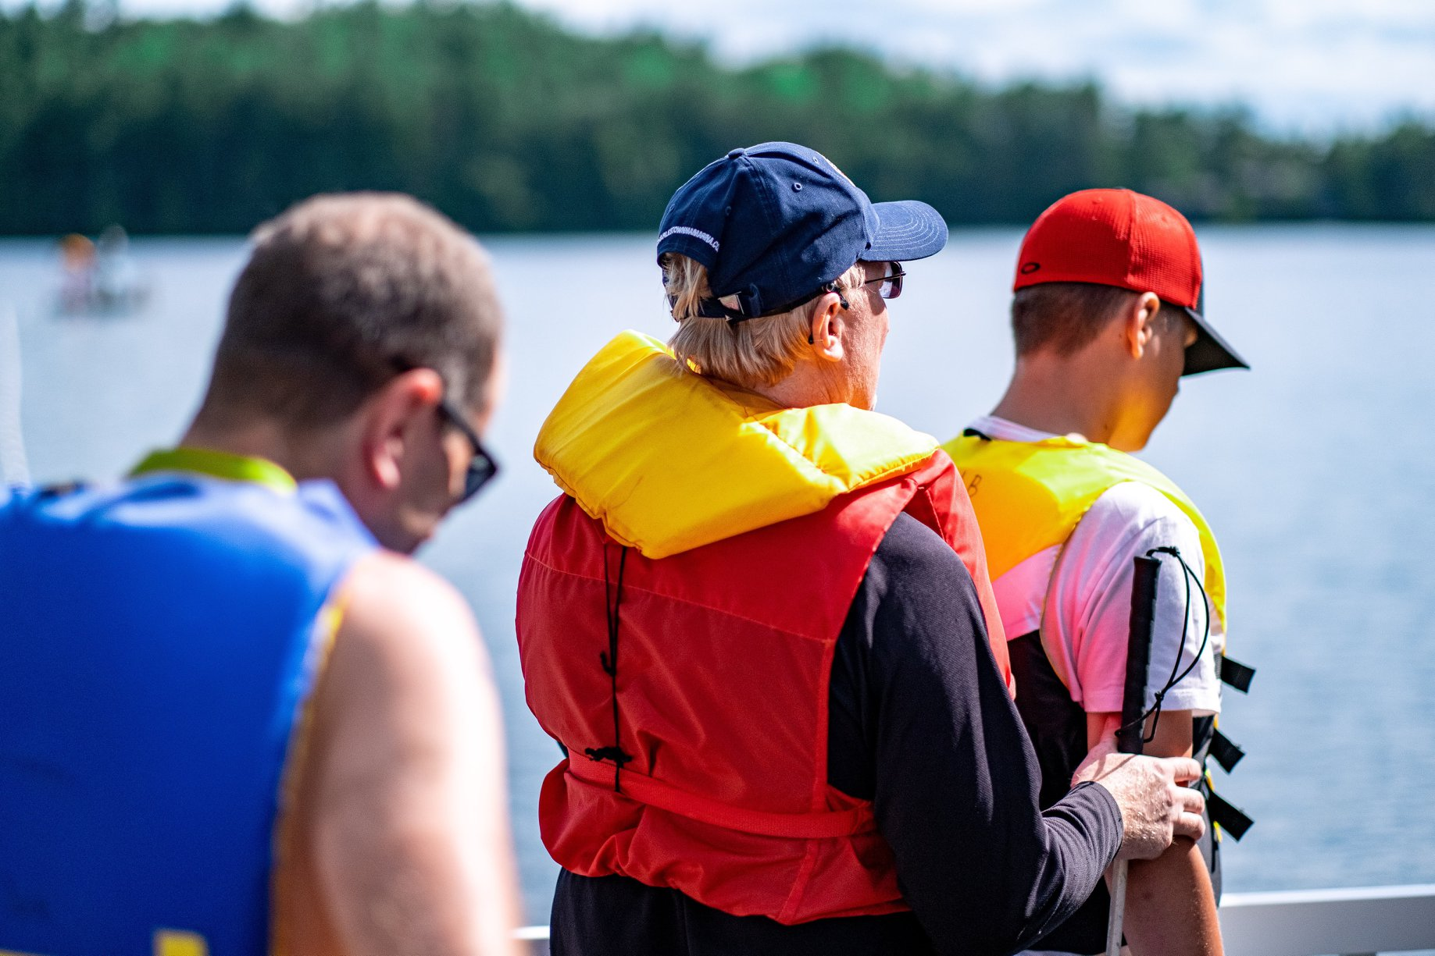

Campers getting ready to go sailing.

Adult Mini-Camp (Summer)
Dates: August 18-22
Enjoy our four-night, five-day adult mini-camp to get a taste of the CNIB Lake Joe experience. Enjoy all the classic summer camp activities like swimming, tubing, tandem biking and campfires. Try out our new water slide, a game of basketball or shuffleboard on the new sports court.

New! Adult Mini-Camp (Fall)
Dates: October 5-9
Fall in Muskoka! What a beautiful time to be at CNIB Lake Joe! Enjoy our four-night, five-day mini-camp to get a taste of the camp experience. Enjoy all the classic camp activities like pontoon cruises, refreshing swims, fall hikes, cozy campfires, and devouring delicious treats from our brand-new outdoor pizza oven.

Program Summary – by date

June
- June 1-4 – Northern Exposure (grades 6-8)
- June 15-19 – Adult Adventure Week (age 19+)
- June 15-19 – Young Adult Week (ages 19-35)
- June 28-July 3 – Summer Camp (ages 8-18)
- June 28-July 3 – WILD (ages 15-19)

July
- July 5-11 – Adult Week #1 (age 19+)
- July 12-18 – Adult Week #2 (age 19+)
- July 19-25 – Family Week #1 3 (all ages)
- July 26-31 – Camp Abilities (ages 8-18)
- July 26-31 – PLAY (ages 8-18)
- July 26-31 – SCORE (ages 15-20)
- July 26-Aug 8 – CIT (ages 15-19)

August & September
- August 2-8 – Family Week #2 (all ages)
- August 10-14 – CLDP (ages 15-21)
- August 18-22 – Adult Mini-Camp - Summer (age 19+)
- August 23-29 – Family Week #3 (all ages)
- August 30-Sept 5 – Adult Week #3 (age 19+)

October
- October 2-4 – Family Fishing Weekend 3 (all ages)
- October 5-9 – Adult Mini-Camp – Fall (age 19+)

Program Summary – by age

Children (8-18)
- Northern Exposure (grades 6-8), June 1-4
- Summer Camp (ages 8-18), June 28-July 3
- PLAY (ages 8-18), July 26-31
- Camp Abilities (ages 8-18), July 26-31

Teens & Youth (12-21)
- Summer Camp (ages 8-18), June 28-July 3
- PLAY (ages 8-18), July 26-31
- Camp Abilities (ages 8-18), July 26-31
- WILD (ages 15-19), June 28-July 3
- SCORE (ages 15-20), July 26-31
- Canadian Leadership Development Program (ages 15-21), Aug 10-14
- Counsellor In Training (ages 15-19), July 26-Aug 8

Adults (19+)
- Young Adult Week (ages 19-35), June 15-19
- Adult Adventure Week, June 15-19
- Adult Week #1, July 5-11
- Adult Week #2, July 12-18
- Adult Week #3, Aug 30-Sept 5
- Adult Mini-Camp - Summer, Aug 18-22
- Adult Mini-Camp - Fall, Oct 5-9

All Ages (adult + child)
- Family Week #1, July 19-25
- Family Week #2, Aug 2-8
- Family Week #3, Aug 23-29
- Family Fishing Weekend, Oct 2-4

Program Summary – by theme

Adventure
- Adult Adventure Week, June 15-19
- WILD (ages15-19), June 28-July 3
- Family Fishing Weekend, Oct 2-4

Athletic/Sports Skill-building/Outdoor "Active" focus
- Northern Exposure (grades 6-8), June 1-4
- Adult Adventure Week, June 15-19
- WILD (ages 15-19), June 28-July 3
- PLAY (ages 8-18), July 26-31
- Camp Abilities (ages 8-18), July 26-31
- Family Fishing Weekend, Oct 2-4

"Classic" Camps
- Young Adult Week (ages 19-35), June 15-19
- Summer Camp (ages 8-18), June 28-July 3
- Young Adult Week (ages 19-35), June 15-19
- Adult Week #1, July 5-11
- Adult Week #2, July 12-18
- Adult Week #3, Aug 30-Sept 5
- Adult Mini-Camp - Summer, Aug 18-22
- Family Week #1, July 19-25
- Family Week #2, Aug 2-8
- Family Week #3, Aug 23-29
- Adult Mini-Camp - Fall, Oct 5-9

Mini-Camps
- Adult Mini-Camp - Summer, Aug 18-22
- Adult Mini-Camp - Fall, Oct 5-9
Youth Leadership
- SCORE (ages 15-20), July 26-31
- Counsellor in Training (ages 15-19), July 26-Aug 8
- Canadian Leadership Development Program (ages 15-21), Aug 10-14

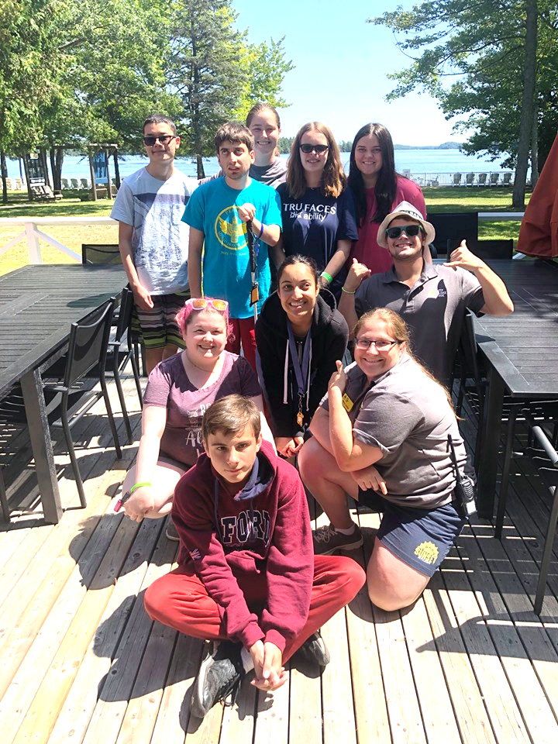
Participants from the Counsellor in Training Program 2019 posing on the deck at CNIB Lake Joe.

Fee Summary

All camp experiences include meals, shared accommodations, and all on-site programs and activities (optional offsite excursions have an additional charge). Thanks to the generosity of CNIB Foundation supporters, camp registration fees are highly subsidized to keep camp fees as low as possible. Further subsidies are available for those who qualify.

Children & Youth Programs
Northern Exposure (grades 6-8)  June 1-4 | Call for details
Summer Camp (ages 8-18)  June 28-July 3 | $460
WILD (ages 15-19)  June 28-July 3 | $600
PLAY (ages 8-18)  July 26-31 | $460
Camp Abilities (ages 8-18)  July 26-31 | $460
SCORE (ages 15-20)  July 26-31 | Call the Rhonda Underhill-Gray at 1-800-563-2642 or 647-535-8962.
Counsellor in Training (ages 15-19)  July 26-Aug 8 | $900
Canadian Leadership Development Program (ages 15-21)  Aug 10-14 | $360

Family Programs
Family Weeks  - #1, July 19-25  - #2, Aug 2-8  - #3, Aug 23-29 | Call for details
Family Fishing Weekend  Oct 2-4 | Call for details

Adult Programs
Young Adult Week (ages 19-35)  June 15-19 | $460
Adult Adventure Week  June 15-19 | $600
Adult Weeks  - #1, July 5-11  - #2, July 12-18  - #3, Aug 30-Sept 5 | $690
Adult Mini-Camps  - Summer, Aug 18-22  - Fall, Oct 5-9 | $460

Register Now!

We take the time to get to know you and are here to answer your questions. Register now and experience the 'magic of camp' at CNIB Lake Joe. We will work with you to ensure every detail is considered:
- accommodation needs
- dietary requirements
- special medical supports
- transportation
- and more!
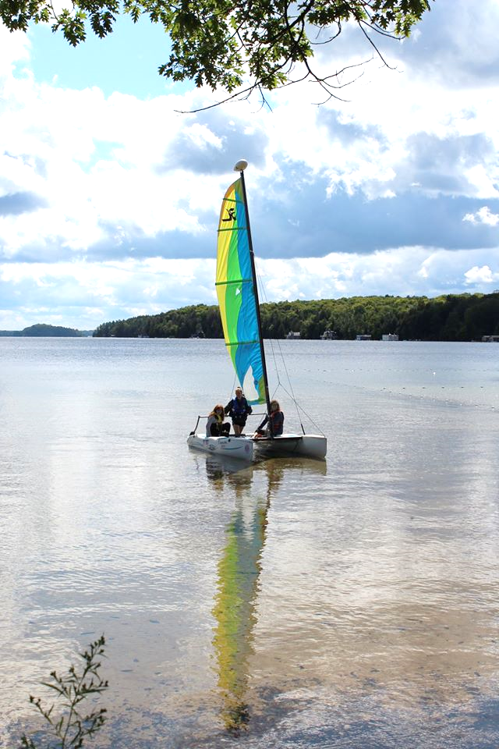
For more information, visit cnib.ca/lakejoe, email lakejoe@cnib.ca, or call
1-877-748-4028 or 705-375-2630.

To register, please visit: cniblakejoe.campbrainregistration.com

Getting to Camp

We welcome guests from across Canada and around the world!

CNIB Lake Joe is located at: 4 Joe Finley Way, MacTier, ON P0C 1H0

Arriving by Car?

Directions from Toronto/Southern Ontario*
- Take Hwy 400 north just past Barrie to Hwy 400 extension (formerly Hwy 69)
- Continue north on Hwy 400 to exit 189 for ON-69 toward MacTier/Gravenhurst
- Merge onto Lake Joseph Road (formerly Hwy 69) past Hwy 169
- Turn right onto Joe Finley Way

*GPS often provides directions to take Hwy 407 toll road. The toll road saves approximately 10 minutes from the drive (approx. 2 hours), but at a cost. Please check a website like mapquest.ca for directions or remember to adjust GPS settings.

Directions from Northern Ontario
- Take Hwy 69 south to Hwy 400 south
- Continue south on Hwy 400 to exit 207 for ON-69 toward MacTier/Gravenhurst
- Merge onto Lake Joseph Road (formerly Hwy 69)
- Turn left onto Joe Finley Way

Directions from Eastern Ontario
- Take Hwy 417 west to Bruce St/County Road 20 to Hwy 60 west
- Continue on Hwy 60 and merge onto Hwy 11 south
- Take exit 219 for Muskoka Rd 3 toward Huntsville/Aspdin
- Turn right onto Aspdin Rd/Muskoka District Road 3 (Regional Road 3 W)
- Turn right onto Hwy 141 west and turn left onto Lake Joseph Rd (formerly Hwy 69)
- Turn left onto Joe Finley Way
Parking is free but limited. Please park in one of the designated parking spaces.

Do You Need Transportation?

We are pleased to work with you to provide transportation from Pearson International Airport and Union Station in Toronto, as well as other cities within Ontario. Additional fees may apply.

Once at CNIB Lake Joe, simply head to the Welcome Centre to check-in and receive your room key. We are waiting for you!

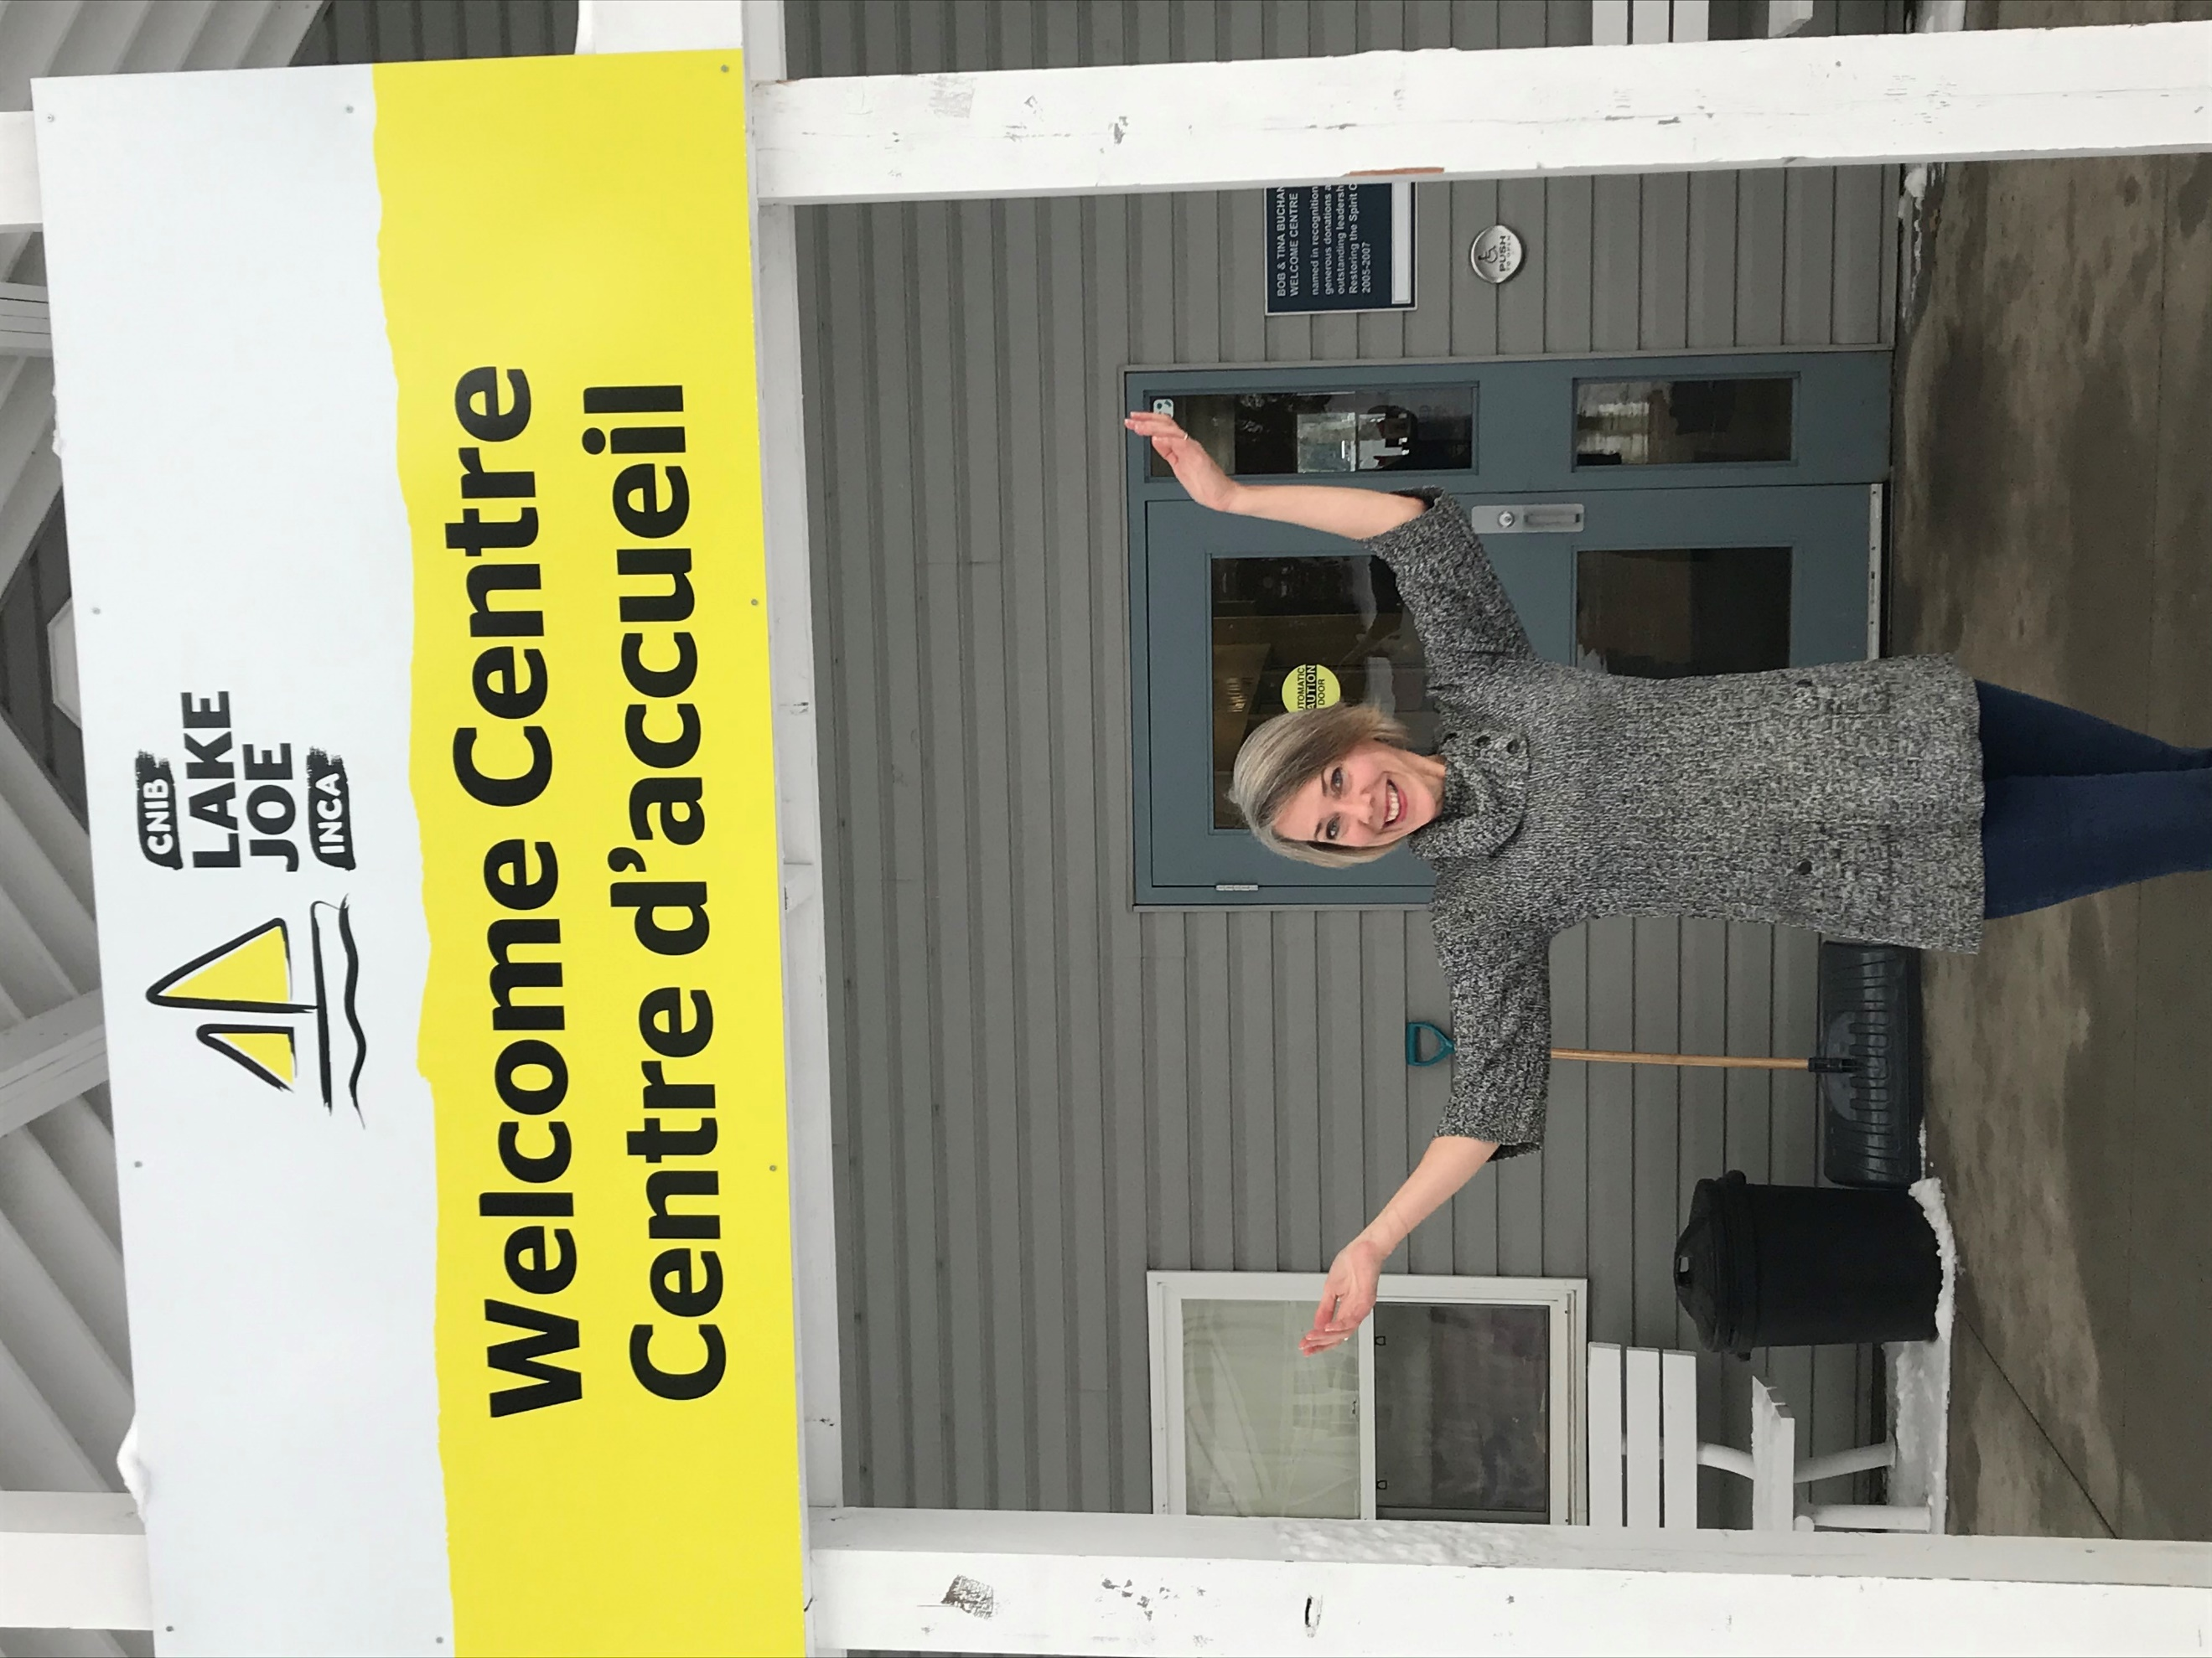

One More Thing…

We can’t wait to welcome you to CNIB Lake Joe as our guest, but there are so many ways to enjoy CNIB Lake Joe:

- Join our staff team
- Volunteer at Lake Joe
- Attend an event (visit cnib.ca/lakejoe for upcoming events)
- Donate
- Subscribe to the Lake Joe e-newsletter
- Follow us on Facebook and Instagram

For more information, visit cnib.ca/lakejoe, email lakejoe@cnib.ca, or call
1-877-748-4028 or 705-375-2630.

CNIB Lake Joe
4 Joe Finley Way
MacTier, ON P0C 1H0
Web: cnib.ca/lakejoe
Email: lakejoe@cnib.ca
Toll Free: 1-877-748-4028
Phone: 705-375-2630

