The Built Environment
Know Your Rights – Legal Information Handbook

Last Reviewed on September 2019
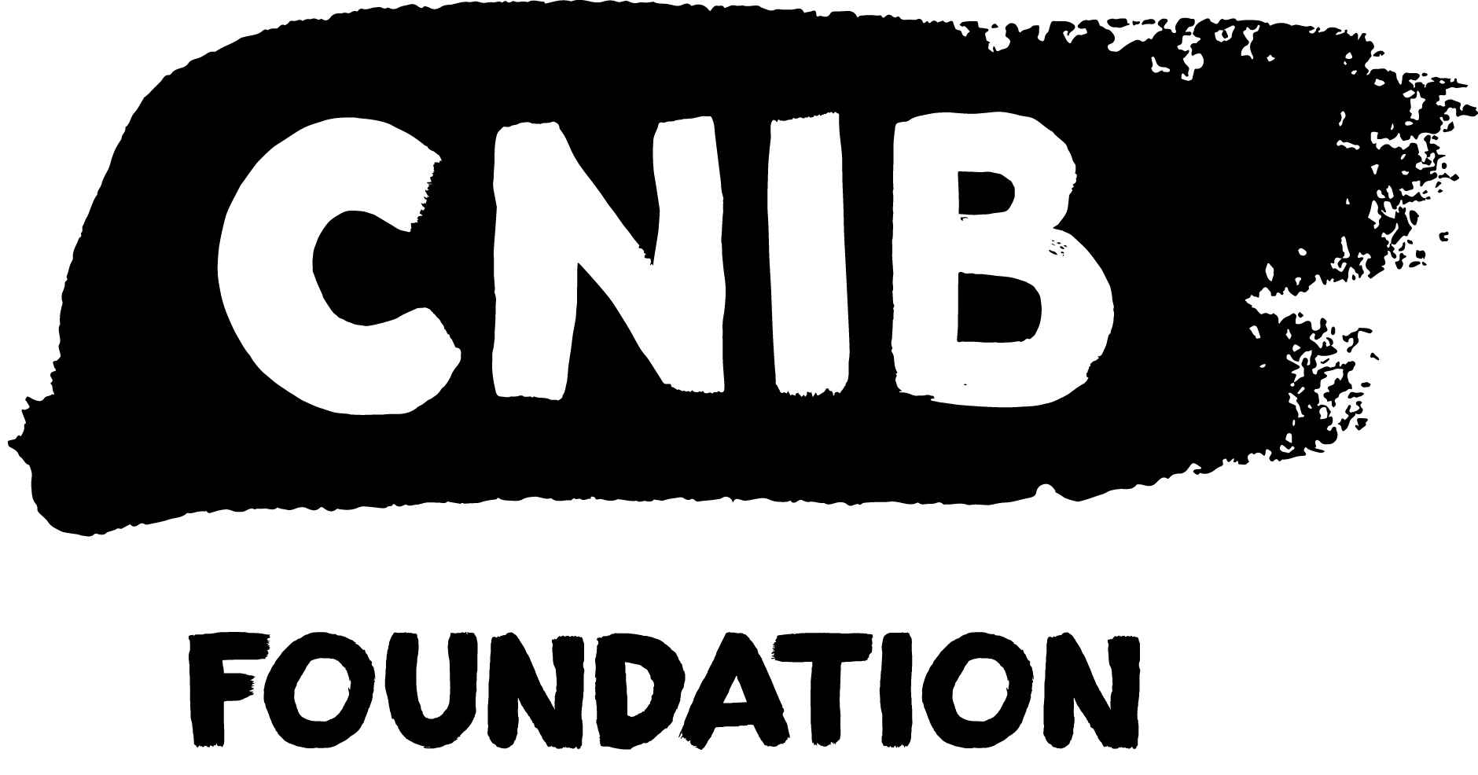
Disclaimer
This content is provided as general information and is not legal advice. If you need advice about a specific legal problem, contact a lawyer or a community legal clinic.
Acknowledgements
Thank you to the many volunteers and institutional collaborators who contributed to developing this legal information handbook. To learn more about the Know Your Rights project, please visit us online.
Thank you to the Law Foundation of Ontario for making the Know Your Rights project possible. While financially supported by The Law Foundation of Ontario, the CNIB is solely responsible for all content.
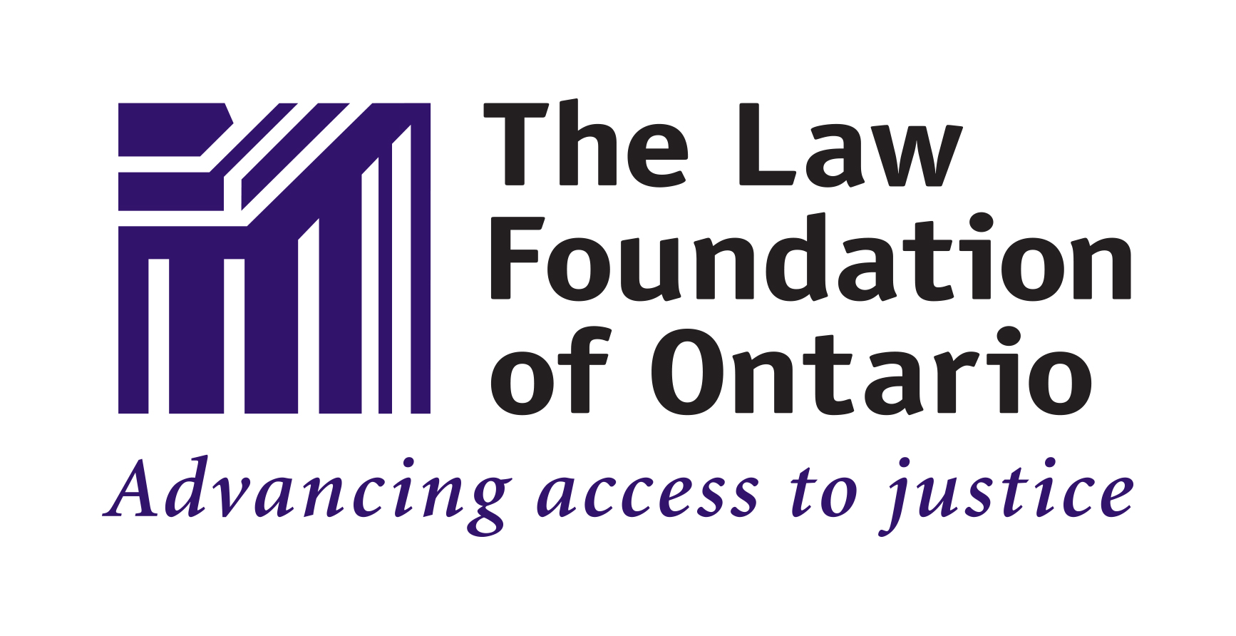

Table of Contents
My Legal Rights 5
Q: What is the "built environment"? 5
Q: What legal rights do I have when it comes to accessing the built environment in Ontario? 5
Duty to Accommodate & Undue Hardship 5
Q: Where do my legal rights come from? 6
Q: Who must comply with Ontario laws relating to the built environment? 7
Q: What can I do to enforce my legal rights? 7
Common Scenarios 9
Outdoor Spaces 9
Q: The Accessible Pedestrian Signal (APS) at a crosswalk isn't working. What can I do? 9
Q: An outdoor public space that I often use (for example, an outdoor eating area, park, trail, or parking lot) has features that are hazardous and inaccessible. What can I do? 9
Inside Buildings 11
Q: Due to my sight loss, I sometimes have difficulty orienting myself in buildings. What can I do? 11
Q: The elevator that I use in a building doesn't have accessible buttons. What can I do? 11
Construction & Hazards 12
Q: Temporary construction barriers are obstructing a sidewalk/building entrance that I commonly use. I do not feel safe navigating through the construction site. What can I do? 12
Q: I’m unable to use a sidewalk because it is blocked by a hazard. What can I do? 13
Getting Help 14
CNIB Services 14
Vision Loss Rehabilitation Ontario 14
CNIB's Guide Dog Program 14
CNIB's Advocacy Team 14
Legal Services 15
Legal Aid Ontario 15
Ontario’s Community Legal Clinics 15
Pro Bono Ontario 15
The Human Rights Legal Support Centre 15
ARCH Disability Law Centre 16
Wayfinding Tools 16
More Resources 17
Access Forward 17
All Access Toolkit 17
CNIB Clearing Our Path 17

My Legal Rights

Q: What is the "built environment"?
A: The term "built environment" refers to the many kinds of places, structures and facilities that we live in or use. Examples of the built environment include cities, towns, neighbourhoods and all kinds of buildings, urban spaces, parks, roads, and walkways.
To learn more about your legal rights related to housing specifically, please see the Housing section of the Know Your Rights website.

Q: What legal rights do I have when it comes to accessing the built environment in Ontario?
A: Under Ontario laws, people with disabilities have important legal rights when it comes to accessing the built environment:
- You have the right to have an equal level of access as anyone else to most public places in the built environment, without discrimination because of your disability.
- In many cases, you have the right to receive accommodations for your disability from the person or organization who is responsible for the public place, up to the point of undue hardship.
- You cannot be denied services or denied access to spaces that are normally available to the public because you are accompanied by a guide dog

Duty to Accommodate & Undue Hardship
If a person or organization has a “duty to accommodate”, it means that they are legally required to provide you with the supports you need to have an equal level of access to a public building or space. However, the duty to accommodate has a limit and this limit is called "undue hardship."
“Undue hardship” is a legal term. It means that if an organization can show that it is very difficult for them to provide you with a certain type of accommodation (because of high costs or health and safety risks), then they don’t have to provide it.
It’s usually difficult for an organization to claim undue hardship because they have to show clear evidence of undue hardship. Their evidence can only relate to these two factors:
1. Whether the cost of this type of accommodation is so high that it will significantly interfere with their ability to operate their business. When calculating cost, they must also consider outside sources of funding, e.g. grants or subsidies from government programs.
2. Whether this type of accommodation is going to create serious health and safety risks for their operations.
Even if an organization shows that a certain type of accommodation will create undue hardship for them, they still have a legal duty to provide you with the next best type of accommodation.

Q: Where do my legal rights come from?
A: Your legal rights come from a variety of different laws, including:
- Ontario’s Human Rights Code which prohibits discrimination based on disability in most areas of public life, including places where “goods, services or facilities” are provided to the public. Note that the term “facilities” includes locations like public parks, recreation centres, malls, stores, government buildings, etc.
- The Blind Persons' Rights Act which prevents discrimination against people who have guide dogs.
- The Accessibility for Ontarians with Disabilities Act which requires almost all organizations in Ontario to meet minimum accessibility requirements when providing services. For more information about the Accessibility for Ontarians with Disabilities Act, see the Essential Legal Information Handbook.
These laws may also be relevant to your situation:
- Municipal bylaws
- The Building Code Act which governs the construction, renovation and change-of-use to buildings in Ontario. The Building Code Act also sets out accessibility requirements for new buildings and for major renovations of existing buildings.
- The Planning Act which governs land use planning in Ontario

Q: Who must comply with Ontario laws relating to the built environment?
A: People and all kinds of organizations that build, maintain or provide services in the built environment in Ontario, including:
- Individual owners and employees
- Private businesses and non-profits
- Government organizations like municipalities, ministries, and agencies

Q: What can I do to enforce my legal rights?
A: If you feel you have been unfairly discriminated against when accessing or trying to access part of the built environment, there are things you can do to stand up for yourself.
In general, you should first try to resolve your concerns by speaking with the people and organizations who are directly involved in an informal and collaborative way.
For more resources on self-advocacy, please visit the Self-Advocacy section of the Know Your Rights website.
If your concerns can’t be addressed through collaborative discussions, you should consider consulting with a lawyer to see if any of the following options are appropriate:
- An application to the Human Rights Tribunal of Ontario
- A claim before an Ontario Court
- In some circumstances, a report to a municipal bylaw enforcement officer may be appropriate as well. CNIB can assist you in connecting with the relevant municipal department.
- A complaint with the police who have the authority to investigate violations of the Blind Person’s Rights Act
The Blind Person’s Rights Act says that you cannot be denied services or denied access to spaces that are normally available to the public because you are accompanied by a guide dog

Common Scenarios
Even though there are laws to protect you from discrimination, people with disabilities still face barriers to having an equal level of access to the built environment.
This section describes barriers that are commonly experienced and suggests practical next steps. Keep in mind that, in most situations, you should first try to resolve your concerns by speaking with the people who are directly involved in an informal and collaborative way.

Outdoor Spaces

Q: The Accessible Pedestrian Signal (APS) at a crosswalk isn't working. What can I do?
A: If you find an APS that’s not working, consider reporting the problem to your municipality. Municipalities are responsible for making repairs to traffic lights and APS systems. Many cities and towns have a person responsible for accessibility who can assist you. When you speak with a customer service representative, explain that you want to speak with someone about a potentially hazardous accessibility issue in a public space.
If an urgent repair is required, many cities have an emergency repair phone line that you can contact for immediate assistance. For example, 3-1-1 is the emergency repair line for Greater Sudbury, Halton Region, Peel Region, Ottawa, Toronto, and Windsor.

Q: An outdoor public space that I often use (for example, an outdoor eating area, park, trail, or parking lot) has features that are hazardous and inaccessible. What can I do?
A: Since the laws about accessibility in outdoor public spaces are complex, you’ll likely need to get help from a legal professional to know what your legal rights are in this type of situation. That said, there are some steps you can begin to take on your own.
First, try to find out what organization owns or manages the outdoor space. For example, if you are concerned about areas inside of a local park that are inaccessible, try to find out whether the park is owned by your municipality, a government agency or some other organization.
Second, try to find out:
- when the outdoor space was built;
- when it last had major renovations; and
- whether any major renovations are planned for the future.
This information can help a legal professional determine what your legal rights are.
In general, two important laws are likely to apply to an outdoor public space:
- the Accessibility for Ontarians with Disabilities Act has specific requirements related to outdoor public spaces. However, these requirements only apply to certain organizations and may only apply if an outdoor space was newly built (or had major renovations done) after 2015.
- Ontario’s Human Rights Code requires organizations that provide services to the public to make reasonable accommodations for your disability, up to the point of undue hardship, so that you can receive an equal level of service as anyone else.
A legal professional can determine if and how these laws apply to your specific situation.
Keep in mind in that effective self-advocacy does not always have to include forcefully asserting your legal rights. Community organizations, like the CNIB, may have advocacy experience with the issue you’re facing and may be able to support you in developing an advocacy plan or helping you speak with the owners of an outdoor space in a collaborative way.

Inside Buildings

Q: Due to my sight loss, I sometimes have difficulty orienting myself in buildings. What can I do?
A: There are now many technological tools that can help people navigate and orient themselves within buildings. If these kinds of technological tools don’t meet your needs, you should approach an employee or manager of the building for assistance.
When you speak with an employee or manager, explain that you are having trouble with navigation or orientation inside the building because of your sight loss. Explain what assistance you require in as much detail as possible. When you disclose your disability to an employee, you trigger that organization’s legal duty to accommodate you to the point of undue hardship.
If the employee or manager is reluctant or refuses to accommodate you, you can politely remind them that they have a duty to provide you with reasonable accommodations so that you’re able to experience an equal level of service as anyone else.
If this does not help, you can gradually escalate your complaint – for example, through an official complaint process or to an organization’s management team. Many government organizations and large private companies have a designated person responsible for accessibility who can assist you.
If your concerns are still not addressed, you should consider consulting with a human rights lawyer to see what options you have.

Q: The elevator that I use in a building doesn't have accessible buttons. What can I do?
A: There are now many technological tools that can help people use services, like an elevator, that might be otherwise inaccessible. If these kinds of technological tools don’t meet your needs, your next steps will likely depend on how often you use this particular elevator.
If you use the elevator only rarely (for example, if you are visiting the building for a one-time meeting) consider asking for help from those around you to locate building staff, like a security guard, employee, or building manager. When you speak with building staff, explain that you are having trouble with the elevator because of your sight loss. Explain what assistance you require in as much detail as possible. When you disclose your disability to an employee, you trigger that organization’s legal duty to accommodate you to the point of undue hardship.
If you use the elevator more frequently (for example, you often have business meetings in a particular building), consider contacting building management directly to explore options for ongoing accommodation. If this does not help, you can gradually escalate your complaint – for example, through an official complaint process or to an organization’s management team. Many government organizations and large private companies have a designated person responsible for accessibility who can assist you.
Note: Ontario’s Building Code Act sets out accessibility requirements for elevators that must be followed when constructing new buildings and when making major renovations to old buildings. Unfortunately, if an elevator is relatively old and no major renovations are scheduled, then the accessibility requirements under the Building Code Act may not apply.

Construction & Hazards

Q: Temporary construction barriers are obstructing a sidewalk/building entrance that I commonly use. I do not feel safe navigating through the construction site. What can I do?
A: Since the laws about accessibility around construction sites are complex, you’ll likely need to get help from a legal professional to know what your legal rights are in this type of situation. That said, there are some steps you can begin to take on your own.
First, try to find out what organizations are involved in the construction – for example, the name of the construction company and the name of the building’s owner or manager. Other organizations might also be relevant to your situation:
- If the building is your place of work, your employer may have a duty to help you secure an appropriate accommodation.
- If you visit the building to access a particular store or service, that service provider may have a duty to help you secure an appropriate accommodation.
Second, consider contacting your city clerk's office or your local city or town hall to learn more about bylaw or building permit requirements related to accessibility around construction sites. For example, there may be requirements related to:
- notification of sidewalk closures
- compliance with municipal accessibility design standards related to pedestrian safety
- compliance with Ontario Traffic Manual Book 7 pedestrian safety considerations
This information can help a legal professional determine what laws apply to your specific situation.
Keep in mind in that effective self-advocacy does not always have to include forcefully asserting your legal rights. Community organizations, like the CNIB, may have advocacy experience with the issue you’re facing and may be able to support you in developing an advocacy plan or helping you speak with the owners of an outdoor space in a collaborative way.

Q: I’m unable to use a sidewalk because it is blocked by a hazard. What can I do?
A: Where immediate service is needed to fix a hazard (like snow removal, sidewalk damage, tree removal, serious damage etc.), many cities have emergency lines that you can contact for assistance.
For example, the emergency repair line for Greater Sudbury, Halton Region, Peel Region, Ottawa, Toronto and Windsor is 3-1-1.
If your city doesn’t have an emergency repair line, contact your city clerk's office or your local city or town hall. Many cities and towns have a person responsible for accessibility who can assist you.
If this is a systemic problem, community organizations, like the CNIB, may have advocacy experience with the issue you’re facing and may be able to support you in developing an advocacy plan or helping you speak with the municipality (or other organization) in a collaborative way.

Getting Help

CNIB Services
We’re here to help – contact CNIB for more services, support and resources. Some ways we can assist include:

Vision Loss Rehabilitation Ontario
Vision Loss Rehabilitation Ontario (VLRO) provides people with the practical skills they need to live safely and independently, including navigating the built environment. For example:
- Guiding techniques: a comfortable way to walk with a sighted person and the ability to use remaining vision and other senses to travel
- Using a white cane and other mobility tools
- Finding and crossing intersections
- Navigating new environments like a workplace or school campus
You can learn more about Vision Loss Rehabilitation Ontario by visiting their Frequently Asked Questions page.

CNIB's Guide Dog Program
CNIB’s Guide Dog Program can assist guide dog handlers with advocating for themselves and understanding their rights when navigating the built environment. They can also provide public education to organizations through guide dog ambassador speaking engagements, lunch and learns, etc.

CNIB's Advocacy Team
CNIB's Advocacy Team can assist clients with advocating for themselves and understanding their rights related to the built environment.

Legal Services

Legal Aid Ontario
Legal Aid Ontario provides legal services to low-income Ontarians. In order to receive services from Legal Aid Ontario:
- You must meet their financially eligibility criteria; and
- Your problem must fall in one of these areas: domestic violence, family law, immigration and refugee law, criminal law, or poverty law.
Even if you don’t meet these two requirements, you can call Legal Aid Ontario’s toll-free hotline and a representative can refer you to other organizations or agencies that can help you with your legal problem.

Ontario’s Community Legal Clinics
In Ontario, legal help is available to people with low-income through 73 independent community legal clinics, including 13 specialty clinics. To get the contact information for your regional community clinic, visit this website.

Pro Bono Ontario
Pro Bono Ontario is a non-profit that provides a toll-free legal advice hotline to help people with their legal needs. By calling their hotline, you can speak to a lawyer for 30 minutes about a civil law matter (they do not provide advice for problems related to family law or criminal law)

The Human Rights Legal Support Centre
The Human Rights Legal Support Centre (also known as HRLSC) is an independent agency, funded by the government of Ontario, to provide legal services to individuals who have experienced discrimination. They have a toll-free hotline where you can get:
- Legal assistance in completing an application to the Human Rights Tribunal of Ontario
- Legal advice about how to address the discrimination that you experienced

ARCH Disability Law Centre
ARCH Disability Law Centre (also called ARCH) is a specialty legal clinic that practices exclusively in disability rights law. ARCH has a toll-free hotline where you can get:
- up to 30 min of free, confidential legal advice
- referrals to organizations that can provide you with further help
If you meet certain criteria, ARCH may be able to provide you with additional legal services.

Wayfinding Tools
The following resources provide more information about technological tools that assist with navigation and orientation:
- Blind Square is a GPS-app developed for people with sight loss that describes the environment and announces points of interest and street intersections.
- Key 2 Access is a pedestrian mobility app that allows users to wirelessly request crossing at intersections without having to locate the button on the pole. It also allows users to wirelessly open doors and obtain information regarding indoor spaces.
- Access Now is a map application that shares accessibility information for locations based on users' feedback.
- Be My Eyes is a volunteer-based app that connects people with sight loss to sighted volunteers, who can assist with tasks such as checking expiry dates, distinguishing colours, reading instructions or navigating new surroundings.
- The American Foundation for the Blind provides an overview of some of the apps that are available to assist consumers with reading product labels, menus, etc.

More Resources

Access Forward
The Access Forward website offers free training modules for service providers (including organizations that own or manage public spaces) on their obligations under the Accessibility for Ontarians with Disabilities Act. It was created in partnership with the Government of Ontario to assist organizations with meeting the training requirements under the Accessibility for Ontarians with Disabilities Act. To learn more about the legal force of the Accessibility for Ontarians with Disabilities Act standards, please see the Know Your Rights – Essential Information Handbook.

All Access Toolkit
The All Access Toolkit is a valuable resource to assist property owners, designers, planners and municipalities with understanding and implementing the design requirements of the Accessibility for Ontarians with Disabilities Act.

CNIB Clearing Our Path
CNIB Clearing Our Path is a manual for architects, designers, building owners, planners, standard bodies and others interested in making indoor and outdoor spaces universally accessible.

Web / Site Web : cnib.ca / inca.ca
Email / Courriel : info@cnib.ca / info@inca.ca
Toll Free / Sans frais : 1-800-563-2624

