BEGIN PRODUCER’S NOTE:
In this document, icons are reproduced by their meaning in brackets.
END PRODUCER’S NOTE.

BEGIN COVER PAGE

Guide to the federal election

FEDERAL ELECTION / MONDAY, OCTOBER 21
#ItsOurVote
[Twitter]
[Facebook]
[Instagram]
[YouTube]
[LinkedIn]

Visit elections.ca for the official information you need to vote

1-800-463-6868
elections.ca
TTY 1-800-361-8935

EC 90334 (08/2019)

BEGIN LOGO:
Elections Canada
END LOGO.

PRINT PAGE 1

Voter’s checklist

□ Make sure you’re registered at your current address

□ Watch for your voter information card in the mail

□ Make a plan to vote
At your assigned polling station on election day, October 21

At your assigned polling station on advance polling days, October 11, 12, 13 or 14

At any Elections Canada office across Canada, before October 15, 6:00 p.m.

By mail: visit elections.ca to find out more (deadlines apply)

□ Find out who the candidates are in your riding

□ Bring ID when you go to vote

This brochure is available in multiple languages at elections.ca.
For other formats, such as braille, large print and audio, call us.

Visit elections.ca for the official information you need to vote

1-800-463-6868
elections.ca
TTY 1-800-361-8935

PRINT PAGE 2

The federal election is on Monday, October 21, 2019

Did you get a voter information card in the mail?

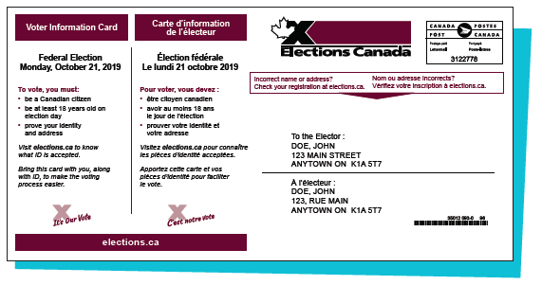

YES
You’re registered to vote. Bring this card with you, along with accepted ID, when you go to vote to make the voting process easier.

NO
You may not be registered or your voter information may not be up to date. Visit elections.ca or call us at 1-800-463-6868 to check and update your registration. You can also register when you go to vote.

To register and vote in the federal election, you must:
- be a Canadian citizen
- be at least 18 years old on election day
- prove your identity and address

PRINT PAGE 3

Ways to vote

You can vote almost any time during the election period. Choose the voting option that works best for you.

1. On election day
- Monday, October 21
Your assigned polling station will be open for 12 hours (hours vary by province).

BEGIN MARGIN:
Check your voter information card for your voting days, locations and times.
END MARGIN.

2. On advance polling days
- Friday, October 11
- Saturday, October 12
- Sunday, October 13
- Monday, October 14

Your assigned polling station will be open from 9:00 a.m. to 9:00 p.m.

3. At any Elections Canada office across Canada
Go to any Elections Canada office before Tuesday, October 15, 6:00 p.m. You will vote using the special ballot process. To find the Elections Canada office nearest you, visit elections.ca or call us.

4. By mail
Visit elections.ca or call us to find out more. Deadlines apply.

PRINT PAGE 4

ID to vote

You have three options to prove your identity and address.

Option 1

Show one of these pieces of ID
- your driver’s licence
- any other card issued by a Canadian government (federal, provincial/territorial or local) with your photo, name and current address

or

Option 2

Show two pieces of ID
Both must have your name and at least one must have your current address.

Examples:
- voter information card and bank statement
- utility bill and student ID card

Don’t have these? No problem!

There are other pieces of accepted ID. Check out the full list at elections.ca.

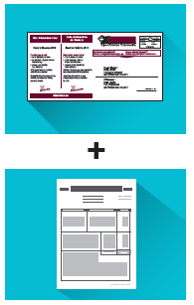

Or

Option 3

If you don’t have ID

You can still vote if you declare your identity and address in writing and have someone who knows you and who is assigned to your polling station vouch for you.

The voucher must be able to prove their identity and address. A person can vouch for only one person (except in long-term care institutions).

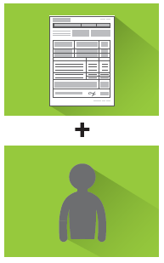

PRINT PAGE 5

Accessibility

All electors are assigned to polling stations for election day and advance polling days. After the election is called, make sure your assigned polling stations meet your accessibility needs by:

- checking your voter information card;
- entering your postal code into the Voter Information Service box at elections.ca; or
- calling us at 1-800-463-6868 or 1-800-361-8935 (TTY).

If you have concerns about the accessibility of your assigned polling stations, call us.

To request voting assistance in advance, including language and sign language interpretation, call the Elections Canada office in your riding before Tuesday, October 15, 6:00 p.m.

Voting assistance tools and services on election day:

- Bigger ballot with candidate names in large print

- Large-print and braille lists of candidates

- Tactile and braille voting template

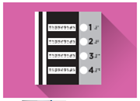

- Magnifiers (4x)

- Large-grip pencil

- Assistance marking your ballot

BEGIN LOGO:
X It’s Our Vote
END LOGO.

END OF DOCUMENT.

