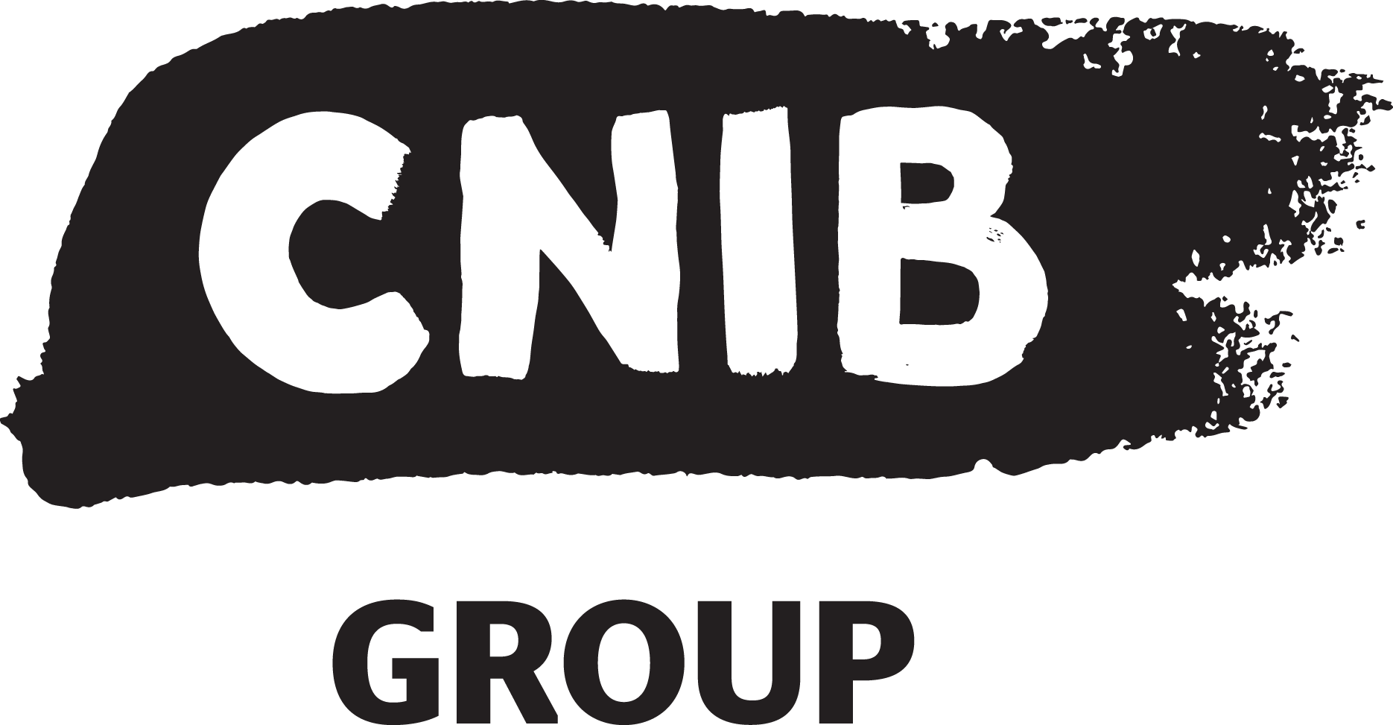

Accessibility at CNIB

CNIB’s Accessibility Commitment
Accessibility and inclusion are our collective responsibility. We will dedicate the time and resources to accessibility and inclusion so that every person is supported for success, irrespective of their roles, obligations and community engagement.

CNIB's Five Points Inclusion and accessibility framework
- Attitudinal (understanding implicit bias, ableism and how it may impact accessibility and inclusion through policy, decision-making practices, social encounters and daily language).

- Usability (user-friendliness of any activity, in which humans interact with any process, information, software or technology. Following ClearPrint Guidelines, AND ensuring that these interactions are easy to understand, navigate, operate, modify and manipulate).

- Technological (Access to high performance and reliable technologies, updated assistive technologies, emergent/innovative technologies. Remediate technical specifications to reduce incompatibilities and functionality across as many new and emergent platforms to which people may use).

- User skills and competencies (any user of any technology & assistive technology has the opportunity to maximize their potential and level of expertise to function at their optimal level of performance).

- Foster Trainer competencies and knowledge translation capabilities to impart not only accessibility but develop inclusive skills and mentoring.

Image 1.0: CNIB Inclusion and Accesibility Framewok

Image Description:
The image contains five circles surrounding the largest middle circle labelled Inclusion and Accessibility. The other five circle edges interlock with the middle circle. The first circle at 12 o’clock reads Aptitudes and Empathy. Clockwise, at two o’clock the circle reads Usability. The circle at five o’clock reads User skill and competencies. At seven o’clock, the circle label includes Trainer knowledge translation. The circle at ten o’clock reads Technology. Each circle is black rimmed with a blue glow fading into the background white at the middle toward the circle’s label.

