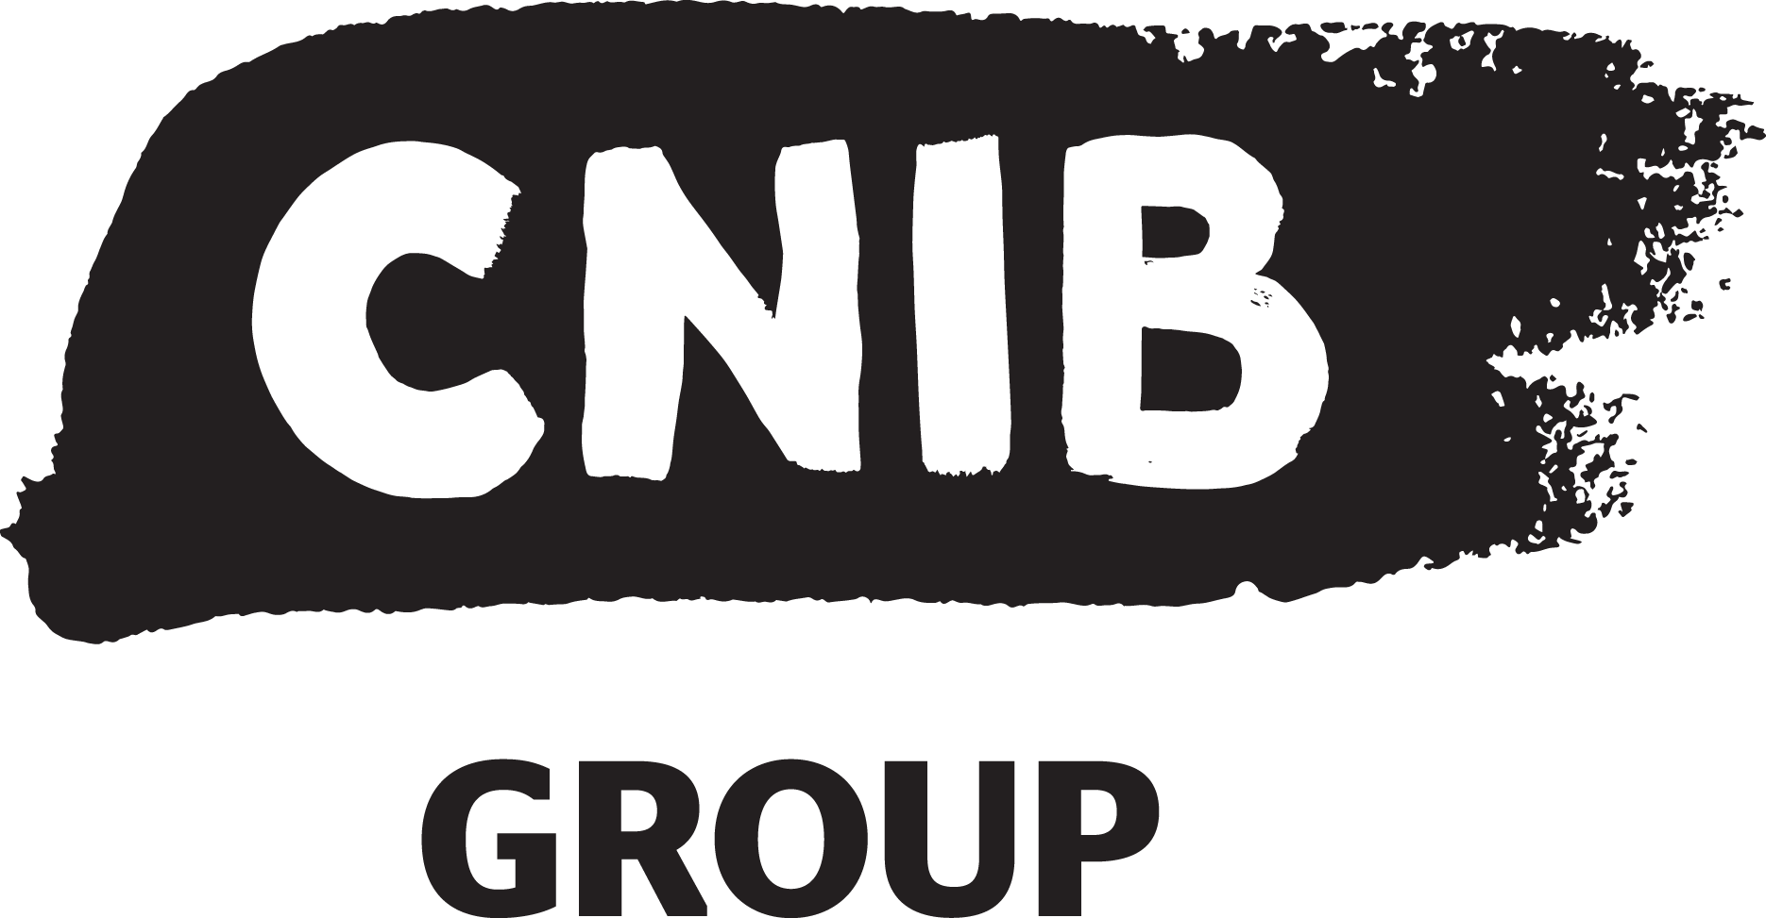

Building Accessibility for a Bright Future

Multi-Year Accessibility Plan Summary 2018-2022

Multiyear Plan Overview:
The Multi-Year Accessibility Plan incorporates three (3) phases. Each phase has initial activities and desired outcomes in realizing five (5) key objectives. Based on this plan, CNIB will identify opportunities, measure progress and sustain best practices in accessibility and inclusion.

5 Core Objectives of the Accessibility Multiyear Plan
- Building a Culture of Accessibility & Inclusive Workplace framework (aligned to Strategic Ambition #1).
- Education, engagement & Skills Development in technical accessibility and inclusion training (aligned to Strategic Ambition #4).
- Fostering an integrated and accessible technological Ecosystem across platforms and equipment (aligned to Strategic Ambition #2)
- Ensuring Physical & Environmental Accessibility by sustaining/promoting built environments and Universal Design innovations across CNIB (aligned to strategic ambition #3)
- Accessibility Monitoring & Evaluation through building and implementing robust evidence-based accessibility practices and processes (aligned to Strategic Ambitions #1 and #4)

3 Phases of Implementation, Activities & Outcomes

Phase One (2018-2019) Initial Activities
- Collect accessibility and inclusion statistics/activities
- Executive & Management Accessibility Statements
- Inclusive leadership and mentoring
- Policy reviews, updates, & creation
- Accessibility integrated into learning strategies
- Implementation of accessible CNIB University Learning Platform & content.
- User accessibility testing panel established.

Desired Outcomes: Improved visibility and reporting on accessibility practices throughout the organization

Phase Two (2019:2020) Initial Activities:
- Research and development partnerships and collaborations in accessibility.
- System-wide usage analytics for accessibility documents/materials on Internal Portal.
- Technology accessibility standards taskforce and projects
- Accessibility Hub, Assessment Toolkit & Survey
- Digital software & systems evaluation and documentation
- Inclusive workplace best practice playbook

Desired Outcomes: Accessibility integrated into organizational practices, decision-making and individual mindsets

Phase Three (2020-2022) Initial Actives:
- Foster experts in key areas (Digital Accessibility, Design, Built Environment and Transportation, Health and Social Inclusion)
- Training & educating youth and volunteers in the accessibility and advocacy in targeted training programs.
- Internal and external Disability Awareness Campaigns.

Desired Outcomes: Dissemination of accessibility expertise & policy papers to society and key decision-makers Community mobilization.

