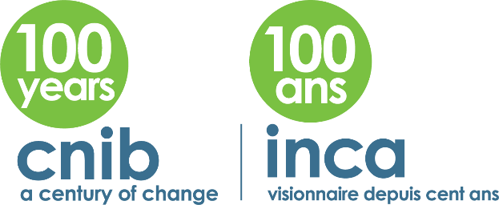

CNIB Scholarships – Application Form

Name:

Address:

City:

Province:

Postal Code:

Telephone:

Email:

Degree of Vision Loss: Right eye ______________ Left eye ______________

Date of Birth: (day/month/year)

School:

Grade Graduating This Year:

Provide the name of the school from where you are seeking degree, diploma or certificate:

List organizations for whom you have performed volunteer service:

What are your educational goals (max 100 words)?

Indicate your career aspirations after completion of your chosen area of study (max 200 words):

How will the scholarship help you attain your educational goals (max 200 words)?

An official transcript of your academic standing for the current year must be received by July 31.

Attachments: Your application must include the following items:
☐ A completed application form;
☐ Proof of secondary education completion (interim);
☐ At least two letters of reference from a teacher/school official/volunteer supervisor;
☐ Letter of acceptance from an accredited postsecondary institution, college or university;
☐ An essay of not more than two pages on the topic “Please tell us how this scholarship will change what it means to be blind for you in your education?” (max 1000 words);
☐ An eye report (not older than one year)
☐ Interim transcript
☐ List other sources of funding, if any.

I understand that by submitting this application I am agreeing to share my essay/story with CNIB communications staff and therefore agreeing to participate in any media outreach or interviews should I be awarded a scholarship. ☐

Are you over 18 years of age? YES ☐ NO ☐

☐ If under 18 by June 30, a parent or guardian must agree to your application

Please send your application by email/fax or regular mail to:

Shampa Bose
Research Coordinator
Grants, Awards & Scholarship Program
CNIB
1929 Bayview Avenue
Toronto, ON M4G 3E8
Tel: 416-486-2500 ext. 7622
Fax: 416-480-7700
Email: shampa.bose@cnib.ca​

About CNIB
CNIB is a registered charity, passionately providing community-based support, knowledge and a national voice to ensure Canadians who are blind or partially sighted have the confidence, skills and opportunities to fully participate in life. To learn more, visit cnib.ca or call the toll-free CNIB Helpline at 1-800-563-2642.

