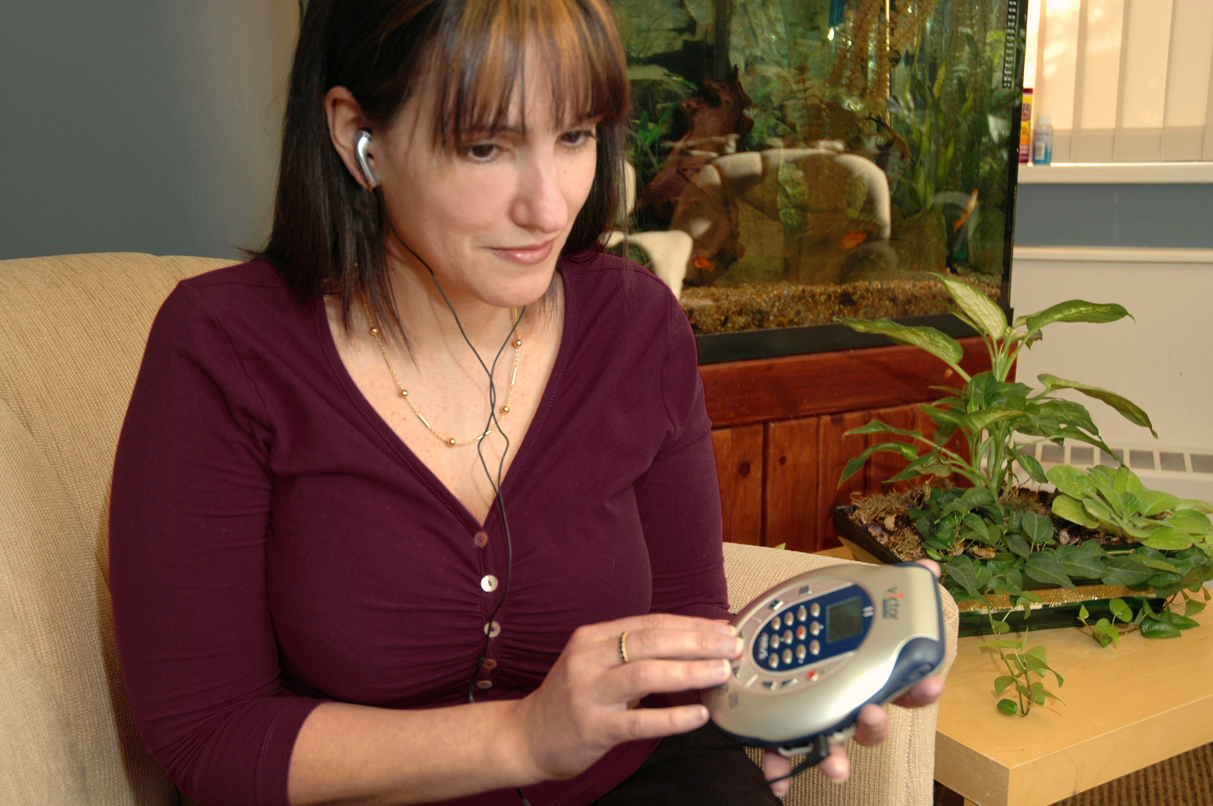

# Re-Vision ADP Report

## CNIB Consultation Summary – September 2018

### Re-Vision ADP (Assistive Devices Program)

Introduction page 3

Application Process page 4

Affordability page 5

Inefficiencies page 6

Training page 7

Inflexible & Outdated Technology page 8

Recommendations page 9

Conclusion page 10

References page 11

### Re-Vision ADP Report CNIB Consultation Summary

#### Introduction

## Introduction

The Government of Ontario should be proud of its Assistive Devices Program (ADP) – it is a lifeline for many Ontarians living with disabilities. Without ADP, many would be unable to afford an assistive device.

Ontarians with sight loss have used the ADP to gain access to tools such as white canes, screen-reading/magnification software, Perkins Braillers, personal computers and countless other accessibility tools. According to Statistics Canada, 81 per cent of individuals living with a disability reported using at least one aid/device to assist them in fully participating in society (2017).

In 2017, through public meetings as well as telephone and online surveys, we spoke to more than 4,000 Canadians impacted by blindness. They told us about their experiences, needs, ambitions and what they want from CNIB. In Ontario, we received a clear message: government-funded assistive devices enable individuals with sight loss to lead active, independent lives.

As part of our Ontario election campaign in 2018, we held eight in-person and telephone consultations with Ontarians living with sight loss. Through this process, we also consulted with medical professionals, ADP vendors and authorizers, manufacturers and other disability groups. These consultations highlighted several areas of the ADP that require improvement:

* Application Process
* Affordability
* Inefficiencies
* Training
* Inflexible & Outdated Technology

#### Application Process

The paper-based application process is inaccessible and inefficient. For example, once an applicant has mailed in their form, s/he may have wait up to eight weeks, according to the Ministry of Health and Long Term Care website), to receive ADP approval for a device. This inefficient process creates unnecessary delays and stress for individuals living with disabilities. According to Spinal Cord Injury Ontario (2018), their contacts in the authorizer community had multiple instances of applications falling through the cracks, with some patients waiting upwards of six months for approval, which resulted in poor outcomes for patients. This extended waiting period for approval is harmful to the physical and mental health of the patient (New, Susilo, Walford, and Warren, 2018).

**Transitioning from the paper-based, mail-in process to an accessible and efficient online platform would be a viable solution.** This would automate the process and ensure the ADP's administrative staff have an opportunity to oversee the process and intervene, as necessary. According to Deloitte and KPMG (Deloitte, 2016; KPMG, 2017; Margetts & Naumann, 2017), this strategy has been successfully used in other jurisdictions, such as Estonia. Through consultations with the ADP office, we understand the ADP will be implementing an administrative system that is digital, but it will be at least two years from now.

There's also an innovative opportunity when it comes to vendor-authorizer interactions. **It would be better if vendors and authorizers had a role in submitting the application to ADP. This could be addressed with an online system that requires authentication by both parties before the application is processed by the ADP.** This would be a welcome addition by vendors and authorizers, as it would eliminate any potential errors, which would lead to greater efficiency in the application process. (SCIO, 2018).

**"T****he authorization process needs to be scrapped as it's inefficient, and not timely. By the time technology is approved, it's outdated.” -Mary, Huntsville**

#### Affordability

##### **Ontario Disability Support Program (ODSP) and Low Income**

Our community raised concerns about the 25 per cent out-of-pocket expense that is paid by individuals who are not Ontario Disability Support Program (ODSP) or Ontario Works (OW) recipients. As some of these devices can be very expensive, **this 25 per cent out-of-pocket expense has created financial barriers, particularly for seniors and individuals with disabilities living on low incomes.** Ontarians 65+ are not entitled to ODSP or OW. Therefore, they're not given equal access to ADP funding - they're required to pay the remaining 25 per cent for their device or secure financial assistance from a charitable source.

**"The cost is prohibitive for those who are not on ODSP or OW. I think the ADP should move to a means-tested amount for the out-of-pocket expenses.” –Scott, Etobicoke**

Given that age-related macular degeneration is the leading cause of sight loss in Canada, this funding formula affects thousands of seniors living with sight loss in Ontario. This out-of-pocket expense forces individuals to choose between a sub-optimal device that they can afford or incurring debt. (SCIO, 2018).

##### **Cost of Assessment**

Providing funding for a person's assistive device is designed to alleviate the financial burden of such a device, **but** **the assessment fees can be costly to the individual.** For example, the ADP's requirement for the high-tech visual aid assessment can be cost-prohibitive for someone living on a low income. Individuals must pay $75 (25 per cent of the $300 ADP-approved cost) for the Vision Loss Rehabilitation Ontario assessment. For those who have been referred to a low vision optometrist, the average cost for an assessment can be $200-250, which is non-refundable. This upfront cost can be a significant financial burden. **Only 1/3 of working-age Canadians with vision loss is employed, and half are struggling to make ends meet on $20,000 a year or less.** For someone earning $20,000/year, a $75 assessment would be roughly 10 per cent of their bi-weekly paycheque, and a $250 assessment would be about 35 per cent of their bi-weekly earnings.

##### **Lack of Vendor Choice**

We also heard about affordability issues from Ontarians in rural areas who can't buy equipment from an ADP-approved vendor, as there no ADP-approved vendors in their communities. This means individuals need to pay for the equipment upfront and submit a claim to the ADP.

**"Paying upfront is a huge barrier." –Pat, Thunder Bay**

By moving to an electronic system, Ontarians in underserviced areas could work with assessors, authorizers and vendors online, and avoid upfront costs for using vendors that aren't approved by ADP. This would ensure the process is more accessible, resulting in cost savings, and ADP users would no longer need to make costly travel arrangements to urban centres to purchase equipment.

The government should consider providing upfront funding for individuals who wish to purchase their devices from mainstream retailers – these devices are often sold at lower prices, which would result in cost savings for the ADP and empower consumer choice.

#### Inefficiencies

##### **Lack of funding for upgrades and repairs**

It can often be less expensive to upgrade a user's existing license for adaptive software such as ZoomText, JAWS, or Kurzweil, rather than purchasing a new version. For example, upgrading JAWS is $720 versus $1,185 for the latest version. Since the ADP doesn't currently finance software upgrades, users tend to buy new versions.

The current ADP policy stipulates device repairs and upgrades are the responsibility of the user. For those living on a low income, it can be devastating when their devices need repairs and they must wait years before they're eligible for new equipment.

**“If devices don't work and they break before five years, it disables people – it is deflating." –Tammy, Kingston**

More flexibility for device repairs and upgrades is required to ensure individuals who are blind, partially sighted and Deafblind have access to the tools they need to maintain their independence. **Funding repairs/upgrades would be more fiscally responsible and efficient than funding new devices/software.**

#### Training

Funded training for assistive devices is an essential part of the program as it ensures the recipient understands how to safely and correctly use their equipment. Under the User Support for Reading and Writing categories, individuals can receive up to 10 hours of training ($400 in total). The $40/hour rate for trainers was set in 1989 - it has not been updated since then. While there are qualified trainers in Ontario, we've heard from users about negative experiences because the structure isn't flexible.

A user in Brampton was supposed to receive training through an ADP-approved vendor, but the instructor wasn't interested in teaching.

**"My girls had $10,000 worth of equipment that just sat in the dining room collecting dust for four years. It's just a waste of the government's money." –Fatima, Brampton**

We have heard from people across the province that the number of training hours are inadequate. Some seniors, individuals who have recently loss their sight and people living with multiple disabilities have difficulties with learning how to use assistive technology. We've learned the 10-hour training structure is not enough time for them to learn how to use their technology.

**“The 10-20 hours I was given to learn two programs wasn't enough.” –Jerry, Barrie**

While we've heard negative feedback, we've also heard some trainers have gone above and beyond the 10-hour training structure, even if they couldn't claim the hours, to ensure users had the training they needed.

Ontarians living with sight loss told us the training provided is not meeting their needs. **They're requesting greater flexibility in the funded training hours for those who need it. They're also asking the government to consider updating the $40/hour rate for training that was established in 1989.** This would encourage more individuals to become trainers, as it would recognize the specialized training that's required for someone to become a trainer.

#### Inflexible & Outdated Technology

According to our research, the ADP’s funded categories (e.g. visual aids) have not been updated since 2001. At that time, no one could predict mobile devices such as smartphones or tablets would become as ubiquitous and indispensable as they are today. The technology that was available 20 years ago wasn't as advanced and mainstream technology wasn't as accessible as it is today. In 2001, accessibility was “chained to a desk” but, that is no longer the case. As technology advances, the ADP must be revised to better meet the needs of Ontarians who are blind, partially sighted or Deafblind.

**Smartphones, tablets, or mobile applications are not currently approved devices. This is a missed opportunity for ADP, as mainstream devices are often less expensive than specialized devices.** For example, iOS and Android devices have built-in screen reading software that individuals with sight loss can use as reading aids. Smartphone cameras can be used as magnifiers, low vision aids, and the GPS/maps applications can used as orientation and mobility aids – three aids within one device. There are also many applications, including BlindSquare, Be My Eyes, Aira and KNFB, that can make the world more accessible.

**"The ADP needs to recognize that smartphones are more than just a phone. Access to more portable technology is important, so accessibility is not chained to a desk.” –Larissa, Brantford**

The current ADP structure has made it impossible for the program to keep up with technological trends, including the rise in accessible mainstream technology, which could result in significant savings.

Devices under the visual aids category have not been significantly updated since 2001. Therefore, the manual doesn't include modern technology, and products (e.g. Pacmate Qx400, Pacmate Bx400 and Braille Note 18/32) that haven't been manufactured since 2008 are still covered. The updated versions of these products, such as the Braille Note Apex, aren't on the approved list.

**“It would be remarkable to see the ADP modernize and cover more current technology, as it is evolving quickly and gives us better opportunities for more independence." –Ramla, Toronto**

An audit of the current list of ADP-approved devices is required to ensure it is up-to-date. The manual should be updated to include modern technology that can be less expensive and more portable, such as smartphones, tablets, mobile applications and portable magnifiers.

#### Recommendations

**Application Process**

* An online system could make the process accessible and efficient, and significantly improve wait times.

**Affordability**

* It's imperative that we investigate other means-testing methods to address the affordability gap for low-income individuals, such as seniors and those who aren't eligible for ODSP or OW.
* By moving to an electronic system, Ontarians in underserviced areas could work with assessors, authorizers and vendors online, and avoid upfront costs for using vendors that aren't approved by ADP.
* The government should consider upfront funding for individuals who wish to purchase their devices from mainstream retailers – these devices are often sold at lower prices, which would result in cost savings for the ADP and empower consumer choice.

**Inefficiencies**

* Rather than having individuals re-purchase equipment or new software, it would be more fiscally responsible and efficient to fund repairs.

**Training**

* To ensure individuals receive the required training, the number of training hours should be tailored to individual needs.

**Inflexible and Outdated Technology**

* Audit the current list of ADP-approved devices to ensure it is up-to-date and ensure products in the manual are available to consumers.
* Update the categories of approved devices to include modern technology that can be less expensive and more portable, such as smartphones, tablets, mobile applications and portable magnifiers.

#### Conclusion

Technology fosters inclusion, and it reduces feelings of isolation and depression for people who are blind, partially sighted or Deafblind – but only when it's **accessible, available and affordable**.

The Government of Ontario should be proud of its Assistive Devices Program (ADP) – it is a lifeline for many Ontarians living with disabilities. Without the ADP, many would be unable to afford an assistive device.

Modernizing the ADP will enhance service delivery and ensure Ontarians who are blind, partially sighted or Deafblind have access to high-quality, timely and essential equipment. Thanks to technological advances, assistive devices can do more than ever before. This means modern devices such as a smartphone or tablet can perform multiple functions (e.g. reading, writing, indoor/outdoor navigation apps, etc.).

**We're asking the government to meet with all ADP stakeholder groups to discuss how we can work together to revision ADP.**

**Contact**

Kat Clarke, Manager, Advocacy and Government Affairs, CNIB Ontario & Quebec

E: [Kat.Clarke@cnib.ca](mailto:Kat.Clarke@cnib.ca) | T: 416-486-2500 ext. 7651

#### References

Canadian Assistive Devices Association. (2018). *Assistive Devices: Proactive Solutions for Ontario’s Seniors and Persons with Disabilities.* Retrieved July 4, 2018 from [http://www.cadaonline.ca/pdf/CADA%20Brief  
%202018%20-%20Assistive%20Devices%20%20Proactive%  
20Solutions%20for%20Ontarios%20Seniors%20and%20Persons%20with%20Disabilities%20April2018.pdf](http://www.cadaonline.ca/pdf/CADA%20Brief%202018%20-%20Assistive%20Devices%20%20Proactive%20Solutions%20for%20Ontarios%20Seniors%20and%20Persons%20with%20Disabilities%20April2018.pdf)

Canadian Institutes for Health Research. (2011). Health Care in Canada: A focus on seniors and aging. Retrieved July 3, 2018 from <https://secure.cihi.ca/free_products/HCIC_2011_seniors_report_en.pdf>

Deloitte. (2016). *AI Augmented Government, using cognitive techniques to redesign public sector work* Retrieved July 6, 2018 from <https://www2.deloitte.com/content/dam/insights/us/articles/3832_AI-augmented-government/DUP_AI-augmented-government.pdf>

Fraser Institute. (2017). *Sustainability of Health Care Spending,* Retrieved July 6, 2018 from [https://www.fraserinstitute.org/sites/default  
/files/sustainability-of-health-care-spending-in-canada-2017.pdf](https://www.fraserinstitute.org/sites/default/files/sustainability-of-health-care-spending-in-canada-2017.pdf)

KPMG (2017). *Demystifying Intelligent Automation, the lament guide to the spectrum of robotics and automation in government.* Retrieved on July 6, 2018 from[https://cdn2.hubspot.net/hubfs/407136/  
PDFs/KPMG/KPMG_demystifying-intelligent-automation.pdf](https://cdn2.hubspot.net/hubfs/407136/PDFs/KPMG/KPMG_demystifying-intelligent-automation.pdf)

Margetts, H. & Naumann, A. (2017). *Government as a platform: What can Estonia show the world. Research Report.* Retrieved July 6, 2018 from <https://www.politics.ox.ac.uk/publications/government-as-a-platform-what-canestonia-show-the-world.html>

New, W.P. Susilo, A., Walford, K. & Warren, N. (2018). *"Emotional Consequences of Delays in Spinal Rehabilitation Unit Admission or Discharge: A Qualitative Study on the Importance of Communication."* Topics in Spinal Cord Injury Rehabilitation (2017). Retrieved July 6, 2018 from <https://www.ncbi.nlm.nih.gov/pubmed/29434461>

Spinal Cord Injury Ontario (2018). *The Ontario Mobile Devices Sector: A Third Party Review.* Retrieved July 10, 2018 from [https://sciontario  
.org/wp-content/uploads/2018/07/SCIO-PGI-Final-Report.pdf](https://sciontario.org/wp-content/uploads/2018/07/SCIO-PGI-Final-Report.pdf)

Statistics Canada. (2014). *Table 115-0001 - Prevalence of disability for adults, by sex and age group, Canada, provinces and territories, occasional (number unless otherwise noted), CANSIM (database).* Ottawa. Retrieved July 4, 2018 from [http://www5.statcan.gc.ca/cansim/a26?lang=eng&retrLang  
=eng&id=1150001&pattern=disability&tab](http://www5.statcan.gc.ca/cansim/a26?lang=eng&retrLang=eng&id=1150001&pattern=disability&tab)

Statistics Canada. (2015). *A profile of persons with disabilities among Canadians aged 15 years or older, 2012*. Ottawa. Retrieved July 4, 2018 from <http://www.statcan.gc.ca/pub/89-654-x/89-654-x2015001-eng.htm>

Statistics Canada. (2017). *Canadian Survey on Disability: A profile of persons with disabilities among Canadians aged 15 years or older, 2012*. Retrieved July 3, 2018, from [http://www.statcan.gc.ca/pub/89-654-x/89-654-x2015001  
-eng.pdf](http://www.statcan.gc.ca/pub/89-654-x/89-654-x2015001-eng.pdf)

Wang, R. & Wilson, M. (2017) *AGE-WELL Project 8.2: Aging, Disability and Technology – Understanding and advancing Canadian policies for technology access*. Retrieved July 4, 2018 from <http://agewell-nce.ca/wp-content/uploads/2015/09/age-well_jurisdictional-scan_2017_June-30_FINAL.pdf>

#### 

## Web: **cnib.ca**

## Email: **info@cnib.ca**

## CNIB Contact Centre: **1-800-563-2642**