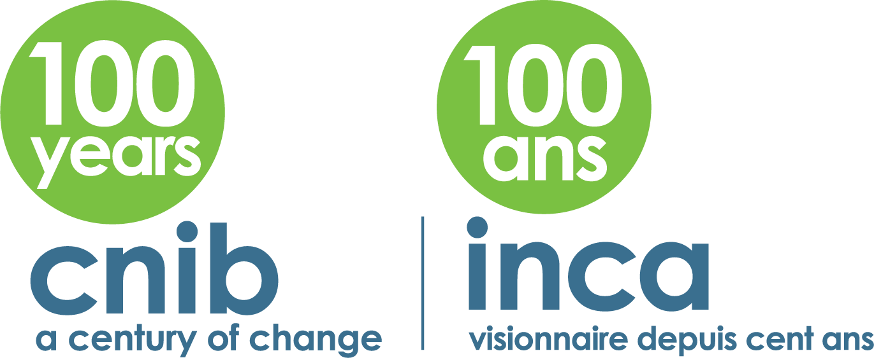

RESEARCH INTENT FORM

Date:

- Name, affiliation, telephone number and email address of the lead researcher: (Please note that while there may be more than one principal investigator on the project, only one person can be identified here as the lead contact or corresponding applicant.)

- Title of project:

- Describe an observation or problem that has motivated this project:

- Objectives: (Include research question or hypothesis being addressed.)

- Relevance of the project to the mission and goals of CNIB’s strategic plan and/or the field of blindness/vision loss research and/or the community of people with vision loss:

- CNIB Approval: (Proposals or research projects must have approval from CNIB official(s) whom assistance, partnership, or support is requested (e.g. District Manager or Executive Director of a Division). Give the name and address of CNIB official(s) who have reviewed and approved the proposal, and attach letter(s) of support.)

- Describe how the research team has the qualifications, expertise and experience to successfully complete the project: (Please attach resumes or CV’s as relevant)

- Include a brief description of work plan and methods: (Please include expected dates for completion of each activity, proposed methods for recruitment of participants, proposed methods for data collection, and proposed methods for data analysis. Describe the nature of expected CNIB staff (local, divisional and/or national office) activity and involvement, if any.) (1/2 page max.)

- Ethical review and approval: (Proposals for research projects involving human subjects must receive ethical review and approval. Give the name of the agency (e.g. university research ethics review committee), and contact information for the person at that agency, who will be responsible for reviewing and approving your proposal. If the proposal has already been reviewed, attach the letter of response from the research ethics board. If the proposal has not been reviewed, please explain.)

- What are the expected results and benefits to the community/society, study participants and CNIB?

- How will the results be communicated to participants and other stakeholders?

12. Name of the funding agency (or academic affiliation, for student projects): (Include expected date for funding decision, and partnership funding, where applicable.)

13. Project Budget (for each year of the project):

14. If you are a student, please name your supervisor and provide his/her contact information below:

15. If you are asking CNIB to assist you in contact our clients for their potential participation in your study, please indicate whether an honorarium for their time, and/or travel funds, are provided, and the proposed amount, if known:

16. If you wish to have CNIB assist you in contacting our clients for their potential consent to participate in your study, please indicate: a) number of clients needed; b) location (city/province/nationwide); c) age range of clients and sex, if applicable:

17. If you wish to CNIB to assist in the recruitment of more than 10 clients for your study, please indicate whether your study is funded to provide CNIB with reimbursement for staff time and/or hard costs of recruitment: N/A

18. Please use the space below for any additional information that you think is relevant for the review of your proposal:

Please send a completed copy of this form to:

Shampa Bose

Executive Assistant

CNIB
1929 Bayview Avenue
Toronto, ON M4G 3E8

E-mail: shampa.bose@cnib.ca
Phone: (416) 486-2500, ext. 7622

