This document contains both information and form fields. To read information, use the Down Arrow from a form field.
Today's Date:
_____________________________________________ Name of guide dog user:
_____________________________________________
Address:
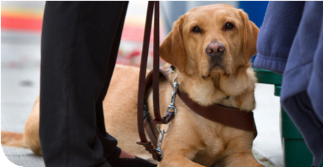
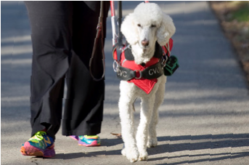
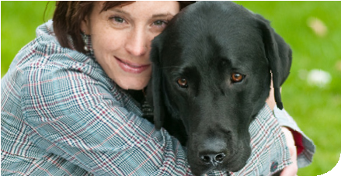
________________________________________________________________________________

Today’s date:
CNIB Guide Dog
Assistance Fund
Application for Reimbursement
for Extraordinary Veterinary Expenses
Phone number:
( ) _______________________________________ Name and age of working guide dog:
_____________________________________________
Name of school where guide dog was trained:
________________________________________________________________________________
Name, telephone, and address of the veterinarian providing care:
(Note: CNIB reserves the right to contact your veterinarian to verify the nature of the treatment.)
________________________________________________________________________________
________________________________________________________________________________
Do you have pet insurance? Yes / No
If yes, have you submitted a claim to them? Yes / No (please explain)
________________________________________________________________________________
If yes, please state what portion of your invoice has been reimbursed: (attach copy of reimbursement)
________________________________________________________________________________

Some guide dog organizations/schools reimburse for veterinary expenses. Have you contacted your guide dog school to request availability of funds to cover these expenses, before applying to CNIB? Yes / No
Were funds made available to you from your guide dog school? Yes/No
If yes, please state what portion of your invoice has already been reimbursed: (attach copy of reimbursement)
________________________________________________________________________________ Description of the illness or condition for which the invoice is being submitted (diagnosis):
________________________________________________________________________________ ________________________________________________________________________________
Brief description of the treatment or service: (e.g. tests, consultation, bloodwork, hospitalization, surgery, injections, intravenous, medications)
________________________________________________________________________________
_____________________________________________ Date of Treatment: _____/_____/_____
Day Month Year
Total amount you wish to claim: (As of January 1, 2014, all claims per calendar year per working guide dog must total no more than $650)
_____________________________________________
I hereby state that the above statements are true: (type name or Signature on faxed form):
Signature or typed name: _________________________________________________________
Return form by email: guidedogfund@cnib.ca
OR
Fax: (416) 480-7700 Attn. Administrator Guide Dog Fund OR mail to:
Administrator, Guide Dog Fund, 1929 Bayview Avenue, Toronto, Ontario, M4G 3E8

Reimbursement Options:
Reimbursement to the user: If the treatment has been completed and you have already paid the veterinarian, the proof of payment* must be forwarded to CNIB no more than three months after the treatment. A payment will only be made after the guide dog has received the treatment. Payment to the veterinarian: Payment will be made to the veterinarian when the applicant submits the itemized invoice and requests that payment be made to the veterinarian.
Appeals Process:
An appeal of a funding decision concerning extraordinary veterinary expenses for a working guide dog can be made within 30 days of receiving the decision, by submitting the appeal in writing to the fund administrator.
*Proof of payment (invoice) must include the name of the veterinarian who provided service, details of the service or medications provided and the cost of each service or medication.
GDF Application revised 1/28/2014

