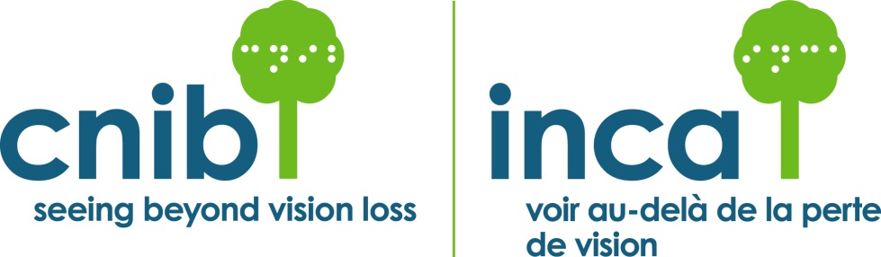

Gift in Will Confirmation Form

Thank you for choosing to make a difference in the lives of people with vision loss by making a future gift to CNIB. Please take a moment to complete this confidential form and return it. The amount of information that you provide is completely optional, not legally binding and will allow CNIB to plan for the future.

______________________ _____________________________________
[Please print your name] [Signature]

_____________________________________________________________
[Address]

[City] [Province] [Postal Code]

_(_____)_____________________________________________________
Home telephone E-mail

- I have already included a gift to CNIB in my Will.

In the amount of $______________or _____% of the residue of my estate.

CNIB Friends for Life

With your permission, CNIB would like to acknowledge you as a Friend for Life. From time to time, CNIB publicly recognizes the names of donors who have made significant contributions, including those who make a deferred gift through the Friends for Life program. This recognition is meant as a tangible form of our appreciation, and also serves to remind others of the ongoing need for support.

Continued…..

We want to thank you in the way that you feel is most appropriate. Please check off one of the following recognition options:
□ Yes, I hereby consent to have my/our name(s) recognized on CNIB donor lists.
□ I would prefer my gift to remain anonymous during my lifetime; however, when my gift is realized, I would like my estate to be recognized.
□ I would like my gift to remain anonymous in perpetuity.
□ I would prefer not to be recognized in any way.

If you have checked “Yes” above, please indicate exactly how your name(s) should appear when publicly recognized:

Which best describes the reasons for your support of CNIB?

□ I believe in the vital role CNIB plays in helping Canadians.
□ I have been personally helped by the services of CNIB.
□ A loved one has been helped by CNIB.
□ I believe CNIB needs strong community support to achieve its mission.
□ I wish to ensure the future financial security of CNIB
□ Other, please specify________________________________________

You are welcome to amend this consent form at any time. Please send your changes in writing, on a copy of this form, to Ruth D’Souza, Manager, Planned Giving, CNIB, 1929 Bayview Avenue, Toronto, Ontario, M4G 3E8 OR, Fax: (416) 480-7700.

For CNIB’s Privacy Policy, please visit www.cnib.ca.

This document is for information only and is not a legally binding contract.

